Alex and Lee - Notes

* Meaning:
* Example:

# 2024example

## Cambly AI CORRECTION

## Other AI correction

## Questions（answer them anytime）

## idiomatic English expressions(1-ai example 2-my example 3-ai correction)

## correction and expanding Expression

# 20241111

## Cambly AI CORRECTION

## Other AI correction

Error: ~~"American is good, and today is good."~~

Improved: "The weekend was good, and today is going well."

Explanation: The original sentence structure is a bit abrupt and doesn't clearly convey that the speaker is talking about the weekend and the current day.

Error: "Yeah, maybe every year, the company will arrange this event to employ, yeah."

Improved: "Yes, the company arranges this event for us every year."

Explanation: The original sentence is grammatically incorrect and unclear. The corrected version is more direct and grammatically correct.

Error: ~~"Oh, we... Yeah, because maybe there are total of 500 people doing the medical checkup, so it needs time to give us feedback about what happened."~~

Improved: "Yes, since there are around 500 people getting the medical checkup, it will take some time to get the results back."

Explanation: The original sentence is wordy and contains unnecessary repetition. The corrected version is more concise and clear.

Error: "And brilliant. Today, this morning, on the weekend, I just continue to think of my work, but"

Improved: "And that's great. This morning, over the weekend, I kept thinking about work, but" Explanation: The original sentence starts with "And brilliant." which doesn't flow well. The corrected version provides a smoother transition.

Error: "In the morning, in this morning, I just ~~spent one hour to solve~~ my problem based on my idea before, yeah."

Improved: "This morning, I spent an hour solving my problem based on a previous idea." Explanation: The repetition of "in the morning" is unnecessary. The corrected version is more concise.

Error: "Yeah, it's successful. Yeah, I fixed it successfully."

Improved: "Yes, it was successful. I managed to fix it."

Explanation: The repetition of "Yeah" is informal and the structure of the sentence can be improved for clarity.

Error: ~~"It's just small things."~~

Improved: "They are just small things."

Explanation: The original sentence is missing a subject. The corrected version includes a subject to make the sentence complete.

Error: ~~"How is your week?"~~

Improved: "How was your week?"

Explanation: The original question is asking about the current week, but the past tense is more appropriate for discussing a week that has already passed.

Error: "So I will go and buy a second-hand car this week. So a little bit expensive, a little bit scary, but it's important. So I have to do it."

Improved: "This week, I'll buy a second-hand car. It's a bit expensive and *scary,* but it's important, so I need to do it."

Explanation: The original sentence has unnecessary repetition of "so" and can be made more concise.

Error: "I think so. Yes. It's hard to repair the van. Yes."

Improved: "I think so. It's hard to repair the van."

Explanation: The repetition of "Yes" is unnecessary and makes the sentence sound less natural.

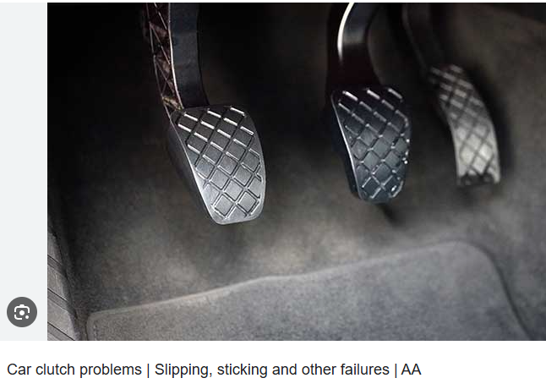

Error: "because the clutch pedal. And this is a very expensive part."

Improved: "because of the clutch pedal, which is a very expensive part."

Explanation: The original sentence is missing a connector between the cause and the effect. The corrected version flows better.

Error: "Check clearly before buying."

Improved: "Make sure to check it thoroughly before buying."

Explanation: The original sentence is abrupt and can be made more polite and complete.

Error: "These two documents both discuss money."

Improved: "Both of these documents discuss money."

Explanation: The original sentence is grammatically correct but can be improved for flow and emphasis.

Error: "So, I just want to begin with the book. I want to share some ideas on the book about money review, and then we can talk about the website. Is it okay?"

Improved: "I'd like to start with the book and share some ideas about the money review, and then we can discuss the website. Is that okay?"

Explanation: The original sentence is a bit disjointed. The corrected version is more coherent and polite.

Error: ~~"I don't prepare it."~~

Improved: "I didn't prepare for it."

Explanation: The original sentence is incomplete. The corrected version is a complete sentence that conveys the same meaning.

Error: "Yeah, we've got it. Okay."

Improved: "Yes, we've got it. Okay."

Explanation: The use of "Yeah" is informal. "Yes" is more appropriate in a professional or formal conversation.

Error: "Money is not a substitute for tenderness. And power is not a substitute for tenderness. I can tell you as I'm sitting here dying when you most need it. Need money or power will give you the feeling you are looking for. No matter how much of them you have."

Improved: "Money isn't a substitute for tenderness, and neither is power. I can tell you that when you're dying and need it the most, neither money nor power will give you the feelings you're looking for, no matter how much you have."

Explanation: The original sentence is confusing and has multiple errors. The corrected version is clear and grammatically correct.

Error: ~~"And it's not the whole thing. So I just pick up some sentence."~~

Improved: "And that's not all. I just picked out a few sentences."   
“这还不是全部，我只是摘录了几句话。”

Explanation: The original sentence is unclear and grammatically incorrect. The corrected version is more coherent and grammatically correct.

Error: "And remember what I said about finding a meaningful life. I wrote it down. But now I can recite it." Improved: "And remember when I mentioned finding a meaningful life? I wrote it down and now I can recite it." Explanation: The original sentence is a bit disjointed. The corrected version provides a smoother connection between the ideas.

Error: ~~"I stop it. I stop the sharing screen."~~

Improved: "I'm stopping the screen share now."

Explanation: The original sentence is not grammatically correct. The corrected version is a complete and grammatically correct sentence.

Error: "Because there are many... Maybe this sentence... There is a big confusion in this country over what we want versus what we need."

Improved: "There's a lot to discuss... Perhaps this sentence captures it: There's a big confusion in this country over what we want versus what we need."

Explanation: The original sentence is disjointed and unclear. The corrected version provides a smoother introduction to the quote.

Error: "What we want maybe means our greed."

Improved: "What we want might indicate our greed."   
“我们想要的可能表明我们的贪婪。”

Explanation: The original sentence uses "maybe" in a way that is not grammatically correct. The corrected version uses "might" to indicate possibility.

Error: "So at that time, I have to ask for others' help, and it can make me think of more ways to earn money."

Improved: "So at that time, I'd have to ask for help from others, and it makes me think of more ways to earn money."

Explanation: The original sentence uses "have to" in a future context, which is not correct. The corrected version uses "would have to" for future situations.

Error: "You have to think of A, you cannot buy now. B, you have to wait for a little while until the price is getting lower."

Improved: "You have to consider not buying A now and waiting for B, the price to lower a bit." Explanation: The original sentence is unclear and repetitive. The corrected version is more concise and clear.

Error: ~~"So it's daunting you when you don't have enough money."~~

Improved: "So it can be daunting when you don't have enough money."

Explanation: The original sentence is grammatically incorrect. The corrected version is a complete and grammatically correct sentence.

Error: "Oh yeah, 思考方式."

Improved: "Oh yes, way of thinking."

Explanation: The original sentence includes a non-English term, which should be translated for clarity.

Error: "So far, so good."

Improved: "It's been satisfactory so far."

Explanation: The original phrase is informal. The corrected version is more formal and suitable for a professional conversation.

Error: "And I'm trying to get more funds about my job."

Improved: "And I'm trying to gain more knowledge about my job."

Explanation: The original sentence uses "funds" incorrectly; it should be "knowledge" or "information."

Error: "I'm confused."

Improved: "I find it difficult to pinpoint exactly."

Explanation: The repetition of "I'm confused" is unnecessary and can be replaced with a more descriptive phrase.

Error: "I feel it's enough."

Improved: "I feel that it's sufficient."

Explanation: "Enough" is informal; "sufficient" is a more formal and precise way to express the same idea.

Error: "But if somebody suddenly gets a lot of money from me, or I need to spend a lot of money more than I have, the things become difficult."

Improved: "But if someone suddenly takes a lot of money from me, or if I need to spend more money than I have, things become difficult."

Explanation: The original sentence is grammatically incorrect and unclear. The corrected version is grammatically correct and more formal.

Error: "At that time, I feel effortless."

Improved: "At that time, I feel helpless."

Explanation: "Effortless" is not the correct word to express a lack of ability to do something; "helpless" is the appropriate word.

Error: "I feel I can do anything without ample money."

Improved: "I feel that without ample money, I can't do much."

Explanation: The original sentence structure is awkward. The corrected version is more natural and clear.

Error: ~~"Spend less money on budget."~~

Improved: "Spend less money and stick to a budget."

Explanation: The original sentence is incomplete and unclear. The corrected version is a complete sentence that conveys the intended meaning.

Error: "You have to think of A, you cannot buy now. B, you have to wait for a little while until the price is getting lower."

Improved: "You have to consider not buying A now, and B, waiting for a bit until the price drops."

Explanation: The original sentence is grammatically incorrect and unclear. The corrected version is grammatically correct and more concise.

Error: "Maybe it's good, because I don't think it can interest me more, because nothing is perfect."

Improved: "Perhaps it's good enough, as I don't believe it can interest me more, given that nothing is perfect."   
也许这已经足够好了，因为我不相信它能让我更感兴趣，因为没有什么是完美的。”

Explanation: The original sentence is unclear and has a negative structure. The corrected version is more positive and clear.

Error: "It's difficult to say, it's difficult to say."

Improved: "It's hard to articulate my thoughts on this."

Explanation: The repetition of "It's difficult to say" is unnecessary and can be replaced with a more descriptive phrase.

Error: ~~"I feel I can do anything without ample money."~~

Improved: "I feel that without ample funds, I'm limited in what I can do."

Explanation: The original sentence structure is awkward. The corrected version is more natural and clear.

Error: "Spend less money on budget."

Improved: "Be mindful of spending and maintain a budget."

Explanation: The original sentence is incomplete and unclear. The corrected version is a complete sentence that conveys the intended meaning.

## Questions（answer them anytime）

## idiomatic English expressions(1-ai example 2-my example 3-ai correction)

## correction and expanding Expression

# 20241104

## Cambly AI CORRECTION

## Other AI correction

Error: "Good, yeah. Are you?"

Improved: "I'm good, thanks. How about you?"

Explanation: This is a more natural way to ask about someone else's well-being after stating your own.

Error: "Yeah, I changed the subscription and the system automatically cancels the class." Improved: "Yes, when I changed the subscription, the system automatically cancelled the class." Explanation: The corrected sentence is more grammatically correct and flows better in conversation.

Error: "Yeah, they didn't notice me."

Improved: "Yeah, I wasn't notified."

Explanation: "Notice" is not typically used in this context; "notified" is the correct term for being informed of something.

Error: "Yeah, I have a full day."

Improved: "Yes, I had a full day."

Explanation: The past tense is more appropriate here as the conversation is about a day that has already passed.

Error: "No, no. Yesterday, I took my mom to take a physical exam and it's good."

Improved: "No, actually. Yesterday, I took my mom for a physical exam, and it went well."

Explanation: "To take a physical exam" is not the correct phrasing; "for a physical exam" is more appropriate, and "it went well" is a more natural way to express that the exam was good.

Error: "Yes, everything's okay."

Improved: "Yes, everything is fine."

Explanation: "Fine" is more commonly used in this context to express that everything is okay.

Error: "Yeah, it's a common physical exam because" Improved: "Yes, it's a routine physical exam because" Explanation: "Routine" is a more natural word to describe a regular or standard physical exam.

Error: "Yeah. I think we need to do something in advance."

Improved: "Yes, I think we need to do something beforehand."

Explanation: "In advance" is correct, but "beforehand" is more commonly used in spoken English.

Error: "Yeah, I didn't hear that."

Improved: "I didn't catch that."

Explanation: "Didn't catch that" is a more natural way to say you didn't hear or understand something.

Error: "Oh, soft opening. It's a child."

Improved: "Oh, a soft opening. It's like a trial run." “哦，试营业。就像试运行一样。”

Explanation: The original sentence was unclear and grammatically incorrect. The corrected sentence provides a clearer explanation of what a soft opening is.

Error: "They wanted to test the waters with a soft opening."

Improved: "They wanted to test the waters with a soft launch."

Explanation: "Soft launch" is more commonly used in business contexts to describe a low-key introduction of a product or service.

Error: "They put a lot of flowers in front of their gate."

Improved: "They decorated the entrance with many flowers."   
“他们用很多鲜花装饰了入口。”

Explanation: This sentence flows better and is more descriptive.

Error: "Because last year, I bought a physical car."

Improved: "Because last year, I bought **a gym membership."**“因为去年我买了一张健身房会员卡。”

Explanation: The original sentence is nonsensical; the corrected sentence makes it clear that a gym membership was purchased.



Error: "You go to the gym."

Improved: "You go to the gym, right?" Explanation: Adding "right?" at the end of the sentence turns it into a question, which is more appropriate given the context.

Error: "They try to see if there are many members."

Improved: "They try to see if there are many potential members."

Explanation: "Potential members" is more specific and accurate in this context.

Error: "Not only the payment."

Improved: "Not just payment."

Explanation: "Not just payment" is a more natural way to say that there are other areas of competition besides payment.

Error: "Yeah. They are rivalries."

Improved: "Yes, they are rivals."   
是的，他们是竞争对手。

Explanation: "Rivalries" should be "rivals" when referring to the companies themselves.

Error: "To prevent him shooting a goal."

Improved: "To prevent him from scoring a goal."

Explanation: "From scoring a goal" is a more natural way to express this action in soccer.

Error: "This is function."

Improved: "This is a function."

Explanation: "Function" should be "a function" to correctly use the indefinite article before a singular noun.

Error: "He is playing a defensive role."

Improved: "He is playing a defensive position."

Explanation: In the context of sports, "position" is more commonly used to describe where a player is on the field.

Error: "On Saturday, our company has a sport meeting and maybe that's not good because I had to get up at 6 a .m."

Improved: "On Saturday, our company had an sport meeting, which wasn't great because I had to get up at 6 a.m."

Error: "I had to participate in the opening ceremony."

Improved: "I had to get up early to participate in the opening ceremony."

Explanation: This sentence is actually correct, but if Lee wanted to emphasize the inconvenience, he could say, "I had to get up early to participate in the opening ceremony."

Error: "Before that, we rehearsed our show for four or five times after work in the past two months."

Improved: "Before that, we rehearsed our show four or five times after work over the past two months."

Explanation: "In the past two months" is more commonly used to indicate a period leading up to the present.“过去两个月”更常用来表示到现在为止的一段时间。

Error: "And I returned to my home on Saturday afternoon."

Improved: "And I got back home on Saturday afternoon."

Explanation: "Got back" is more idiomatic than "returned" in this context.

## Questions（answer them anytime）

## idiomatic English expressions(1-ai example 2-my example 3-ai correction)

### 通知/沟通

地道英语句子："I didn't receive any notification about the event; please make sure to inform me next time."

### 运动会开幕式

地道英语句子："I'm looking forward to seeing you in the opening ceremony on Saturday afternoon."

### 休息日/假期

地道英语句子："I'm taking a full day off for a routine check-up at the doctor's office."

### 汽车离合器

地道英语句子："The clutch is what changes the gears in a manual transmission car."

### 自动挡汽车

地道英语句子："Automatic cars are easier to drive because they don't require you to operate the clutch."

### 手动挡汽车

地道英语句子："Manual gears give you more control over the car's acceleration and deceleration."

### 柔软/温和

地道英语句子："She speaks so softly and with such a gentle tone that it's hard not to listen."

### 软饮料

地道英语句子："I'd rather have a soft drink, like a cola, instead of a hot coffee right now."

### 低调开业

地道英语句子："We're planning a soft opening for the business to test the waters before the grand opening."

### 盛大开业

地道英语句子："The grand opening of the store was a huge success, attracting a lot of customers."

### 健身卡

地道英语句子："I need to renew my gym subscription; it's been a great way to stay fit."

### 竞争

地道英语句子："We have a competitive relationship, always pushing each other to do better."

### 垄断

地道英语句子："Monopolies can **stifle innovation and competition** in the market."

### 支付方式

地道英语句子："Alipay and WeChat Pay are the most commonly used payment methods in China."

### 足球术语

地道英语句子："The defender intercepted the ball, tackling the attacker and preventing him from shooting a goal."

### 愤怒

地道英语句子："Anger is like a devil that can lead to **rash decisions and impulsive actions**."

### 强迫性的

地道英语句子："Compulsive behavior can be a sign of an underlying anxiety or stress."

## correction and expanding Expression

they didn’t notify me

in the opening ceremony

on Saturday afternoon

a full day off

a routine check up

the clutch

the clutch changes the gears

automatic gars

an automatic car

manual gears

[engoo.com/app/daily-news/article/science-finds-soft-complaints-more-effective-than-anger/GNcbsmXwEe-lem-iKVmVBg](https://engoo.com/app/daily-news/article/science-finds-soft-complaints-more-effective-than-anger/GNcbsmXwEe-lem-iKVmVBg" \t "https://www.cambly.com/en/_blank)

Alexandra

in a textural way

as a texture/ soft

she is softly spoken/ to use soft language

soft drinks/ carbonated drinks

business/ we will start with a soft opening

grand opening

Alexandra

a grand opening

without any fanfare

fanfare/ fuss and celebration

a gym subscription?

test the waters/ idiom, phrase, expression

they wanted to test the waters with a soft opening

he is soft in the head

to describe a person who is naive or possibly stupid

slang

clever/ smart/ intelligent

they are competiters

they have a competitive relationship

rivals

monopoly/ monopolies

Alipay and Tencent

they are the most commonly used way to pay

### football shirt

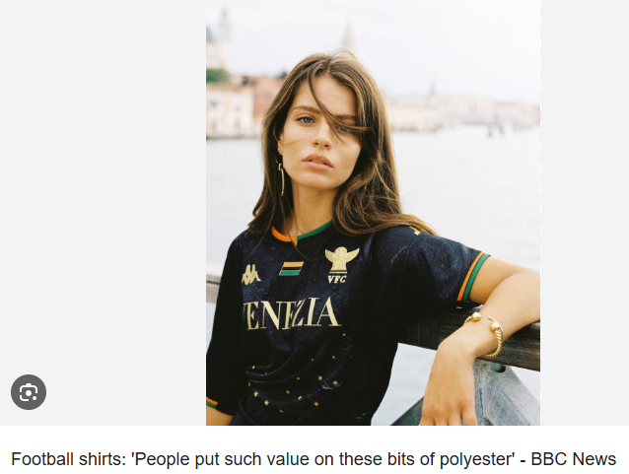

intercept

to intercept the ball

T

he is tackling the other player

to stop him from attacking

he is likely to **score a goal**

shooting

to prevent him **shooting (a goal)**

a defender

he is playing a defensive role

the /a devil

anger is a devil

a rash decision

a rash decision/ a decision taken in haste or without thinking it through

compulsive

# 20241029

[engoo.com/app/daily-news/article/science-finds-soft-complaints-more-effective-than-anger/GNcbsmXwEe-lem-iKVmVBg](https://engoo.com/app/daily-news/article/science-finds-soft-complaints-more-effective-than-anger/GNcbsmXwEe-lem-iKVmVBg" \t "https://www.cambly.com/en/student/progress/_blank)

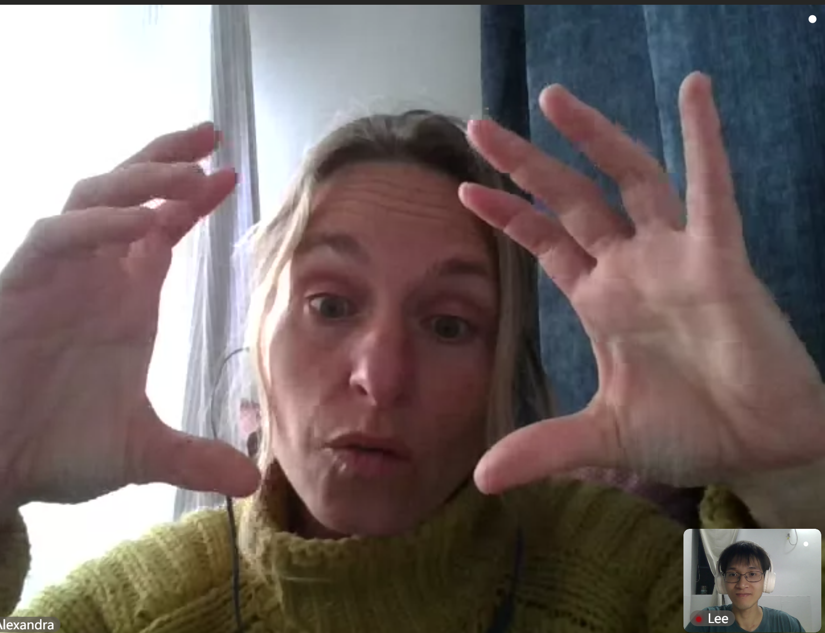

## Cambly AI CORRECTION

Yeah, and today, I still ask a lot of question.

Yeah, and today, I still ask a lot of questions.

so I need to ask him, and he patiently answer me.

so I need to ask him, and he patiently answers me.

I found you have finished a lot of project

I found you have finished a lot of projects

 what question you think is the most difficult

what question do you think is the most difficult

Do you have made any plans about your future?

Have you made any plans about your future?

if this employee have a clear growth path

if this employee has a clear growth path

## Other AI correction

Error: "she can improvise excellently."

Improved: "she can improvise excellently."

Explanation: The word "can" should be included to indicate ability.

Error: "She takes the interview questions in her blog."

Improved: "She takes the interview questions in her stride."

Explanation: "Blog" was likely a mistake for "stride," which is the correct idiom.

Error: "Why are these good questions? What makes these good questions?"

Improved: "What makes these questions good? Why are they considered good questions?" Explanation: This rephrases the question for clarity and flow.

Error: "According to your question, mm, the first question, what, mm, we can, when the interview displaying or elaborate our project to the employee, employer."

Improved: "In response to your question, for the first question, we can **elaborate on our project to the interviewer** during the interview."

Explanation: This corrects the sentence structure and clarifies the meaning.

Error: "Is it true for her to finish her project herself or just copy somebody's work?"

Improved: "Can she truly complete her project on her own, or is she just copying someone else's work?"

Explanation: This rephrases the sentence for clarity and to form a clear question.

Error: "And the second, we can know that if this employee, or employee can express herself clearly in a short time."

Improved: "Secondly, we can determine if the employee can express herself clearly and concisely in a short time."

Explanation: This corrects the sentence structure and uses "and" to connect ideas.

Error: "And what difficulties you have when you do your project and how to solve them? This question can show employee, it can show employee that the employee, if the employee, maybe they just want to know when they face difficulties, what will she do?"

Improved: "What difficulties did you encounter during your project, and how did you solve them? This question can show the employer how the employee approaches challenges and how she handles problems."

Explanation: This rephrases the sentence for clarity, corrects grammar, and forms a coherent question.

Error: "And the second, another important point is that the company also pay attention to the reliable people because when you, when the leader or the boss handle, give you a task or urgent task, you cannot finish that off or you know you cannot finish that, but you don't tell your boss or you don't, and you hide it, it's a reliable behavior."

Improved: "Additionally, companies value reliable individuals. If a leader or boss **assigns a task** or urgent task, and you know you cannot complete it, but you don't **inform** your boss and instead hide it, that's not a reliable action."

Explanation: This corrects the sentence structure, grammar, and clarifies the meaning of reliability in the workplace.

## Questions（answer them anytime）

## idiomatic English expressions(1-ai example 2-my example 3-ai correction)

### 知识渊博 (Knowledgeable)

"She is very knowledgeable and can discuss a wide range of topics with ease."

### 表达清晰 (Articulately)

"He articulates his thoughts clearly and concisely, making complex ideas easy to understand."

### 对答如流 (Responsive)

"During the interview, she was very responsive, answering all questions promptly and effectively."

### 随机应变 (Adaptable)

"**She took the interview questions in her stride**, showing her ability to adapt to unexpected situations."

### 自信的步伐 (Confident Stride)

"He entered the room with a confident stride, clearly **at ease with** the interview process."

### 修复 (Repair)

"They are replacing the meter to ensure accurate readings and improve the system's reliability."

### 保持乐观 (Keep Chin Up)

"Despite the challenges, they keep their chin up and maintain a positive attitude."

### 个人优势 (Strengths)

"When asked about her strengths, she highlighted her problem-solving skills and ability to work well under pressure."

### 职业规划 (Career Plan)

"In the interview, they were asked about their 5-year plan to **gauge their long-term goals** and commitment to the company."

### 评估 (Assessment)

"This enables employers to evaluate whether the candidate has a clear growth path and **aligns with** the company's objectives（与公司的目标一致）."

### 封闭式问题 (Closed Questions)

"The interviewer asked several closed questions to get straightforward answers and gauge the candidate's experience."

### 开放式问题 (Open Questions)

"They also used open questions to encourage detailed responses and assess the candidate's ability to elaborate on their projects."

### 剽窃 (Plagiarism)

"Plagiarism is a serious offense in academia, and students must ensure they properly cite their sources to avoid it."

### 注重 (Emphasis)

"The emphasis was on their ability to explain themselves articulately in their field and demonstrate a deep understanding of the subject matter."

### 应对挑战 (Approach to Challenges)

"The interviewers paid close attention to how the candidates approached difficulties and challenges, looking for innovative problem-solving skills."

## correction and expanding Expression

Pegasus



knowledgeable

articulately

she is very articulate

she takes the interview in her stride

she can improvise

she takes the interview questions in her stride

to stride/ to walk confidently

they are replacing the meter

they keep their chin up

what are your strengths?

what is your 5 year plan?

where do you see yourself in 5 years?

this enables the employers to evaluate.....

whether this employee has a clear growth path

closed question/ yes or no answer

open questions/ require a detailed answer

elaborates on their project

to what degree they know/ knew their project

plagarism

can explain themselves articulatley in their field

to pay attention to

their ability to express themselves clearly and concisely

how they approach difficulties/ challenges

# 20241028

[engoo.com/app/daily-news/article/science-finds-soft-complaints-more-effective-than-anger/GNcbsmXwEe-lem-iKVmVBg](https://engoo.com/app/daily-news/article/science-finds-soft-complaints-more-effective-than-anger/GNcbsmXwEe-lem-iKVmVBg" \t "https://www.cambly.com/en/student/progress/_blank)

## Cambly AI CORRECTION

~~Yeah, it's on the dormitory.~~

Yeah, it's in the dormitory.

The preposition 'on' is incorrect when referring to a location inside a building.

## Other AI correction

~~Error: "I sleep a lot and I, yeah, I print something."~~

Improved: "I slept a lot and also did some 3D printing."

Explanation: This combines the two activities into a coherent sentence and corrects the tense to past.

Error: ~~"I bought a 3D printer and I print a lot of things. A character or a phone. Phone supporter or a boat."~~

Improved: "I bought a 3D printer and have been printing various things, like characters, phone stands, and even a boat."

Explanation: This rephrases the sentence for better flow and clarity.

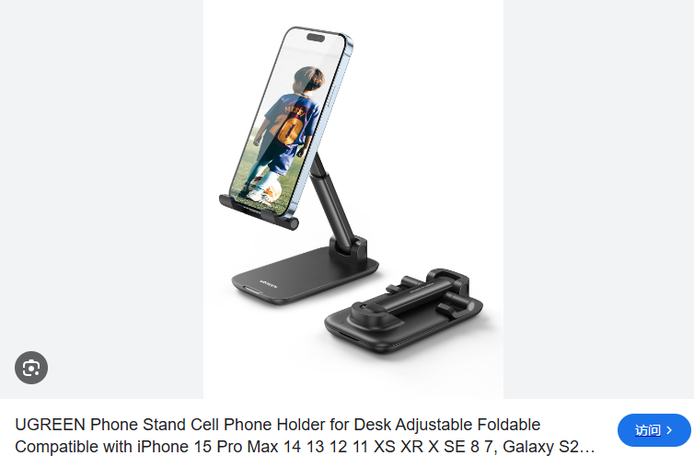

Error: ~~"How do you get the videos?"~~

Improved: "How do you access the videos?"

Explanation: "Access" is a more appropriate term for retrieving or viewing online content.

Error: ~~"Yeah, it's on the dormitory."~~

Improved: "Yes, it's in the dormitory."

Explanation: "In the dormitory" is a clearer way to indicate the location of the 3D printer.

Error: "Because you just need to paint, design something you want."

Improved: "Because you just need to design something you want."

Explanation: This corrects the sentence structure and removes unnecessary words for clarity.

Error: ~~"Like the robot. The robot needs to have their body. We print the body with the 3D printer."~~

Improved: "For example, a robot needs a body, which we can print using the 3D printer." Explanation: This provides a clearer example and corrects the pronoun usage from "their" to "a."

Error: "It's common in the past."

Improved: "It was more common in the past."

Explanation: This corrects the tense and provides a clearer comparison.

Error: ~~"At this time, you can use 3D components."~~

Improved: "At this point, you can use 3D-printed components."“此时，你可以使用 3D 打印的组件。”

Explanation: This clarifies that the components are printed using a 3D printer.

Error: "Because now it's quite insecure."

Improved: "Because currently, it feels quite insecure."

Explanation: This rephrases the sentence for better flow and clarity.

Error: ~~"To be unsure of yourself. You don't have security. In your own words."~~

Improved: "To feel unsure of yourself because you lack a sense of security."

Explanation: This rephrases the sentence for clarity and provides a more natural expression.

Error: "Maybe they are not colleagues."

Improved: "Perhaps they are not colleagues."

Explanation: "Perhaps" is a more formal way to express uncertainty.

Error: "If you are not colleagues."

Improved: "If they are not colleagues."

Explanation: This corrects the pronoun to match the subject (they).

Error: "Why do you think that they are a couple? What clues in the picture tell you that they are a couple?"

Improved: "Why do you think they might be a couple? What clues in the picture suggest this?" Explanation: This rephrases the question for clarity and uses "might be" to indicate possibility.

## Questions（answer them anytime）

## idiomatic English expressions(1-ai example 2-my example 3-ai correction)

## correction and expanding Expression

lagoon

water and wetland

Lagoon



item

[engoo.com/app/daily-news/article/science-finds-soft-complaints-more-effective-than-anger/GNcbsmXwEe-lem-iKVmVBg](https://engoo.com/app/daily-news/article/science-finds-soft-complaints-more-effective-than-anger/GNcbsmXwEe-lem-iKVmVBg" \t "https://www.cambly.com/en/student/progress/_blank)

### insecure

personality trait/ to be insecure/ to be unsure of yourself

you don’t have security in your own worth

"He felt insecure about his public speaking skills, so he decided to join a workshop to improve his confidence and delivery."

"After the company's data breach, customers became insecure about the safety of their personal information, leading to a drop in the company's stock price."

"She had always been a bit insecure about her artistic abilities, but the encouragement from her peers helped her to gain the self-assurance she needed to exhibit her work."

someone without intelligence is.......

stupid

to make a complaint

negotiated a business deal

### to strive for/ to try to achieve a goal

to fight for your own benefit

to work in harmony

harmonious

collaboration/ to collaborate

### two heads are better than one

The phrase "two heads are better than one" is an idiomatic expression that means two people working together can solve problems or think of ideas more effectively than one person working alone. It emphasizes the value of collaboration and the idea that multiple perspectives can lead to better outcomes.

"When tackling complex projects, remember that two heads are better than one; brainstorming with your teammates can lead to innovative solutions."

"We decided to start a business together, believing that two heads are better than one and that our combined skills would make us successful."

"Before making the final decision, let's discuss it further; after all, two heads are better than one, and we might come up with a more comprehensive plan."

### Resentful

to resent

to be resentful

fair

Just

The word "resentful" describes a feeling of bitterness or anger that lingers, often due to perceived unfairness or being treated poorly. It can be directed towards others or oneself and is typically associated with holding onto negative emotions rather than letting them go.

"After being overlooked for the promotion, she became resentful and felt that the selection process was unjust."

"He felt a pang of resentment(一阵怨恨) when he saw his former friend succeed without him, especially since they had started the business together."

"It's important to address and resolve feelings of resentment(处理和解决怨恨情绪) in a relationship to avoid them festering and causing further issues."

# 20241022

## Cambly AI CORRECTION

~~A person can always change to adapt to new situation.~~

A person can always change to adapt to a new situation.

The sentence is missing an article before 'new situation'.

## Other AI correction

Error: "Okay. Yes. Okay."

Improved: "I'm doing well, thank you. How about your day?"

Explanation: This response is more polite and conversational, showing interest in the other person's well-being.

Error: ~~"because he has temperature."~~

Improved: "because he is warm."

Explanation: "Temperature" is not typically used to describe a person's demeanor. "Warm" is a better adjective to describe someone who is kind and affectionate.

Error: ~~"A flexible person can always change to adapt to new situation."~~

Improved: "A flexible person can always adapt to new situations."

Explanation: This corrects the sentence to use the present tense and provides a more natural structure.

Error: ~~"And what person shows that they love or like someone?"~~

Improved: "What kind of person demonstrates love or affection towards others?"

Explanation: This rephrases the question to sound more natural and engaging.

Error: ~~"Enthusiasm to appeal."~~

Improved: "Enthusiasm to show affection." “热情地表达爱意。”

Explanation: "Appeal" is not the correct term in this context. "Show affection" is a more appropriate phrase.

Error: ~~"Affectionate person shows that they love or like someone."~~

Improved: "An affectionate person shows love or liking towards others." “一个深情的人向他人表达爱或喜欢。”

Explanation: This corrects the sentence structure for clarity and flow.

Error: "Because one person is not good at saying anything to you."

Improved: "Because some people are not good at expressing themselves verbally."

Explanation: This provides a clearer explanation of why someone might **be more action-oriented in showing affection**.

Error: ~~"You're in a good mood or you're in a good mood or you're in a bad mood."~~

Improved: "Are you in a good mood or a bad mood today?"

Explanation: This corrects the repetition and rephrases the question for clarity.

Error: ~~"My sister is always telling people what to do. Body."~~

Improved: "My sister is always telling people what to do, which can be overbearing."

Explanation: This completes the thought and provides a more natural description of the behavior.

Error: ~~"This describes someone who quickly gets angry and next fighting and arguing."~~

Improved: "This describes someone who quickly gets angry and often ends up fighting and arguing."

Explanation: This corrects the sentence structure and provides a clearer description of the behavior.

Error: ~~"I could never tell in that. I'm too honest."~~

Improved: "I could never lie; I'm too honest."

Explanation: This corrects the sentence to clearly express the intention of being truthful.

## idiomatic English expressions(1-ai example 2-my example 3-ai correction)

## example 3-ai correction)

## correction and expanding Expression

That old man has never bought anything for his wife. He’s so (mean)

A (warm) person is kind and affectionate. This is also a temperature.

A (flexible) person can always change to adapt to new situations.

She never does any work. She’s really (lazy).

Everything in her bedroom is always in the right place. She is so (tidy).

My sister is always telling people what to do, she is so (bossy).

An (affectionate) person shows that they love or like someone.

One day he’s happy, the next day he’s sad. He also gets angry very easily. He’s really (moody).

Unemotional and without warmth. > cold

A short word which describes someone who is friendly and generous. > kind

Describes somebody who wants to achieve a lot in life. >ambitious

I could never tell a lie. I am too (honest).

A simple word which describes a good-natured person.

Someone without intelligence is (stupid).

Describes a person who is not confident about themself. > insecure

I’m too nervous to speak to people at parties, I’m so (shy).

they are not good at **articulating** they can show their love through affection

4. One day he's happy, the next day he's sad. He also gets angry very easily. He's really _____. (5)

they are so **neat and tidy**

the room is neat and tidy

### safe and sound

the foundations for the house are sound

i will call you when you get home to make sure you are safe and sound

did you arrive safe and sound at your destination?

### social anxiety

Introverts

unemotional and without warmth

they are a bit of a cold fish

a cold fish/ someone who is cold and hard to get to know

# 20241015

## Cambly AI CORRECTION

~~recently, maybe I think I formally started my project work.~~

Recently, maybe I think I started my project work formally.

~~I totally contact a new area.~~

I totally contacted a new area.

how is it going about you?

How is it going with you?

When you see a doctor at first, the doctor needs to know your concrete symptoms or they just want to make a correct dialogues.

When you see a doctor at first, the doctor needs to know your concrete symptoms or they just want to make a correct dialogue.

this is the enter.

this is the entrance.

And you don't know where you go to register.

And you don't know where to go to register.

## Other AI correction

Error: "I need to solve them."

Improved: "I need to figure them out."

Explanation: "Figure out" is a more idiomatic way to express the process of solving problems.

Error: "it's good. Yeah, I had many problems with my work."

Improved: "It's fine. Though, I've encountered several issues with my work."

Explanation: This provides a smoother transition and uses "encountered" for a more formal tone.

Error: "I enjoy the routine and everybody is friendly."

Improved: "I enjoy the routine, and I find everyone to be very friendly."

Explanation: Adding "I find" before "everyone to be" makes the statement more personal and natural.

Error: "But simple work that I can finish."

Improved: "But work that is simple enough for me to finish."

Explanation: This restructures the sentence for better readability and flow.

Error: "I totally contact a new area."

Improved: "I've recently ventured into an entirely new field."

Explanation: "Ventured into" is more idiomatic, and "entirely new field" emphasizes the novelty.

Error: "So, I need to wing it."

Improved: "So, I guess I'll need to improvise."

Explanation: "I guess I'll" adds a tone of casualness and "improvise" is more formal than "wing it".

Error: "As I know."

Improved: "From what I know."

Explanation: "From what I know" is a more common way to preface information based on personal knowledge.

Error: "Some main doctor will train a trainee."

Improved: "A senior doctor will typically mentor a junior one."

Explanation: "Senior" and "junior" are clear indicators of experience levels, and "mentor" is a better fit than "train".

Error: "An experienced doctor not only cure the disease, be a patient."

Improved: "An experienced doctor doesn't just treat the disease; they also care for the patient."

Explanation: This separates the two actions more clearly and uses "treat" and "care for" for better medical terminology.

Error: "When you see a doctor at first, the doctor needs to know your concrete symptoms." Improved: "When you first see a doctor, they need to understand your specific symptoms."

Explanation: This restructures the sentence for better flow and uses "understand" and "specific" for clarity.

Error: "Because normally I think with a healthy heart rate, maybe it ranges from 60 to 70." Improved: "Normally, a healthy heart rate is thought to be around 60 to 100 beats per minute."

Explanation: Provides a standard range and specifies "beats per minute" for accuracy.

Error: "This is a small hospital. In the middle, there are some Chinese in the right."

Improved: "This is a small hospital. In the middle, there's a sign in Chinese on the right."

Explanation: Clarifies that it's a sign and specifies its location.

Error: "And you can know, you can know, you can recall, they can recall something."

Improved: "And you can be informed, and they can access your medical history."

Explanation: "Be informed" and "access your medical history" are clearer and more professional ways to express this idea.

Error: "You can log into the hospital public system."

Improved: "You can access the hospital's online system."

Explanation: "Access" is more commonly used than "log into" in this context, and it's more secure to say "the hospital's online system" rather than "public system".

Error: "And you also, you can make an appointment online with this part, this website."

Improved: "And you can also schedule an appointment online through this part of the website."

Explanation: "Schedule an appointment" is a more common phrase, and the sentence flow is improved by clarifying the action and the object.

Error: "I don't know what I said last or last message." Improved: "I'm not sure what I mentioned in my last message."

Explanation: This rephrases the sentence for clarity and uses "mentioned" for a more formal tone.

Error: "I want to talk about hospital medicine."

Improved: "I'd like to discuss hospital medicine today."

Explanation: "I'd like to" is a more polite way to express a desire to talk about a topic.

Error: "I prepared some photos."

Improved: "I've prepared some photos for us to look at."

Explanation: Adding "for us to look at" makes the purpose of preparing the photos clearer.

Error: "And if you want to talk some topic, and you can tell me, I can find some photos." Improved: "If you have any specific topics in mind, feel free to let me know, and I can find relevant photos."

Explanation: This rephrases the sentence to be more inviting and clear.

Error: "You can just give me a quiz."

Improved: "You could also give me a quiz to work on."

Explanation: "Could also" suggests an additional idea gently, and "to work on" implies engagement.

Error: "I can find some photos related to it."

Improved: "I can find some photos related to that topic."

Explanation: "That topic" is a more specific and clear reference than "it".

Error: "We can start from the doctor today."

Improved: "Let's start with the role of doctors today."

Explanation: This suggests a structured approach to the discussion and is more engaging.

Error: "I think that's a tough job."

Improved: "I think being a doctor is quite demanding."

Explanation: **"Demanding" is often used to describe jobs that require a lot of effort and skill.**

Error: "And the doctor needs to go to the school more than common students or than the students who major in other subjects."

Improved: "Doctors typically spend more time in school compared to students in other fields."

Explanation: This simplifies the comparison and uses "compared to" for clarity.

Error: "And they train, they are trained strictly."

Improved: "And they undergo rigorous training."

Explanation: "Undergo" and "rigorous" are more formal ways to express intensive training.

Error: "And maybe after they master a lot of knowledge about medical or illness, they need to be sent to the hospital as a trainer."

Improved: "And after they've gained extensive knowledge in medicine and illness, they often start their hospital residency."“在他们获得了广泛的医学和疾病知识后，他们通常会开始住院实习。”

Explanation: "Gained extensive knowledge" and "start their hospital residency" are more precise and professional ways to describe this stage of a doctor's career.

Error: "As I know. Well, sometimes I go to the hospital as a trainee next to the main hospital, the main doctor or the professional." Improved: "From what I know, sometimes I observe at the hospital, working alongside the main doctors or professionals."

Explanation: "Observe" and "working alongside" provide a clearer picture of the learning experience.

Error: "An experienced doctor will train junior doctor."

Improved: "An experienced doctor will guide and instruct a junior doctor."

Explanation: "Guide and instruct" provides a more detailed description of the mentoring process.

Error: "And the experienced doctor not only cure the disease, be a patient."

Improved: "Moreover, an experienced doctor doesn't only treat the disease but also cares for the patient."

Explanation: This corrects the sentence structure for clarity and uses "Moreover" to add information.

Error: "And maybe you can know, you can know, you can recall, they can recall something." Improved: "And perhaps you can gain insights, and they can review your medical history."

Explanation: "Gain insights" and "review your medical history" are clearer and more professional ways to express this idea.

Error: "The doctor usually wears a white coat."

Improved: "Doctors typically wear white coats."

Explanation: Using "Doctors" as the subject makes the sentence more general, and "typically" indicates a usual situation.

Error: "I need to learn a lot of new things."

Improved: "I need to learn a variety of new things."

Explanation: "A variety of" emphasizes the diversity of new things to be learned.

Error: "I had many problems with my work."

Improved: "I had several work-related issues to deal with."

Explanation: "Several" is more precise than "many," and "work-related issues" is a more professional expression.

## Questions（answer them anytime）

"How was your Monday?"

"Easy day? Hard day? Boring day? Interesting day?"

"Oh, I'm sorry. Are you a little tired or are you OK?"

"How are you getting on with the team? Are you enjoying working with your team? Is everybody helpful and friendly?"

"And what would you like to do today? Are we going to finish the pictures?"

"Is it this one here? Yeah. Is that correct?"

"What do you think about a doctor?"

"How is it going about you?"

"How are you getting on with the team?"

"Are we going to finish the pictures?"

"Is it this one here? Yeah. Is that correct?"

"What do you think about a doctor?"

"What is this doctor wearing on their heads?"

"What does that refer to? They're talking about doctors, an angel in white. Have you ever heard the expression white coat syndrome?"

"What is this doctor wearing on his head?"

## idiomatic English expressions(1-ai example 2-my example 3-ai correction)

### 即兴发挥 (Winging It)

|  |  |
| --- | --- |
| 1 | "I didn't have time to prepare for the presentation, so I just had to wing it." |
| 2 |  |
| 3 |  |

### 实习 (Trainee)

"As a trainee, you'll shadow the experienced doctors and **learn the ropes** over time."

### 医疗服装 (Medical Attire)

"Before entering the operating room, all staff must change into scrubs and wear a surgical cap to maintain sterility."

### 防护服 (Protective Clothing)

"During surgery, doctors wear a surgical gown over their scrubs to protect both themselves and the patient from infections."

### 医疗人员称谓 (Medical Personnel Titles)

"Nurses are often referred to as 'angels in white' for their compassionate care and dedication."

### 医疗设施 (Medical Facilities)

"The family doctor assistant workstation is equipped with all the necessary tools for efficient patient consultations."

### 医院视角 (Hospital Perspective)

"Upon entering the hospital, the first thing you notice is the bustling activity at the front desk and the long lines in the waiting room."

### 挂号 (Registration)

"If you're new to this hospital, you'll need to register at the front desk to get a patient number and access the hospital's services."

### 医院系统 (Hospital System)

"To ensure your medical records are up to date, make sure to log in to the hospital's private system with your patient number."

### 医疗保险 (Medical Insurance)

"Registering your medical insurance with the hospital allows them to bill your insurance directly for your treatments."“在医院注册你的医疗保险可以让他们直接向你的保险收取你的治疗费用。”

### 医院前台与等待区 (Hospital Front Desk and Waiting Room)

"The front desk is often the first point of contact for patients, and the waiting room can be overwhelming with the number of people seeking care."

## correction and expanding Expression

you can show up and be seen by a doctor

your medical records

express how you are feeling

explain your symptoms

how is their bedside manner

### 'bedside manner'

the bigger the hospital the worse the bedside manner is likely to be

drug/ medicine/ pharmaceuticals

### a mixed bag

a mixed bag when it come to bedside manner

"The new restaurant has gotten a mixed bag of reviews; some people love it, while others were disappointed with the service."

a blocked nose

a stuffy nose

a runny nose

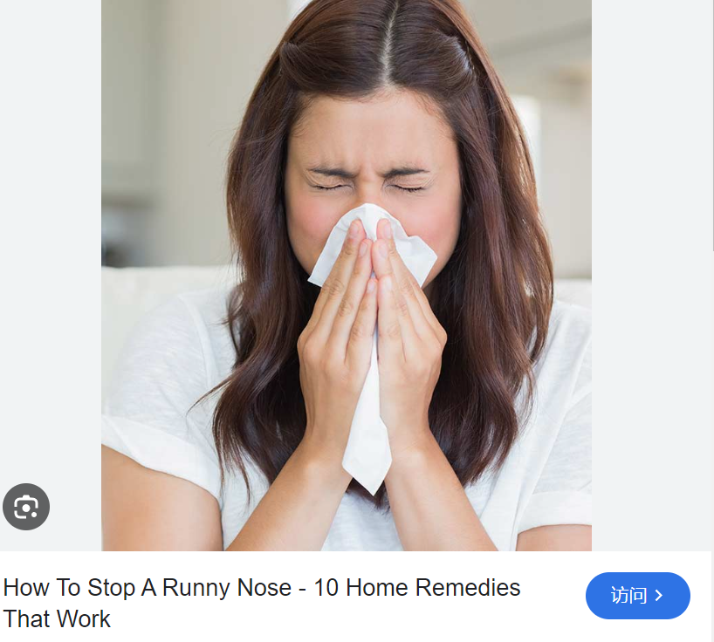

a dislocated shoulder

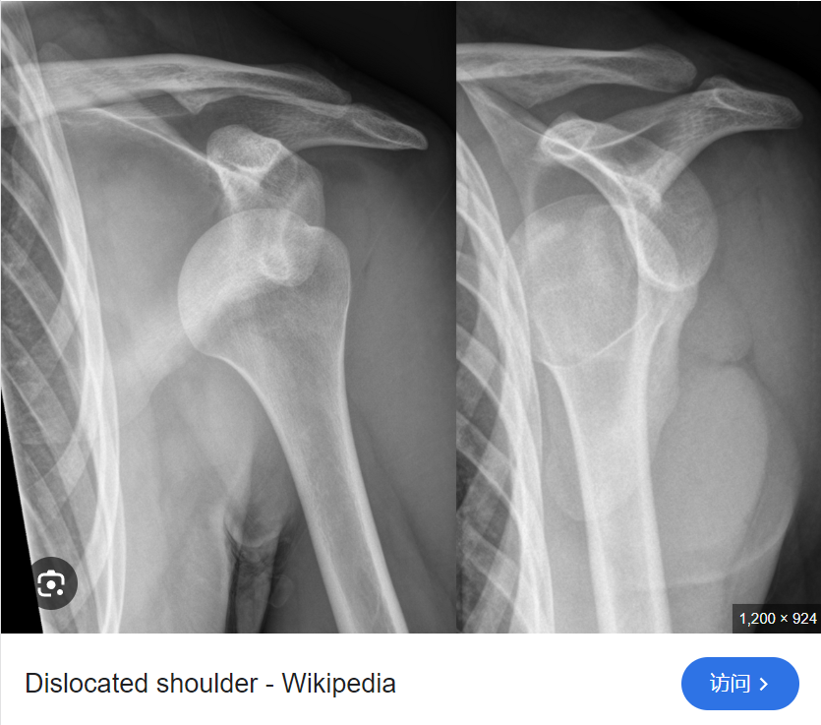

stomachache

i have an upset stomach

food poisoning

Gastroenteritis  
胃肠炎

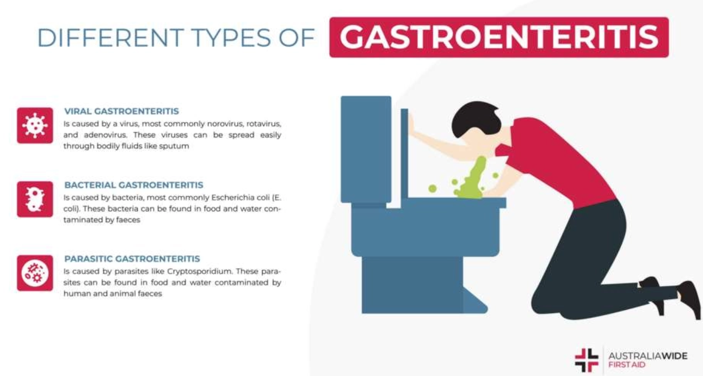

Symptoms

diarrhea腹泻

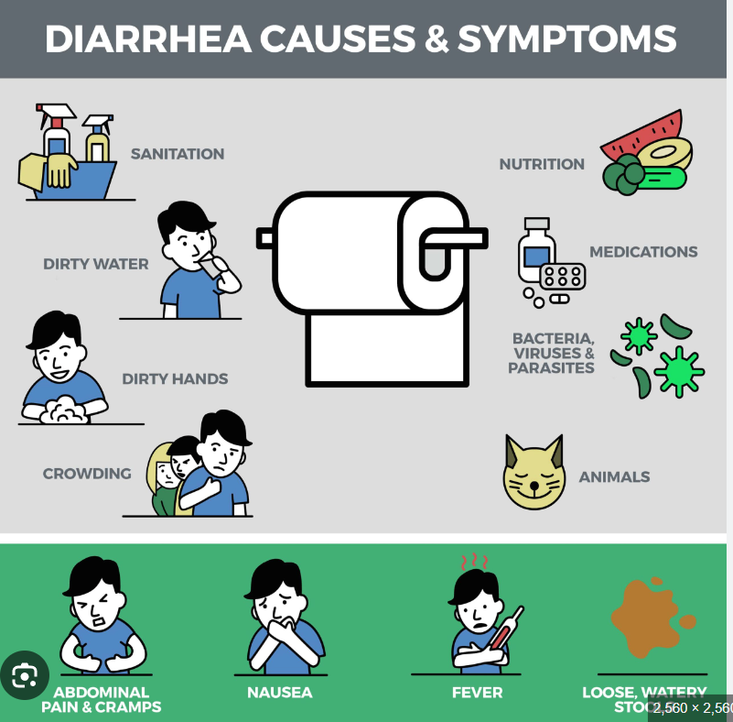

constipation便秘

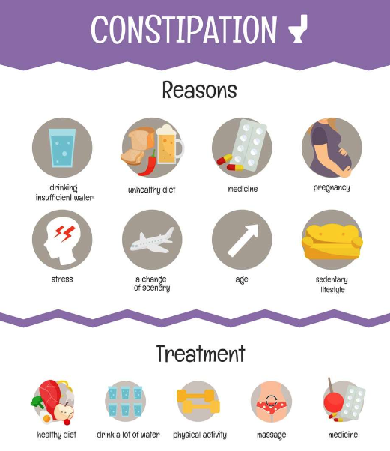

digestive issues

dizziness

low or high blood pressure

respiratory issues呼吸问题

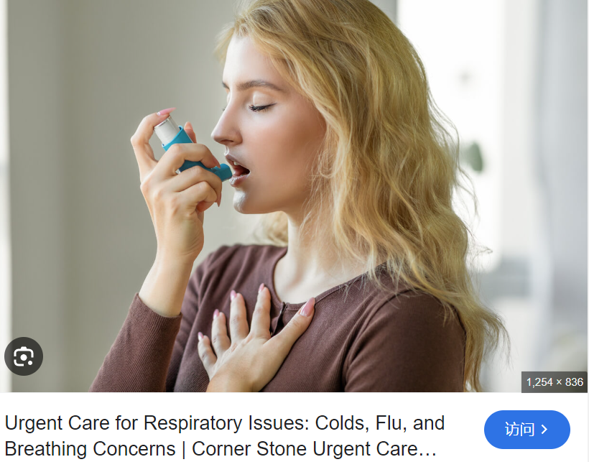

the pay desk

# 20241014

[docs.google.com/document/d/1eB-E-klMUqC6n8Z8LToRlu4RahIIgKRAK-TaBvJZm0U/edit?tab=t.0](https://docs.google.com/document/d/1eB-E-klMUqC6n8Z8LToRlu4RahIIgKRAK-TaBvJZm0U/edit?tab=t.0" \t "https://www.cambly.com/en/student/progress/_blank)

## Cambly AI CORRECTION

## Other AI correction

## Questions（answer them anytime）

## idiomatic English expressions(1-ai example 2-my example 3-ai correction)

## correction and expanding Expression

to wing it

to fake it till you make it

as a trainee

scrubs

an experienced doctor will train a junior doctor

a trainee is trained by the trainer

a surgical cap/ hat

stethoscope

if your heart rate is irregular

a surgical gown

informally, more casual/ scrubs

a doctors scrubs

the doctor is wearing scrubs

coat

a white coat

white coat syndrome

angel in white

'white coat syndrome' expression, phrase

a placebo

an illusion

an illusion of authority

you can whole heartedly

family doctor assistant workstation

this is the view when you first enter the hospital

you dont know where to go or where to register

a patient number

log in to the hospitals private system

medical insurance

you need to register with the hospital so that they can access your medical files and medical insurance number

at the front desk

the waiting room

overwhelmed

# 20241008

## Cambly AI CORRECTION

## Other AI correction

Error: "It was my first day back for today."

Improved: "It was my first day back at work today."

Explanation: "The phrase 'first day back at work' is more commonly used to indicate returning to a job."

Error: "Many people choose to choose the high-speed train as a way of travel."

Improved: "Many people choose the **high-speed train** as a mode of travel."

Explanation: "'Choose' is not needed before 'the high-speed train', and 'mode of travel' is a more standard phrase."

Error: "There are three types of taking."

Improved: "There are three types of tickets."

Explanation: "'Tickets' is the correct term for different classes or options on a train."

Error: "The second is you just stand."

Improved: "The second type is standing."

Explanation: "It's more natural to say 'standing' rather than 'you just stand'."

Error: "And the third is business ticket."

Improved: "And the third is a business class ticket."

Explanation: "'Business ticket' should be 'business class ticket' for clarity."

Error: "They select stand ticket and they can just sit on the path."

Improved: "They bought a standing ticket, but they can sit on the floor if there's space." Explanation: "'Stand ticket' should be 'standing ticket', and 'path' is not the right term; 'floor' is more appropriate."

Error: "This sit on the phone down."

Improved: "Fold-down seat."

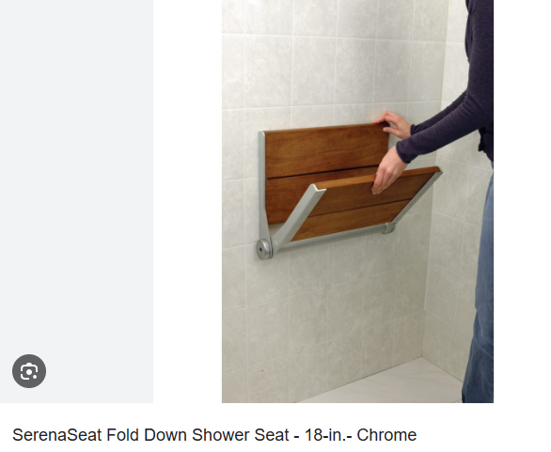

Explanation: "The phrase 'this sit on the phone down' is unclear; 'fold-down seat' is the correct term."

Error: "From the window."

Improved: "Through the window."

Explanation: "'Through the window' is the correct preposition to indicate looking out from inside a vehicle."

Error: "A second class ticket."

Improved: "A second-class ticket."

Explanation: "Hyphens are used in compound adjectives, so 'second class' should be hyphenated."

Error: "Inspect on the train."

Improved: "Inspection on the train." “在火车上检查。”

Explanation: "'Inspect on the train' should be 'inspection' to match with 'ticket inspectors'."

Error: "Long sitting ticket."

Improved: "Standing ticket."

Explanation: "'Long sitting ticket' is not a standard term; 'standing ticket' is correct."

Error: "The people who buy the standing ticket would find some empty seats."

Improved: "People with standing tickets might find empty seats."

Explanation: "The sentence should be in the present tense and 'might' is used to indicate possibility."

Error: "The owner sits and they can give them, give the seating to them."

Improved: "The rightful seat owner arrives, they have to give up the seat."   
“正席主人来了，必须让座。”

Explanation: "The sentence structure should be clearer and indicate the obligation to relinquish the seat."

Error: "Advocate. What is advocate?"

Improved: "**Etiquette.** What is etiquette?"

Explanation: "Lee seems to have confused 'etiquette' with 'advocate'; 'etiquette' is the correct term."

### Etiquette

"Etiquette" refers to the customary code of polite behavior in society or among members of a particular profession or group. It involves a set of rules or guidelines that help people navigate social situations with grace and respect for others. Here are some explanations and natural English sentences using the term "etiquette":

Business Etiquette

Explanation: The set of rules or standards that dictate professional behavior in a business setting.

Natural Sentence: "In business meetings, it's important to follow etiquette by turning off your phone and maintaining eye contact during discussions."

Table Etiquette

Explanation: The rules of polite behavior while eating, such as using utensils correctly and not speaking with a full mouth.

Natural Sentence: "My mother always taught me the importance of good table etiquette, like waiting until everyone is served before starting to eat."

Email Etiquette

Explanation: The guidelines for polite and effective communication through email, including the use of appropriate subject lines and salutations.

Natural Sentence: "When sending a formal email, remember email etiquette and always include a clear subject line and sign off with 'Best regards'."

Phone Etiquette

Explanation: The礼貌准则 for using telephones, such as not interrupting the speaker and introducing oneself when answering calls.

Natural Sentence: "During a business call, it's considered good phone etiquette to introduce yourself and speak clearly so the other party can understand you."

Social Etiquette

Explanation: The rules for polite behavior in social situations, such as greeting people with a handshake and respecting personal space.

Natural Sentence: "At the party, it's important to follow social etiquette and not monopolize the conversation; make sure to include others in the discussion."

Travel Etiquette

Explanation: The guidelines for behaving politely while traveling, including being respectful of local customs and cultures.

Natural Sentence: "When traveling abroad, it's crucial to learn the travel etiquette, such as tipping customs and how to greet locals respectfully."

Workplace Etiquette

Explanation: The code of conduct that promotes a positive and professional work environment, including punctuality and respectful communication.

Natural Sentence: "In our workplace, it's expected that everyone adheres to workplace etiquette, like respecting colleagues' personal space and avoiding office gossip."

Online Etiquette

Explanation: The rules for polite behavior on the internet, such as not posting offensive comments and respecting others' privacy.

Natural Sentence: "Online etiquette is essential in today's digital age, so always think before you post and be mindful of how your words may affect others."

Meeting Etiquette

Explanation: The guidelines for conducting and participating in meetings, such as being punctual and prepared.

Natural Sentence: "To make a good impression in a job interview, follow meeting etiquette by arriving on time, dressing appropriately, and coming prepared with questions."

Cultural Etiquette

Explanation: The customs and behaviors that are considered polite within a specific culture or country.

Natural Sentence: "When doing business in Japan, it's important to understand cultural etiquette, such as the significance of exchanging business cards with both hands."

Error: "And the train, you cannot, you mustn't smoke."

Improved: "You must not smoke on the train."

Explanation: "'Must not' is a clearer way to express prohibition."

Error: "I can imagine your time after a journey or, yeah, after you finish your journey, your time, and you don't like to, there are many noise around you."

Improved: "I can imagine that after a journey, you'd prefer some quiet, not a lot of noise around you."

Explanation: "The sentence should be restructured for clarity and to remove unnecessary repetition."

Error: "Most children just keep nodding."

Improved: "Most children just keep fidgeting."   
“大多数孩子只是坐立不安。”



Explanation: "'Nodding' is not the right term; 'fidgeting' better describes restless behavior in children."

Error: "Because the ancient people don't always have a hat."

Improved: "Because not all ancient people wore hats."

Explanation: "The sentence should be rephrased for clarity and to correct the misunderstanding about ancient attire."

## Questions（answer them anytime）

## idiomatic English expressions(1-ai example 2-my example 3-ai correction)

### 高速列车

地道英语句子：**"The high-speed train** significantly reduces travel time between cities."

### 商务舱车票

地道英语句子："I booked a business class ticket for the high-speed train to ensure a more comfortable journey."

### 折叠椅子

地道英语句子："In the compact car, the back seats **fold down to create extra storage space.**"

### 观赏窗外景色

地道英语句子："Passengers on the train are enjoying the scenery from the window as it speeds through the countryside."

### 座位类型

地道英语句子：**"I prefer to book a second-class ticket for affordability without sacrificing too much comfort."**

### 查票员

地道英语句子："The ticket inspector will do spot checks to ensure all passengers have valid tickets."  
“检票员将进行抽查，以确保所有乘客都持有有效机票。”

### 无座票

地道英语句子："During peak travel seasons, **standing tickets** are sold when all seated tickets are **booked out**."

### 礼仪/适当行为

地道英语句子："It's important to follow proper etiquette and maintain good manners when using public transportation."

### 副驾驶

地道英语句子："The passenger in the front seat should always wear a seat belt for safety."

### 收费公路

地道英语句子："When using the toll road, you have to pay a toll at the booth."“使用收费公路时，必须在收费亭交费。”

### 节假日免费

地道英语句子："They **waive the toll fees免除通行费** on national holidays to encourage travel within the country."

### 电塔

地道英语句子："The pylons carrying power lines are a common sight along the highway."

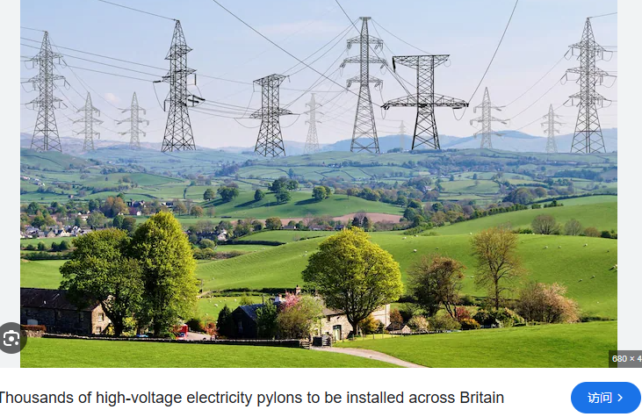

### 游乐场设施

地道英语句子："We visited the fairground and rode the thrilling roller coasters and other rides."

### 购买物品

地道英语句子："I bought a **souvenir** from the local market to remember our trip."

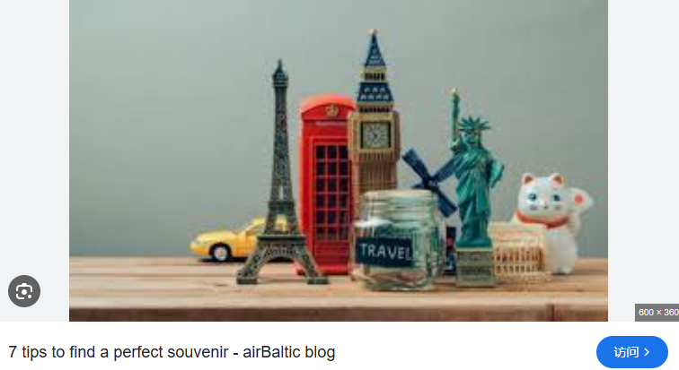

### 朱砂珠子

地道英语句子："Cinnabar beads are believed to have protective properties and are often used as amulets."

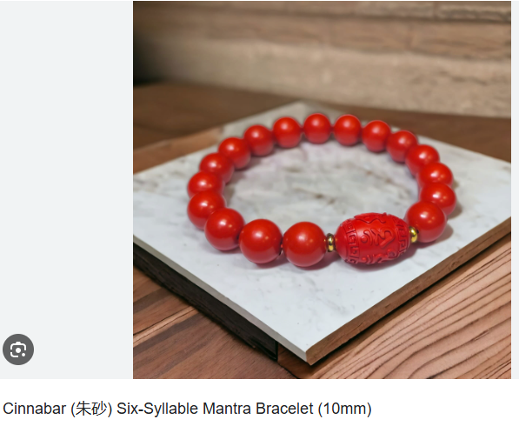

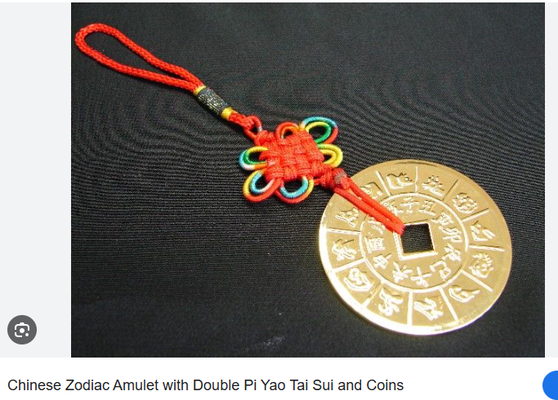

### 情诗

地道英语句子："He wrote a romantic poem to express his deep feelings for her."

## correction and expanding Expression

# 20241007

## Cambly AI CORRECTION

Okay, so the weather is bad and there will be 100 miles rain, a strong storm, it's safe to...

Okay, so the weather is bad and there will be heavy rain, a strong storm, it's safe to...

Scofield scale, no, what does that mean, what is that, okay,

Scoville scale, no, what does that mean, what is that, okay,

your train is coming, you need to kill, yeah, and people can see the concrete information

your train is coming, you need to queue, yeah, and people can see the concrete information

slap your card, your ID card, yeah, you, you need to slide your ID card to pass, to pass,

you need to swipe your ID card to pass

stand back away, stand back, stand right, stand back the white line, stand behind,

Please stand behind the white line

the station don't allow people to throw

the station doesn't allow people to throw

## Other AI correction

Error: "so the weather is bad and there will be 100 miles rain, a strong storm,"

Improved: "so the weather is bad and there will be 100-mile-per-hour winds, a strong storm," Explanation: "Mile-per-hour is the correct unit for wind speed, and 'miles' should not be plural."

Error: "I have a sore nose,"

Improved: "I have a runny nose,"

Explanation: "'sore nose' is not a standard expression; 'runny nose' is used to describe a nose with a continuous flow of mucus."

Error: "our food is mild taste,"

Improved: "our food has a mild taste,"   
“我们的食物味道温和”

Explanation: "'has a mild taste' is the correct phrase to describe the flavor of food."

Error: "I'm not used to the very, very spicy food,"

Improved: "I'm not used to eating very spicy food,"

Explanation: "It's more natural to say 'used to doing something' in this context."

Error: "In China, do you use the Schofield scale?"

Improved: "In China, do you use the Scoville scale?"

Explanation: "The correct name of the scale that measures the spiciness of chili peppers is the Scoville scale."

Error: "they challenge the spicy food level by level, until they can't, they collapse,"

Improved: "they challenge the spicy food level by level, until they can't handle it and collapse," Explanation: "It's more natural to say 'can't handle it' in this context."

Error: "you have to queue everybody,"

Improved: "you have to wait for everyone,"

Explanation: "'kill everybody' is not appropriate; 'wait for everyone' is the correct phrase."

Error: "concrete information"

Improved: "specific information"

Explanation: "'Specific information' is the correct term when referring to detailed or particular information."

Error: "on the blue screen, on the blue"

Improved: "on the blue screen,"

Explanation: "Repeating 'on the blue' is unnecessary; one instance is sufficient."

Error: "the white words, that means the train,"

Improved: "the white words indicate that the train,"

Explanation: "'Indicate' is a more formal and clear choice than 'means' in this context."

Error: "the announcement, told them, um, your train is coming, you need to kill,"

Improved: "the announcement tells them, um, your train is coming, you need to queue," Explanation: "'Kill' is incorrect; 'queue' is the correct term, and 'tells' is the present tense of 'tell'."

Error: "people can see the words, and in white, the white words, that means the train,"

Improved: "people can see the words in white, which indicate the train...,"

Explanation: "'Which indicate' is a more grammatically correct structure than 'that means'."

Error: "the checklist, and people cannot check their ticket anymore,"

Improved: "the check is closed, and people cannot check their tickets anymore,"

Explanation: "'Checklist' is not the correct term; 'check is closed' is more appropriate."

Error: "the words without color, the white color, the words, the white color words,"

Improved: "the words in white,"

Explanation: "Repeating 'white color' is unnecessary; 'words in white' is more concise."

Error: "you need to pass through the gate, and"

Improved: "you need to pass through the gate,"

Explanation: "The sentence is already complete; 'and' at the end is unnecessary."

Error: "the machine will scan our face at the same time,"

Improved: "the machine will scan our faces at the same time,"

Explanation: "'Faces' is the plural form, which is appropriate when referring to multiple people."

Error: "the departure has arrived,"

Improved: "the departure board shows that the train has arrived,"

Explanation: "'Departure has arrived' is not a standard phrase; it should be rephrased to indicate that the train has arrived according to the departure board."

## Questions（answer them anytime）

## idiomatic English expressions(1-ai example 2-my example 3-ai correction)

### 风速

地道英语句子："We had to secure our tents during the storm with 100-mile-an-hour winds."

### 流鼻涕

地道英语句子："I've got a runny nose, I think I'm catching a cold."

### 食物口味

地道英语句子："The food in my province is known for being light and not too spicy."

### Schofield Scale

地道英语句子："Some restaurants use the Schofield scale to indicate the heat level of their spicy dishes."

地道英语句子："Are you used to eating spicy food, or do you prefer milder flavors?"

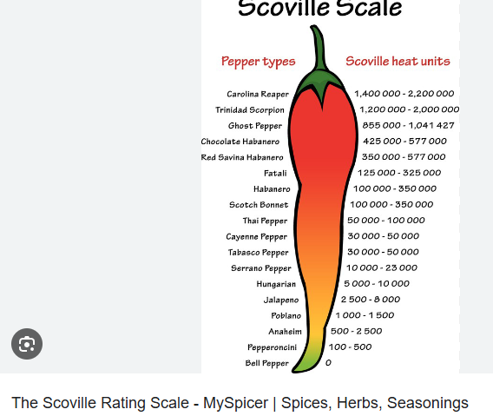

### 排队

地道英语句子："You have to queue everywhere, even at the most popular attractions."

### 公告后排队

地道英语句子："Everyone had to queue after the announcement was made."

### 列车时刻

地道英语句子："Check the departures screen for the arrival and departure times of your train."

### 停止检票

地道英语句子："The red words indicate that the high-speed train has already stopped ticket checking."

### 身份证

地道英语句子："You have to pass through the gate and swipe your ID card to be able to board the train."

### 列车到站颜色提示

地道英语句子："The green light shows that the train is arriving, while the red indicates that it has departed."

### 等待列车

地道英语句子："The white words on the board indicate that people must wait because the train has not arrived yet."

### 晚点

地道英语句子："If the train arrives late, your journey will be delayed."

### 站台安全

地道英语句子："You must stay behind the white line on the platform for safety reasons."

### 广播通知

地道英语句子："The speaker will make an announcement over the tannoy when the train is about to depart."

### 不要乱跑

地道英语句子："Don't let the children wander off; make sure they stay close to you in the station."  
“不要让孩子们走开；确保他们在车站里靠近你。

### 列车车厢

地道英语句子："Knowing your seat number helps us figure out which carriage we need to board."

### 站台标记

地道英语句子："The demarcations on the platform help passengers find the correct spot to board their carriages."

## correction and expanding Expression

100 mile an hour wind

a runny nose

light

the food in my province is mild

the Schofield scale

do you use the Schofield scale?

collapse

are you used to eating spicy food?

everywhere you have to queue

[docs.google.com/document/d/1eB-E-klMUqC6n8Z8LToRlu4RahIIgKRAK-TaBvJZm0U/edit](https://docs.google.com/document/d/1eB-E-klMUqC6n8Z8LToRlu4RahIIgKRAK-TaBvJZm0U/edit" \t "https://www.cambly.com/en/student/progress/_blank)

everyone has to queue after the announcement

arrival and departure times

you have to pass through the gate and swipe your ID card

to be able to board the train

the green light shows that the train is arriving

The red words show that the train has departed

The white words indicate that people must wait because the train has not arrived yet

the departures board

the departures screen

if the train arrives late

your journey will be delayed

the platforms

you must stay behind the white line

stand back

stand behind the white line

the tannoy

the speaker will make an announcement over / on the tannoy

dont let them wander off/ wander about/ wander off anywhere

dont run around

11.23 pm now

1.5 hours early

9.30pm

landmark/s

carrigage

carriages

i need to know my seat number

# 20241001

## Cambly AI CORRECTION

about the some the books talk about many experience on many.

Some of the books talk about many experiences.

One is written, the road's name, or one set of street's name.

One says the street's name.

And one sets the street's direction, or another street's direction.

One indicates the street's direction.

He is taking a turn on the road.

He is turning a corner on the road.

I have to catch up my train, my underground.

I have to catch my train, my underground.

## Other AI correction

Error: I lay until 9 a .m.

Improved: I lay in until 9 a.m.

Explanation: The correct phrase is "lay in" to mean staying in bed later than usual, and "a.m." should be written together without a space.

Error: They are raising their hand and they're smiling.

Improved: They are raising their fists and they're smiling.

Explanation: The context suggests that they are raising their fists, not just their hands, which is a gesture of confidence or achievement.

Error: It looks like this is their meeting room.

Improved: It looks like this is a meeting room.

Explanation: The article "a" is more appropriate here as it refers to a general meeting room, not a specific one they have mentioned before.

Error: I learned a vocabulary.

Improved: I learned some vocabulary.

Explanation: "Vocabulary" is an uncountable noun, so "some" is used instead of "a".

Error: In the foreground, there are two computers and some piece of paper on the desk. Improved: In the foreground, there are two computers and some pieces of paper on the desk. Explanation: "Pieces of paper" is the correct plural form, and "some" should be followed by the plural noun.

Error: They can stick them to the board or pin them to the board to remind them what to do in the next step.

Improved: They can stick them to the board or pin them to the board to remind themselves what to do in the next step。

Explanation: "Themselves" is the correct reflexive pronoun to use after "remind" in this context.

Error: That is my dream office atmosphere.

Improved: That's my dream office atmosphere.

Explanation: Contractions are commonly used in spoken English, so "That's" is more natural than "That is".

Error: We can offer help to each other until we finish the project.

Improved: We can help each other until we finish the project.

Explanation: The verb "help" does not need the preposition "to" in this context.

Error: I still feel stuck.

Improved: I still feel stuck in my English.

Explanation: It's more specific to mention feeling stuck in English, as that is the context of their conversation.

Error: The first day you just gave a summary of what you see and then you can give some details. Improved: **On the first day**, you just give a summary of what you see and then you can give some details.

Explanation: "On the first day" is a more natural way to refer to a specific point in time, and "give" should be in the simple present tense to match the advice being given.

Error: They gave the learner some steps to describe pictures.

Improved: They gave learners some steps to describe pictures.

Explanation: The plural form "learners" is more appropriate as it refers to a general group of people learning English.

Error: I can know what happened.

Improved: **I can understand what happened.**

Explanation: "Understand" is more appropriate than "know" in this context, as it refers to **grasping the meaning of events.**

Error: We are easily concerned that we can't finish our project.

Improved: We easily **become concerned** that we can't finish our project.

Explanation: "Become concerned" is a more natural phrasing, and "easily" should be placed before the verb to modify it correctly.

Error: There is a crossroad.

Improved: There is a crossroads.

Explanation: "Crossroads" is the correct term for an intersection of roads, and it is a countable noun.

Error: There are several signposts.

Improved: There are several signs.

Explanation: "Signs" is more commonly used in this context to refer to **traffic signs or signposts**.

Error: One sets the street's direction, or another street's direction.

Improved: One shows the street's name, another shows the direction of another street.

Explanation: "Sets" is not the correct verb to use here; "shows" is more appropriate, and the sentence structure should be clearer.

Error: Another one sets its speed limit.

Improved: Another one shows the speed limit.

Explanation: Again, "shows" is the correct verb to use, and "its" should be "the" to refer to the speed limit in general.

Error: It looks like it's cold.

Improved: It looks cold.

Explanation: The phrase "it looks cold" is more concise and commonly used in spoken English.

Error: I still feel stuck.

Improved: I feel like I'm not making progress.

Explanation: This provides a clearer expression of Lee's struggle with English.

Error: Yes. It's too abstract definitely.

Improved: Yes, it is definitely too abstract.

Explanation: "It is" is more formal and clear than the contraction "It's".

Error: Yeah, I'm taking the dog for a walk but i'm gonna go and grab a coffee do you want to join me Do you have time to come for a coffee with me?

Improved: Yes, I'm taking the dog for a walk, but I'm going to grab a coffee. Would you like to join me? Do you have time to come for a coffee with me?

Explanation: The sentence structure should be broken down for clarity and to make the invitation more formal.

## Questions（answer them anytime）

## idiomatic English expressions(1-ai example 2-my example 3-ai correction)

### 固执己见 (Obstinate)

"He's so obstinate that once he's made up his mind, there's no changing it."

### 原因与理论 (Reasons and Theories)

"We need to explore the reasons behind the theory to understand its implications better."

### 公告栏 (Notice Board/Pin Board)

"Let's post the announcements on **the notice board** so everyone can see them."

### 张贴 (To Stick or Pin)

"We can pin the event flyers to the pin board in the lobby."

### 努力工作，尽情玩乐 (Work Hard, Play Hard)

"Our team's motto is to work hard and play hard, ensuring a good balance between work and leisure."

### 团队合作 (Many Hands Make Light Work)

"With more hands on deck, the project will be completed faster; **two hands are better than one.**"

"Many hands make light work."

"Many hands make light work, so let's all pitch in and clean up the yard."

"Two heads are better than one."

"Let's brainstorm this project together; two heads are better than one."

"Unity is strength."

"By working together, we've shown that unity is strength, and we've achieved our goals more quickly."

"It takes a village."

"Raising a child is a big responsibility, and **as the saying goes**, it takes a village."

"Two are quicker than one."

"We need to finish this report by tomorrow; two are quicker than one, so let's split the work."

"协作带来效率。"

"By collaborating, we can divide the tasks and finish the project more efficiently."

"Working together, we can achieve more."

"I believe that working together, we can achieve more and overcome any challenge."

### 个人优势 (Individual Strengths)

"By leveraging our individual strengths, we can achieve more as a team."

### 斑马线 (Zebra Crossing)

"Please cross the street only at the zebra crossing for safety."

### 十字路口 (Crossroads)

"At the crossroads, take a left to reach the library."

### 标识信息 (Signage)

"One sign reads 'Caution' while another says 'Children Crossing'."

### 速度限制 (Speed Limit)

"Please be aware of the speed limit and drive responsibly."

### 建筑描述 (Building Description)

"There is a building with a grey wall that stands out in the neighborhood."

### 住宅或商业 (Residential or Commercial)

"The area is primarily residential, with some commercial spaces on the main street."

### 转弯 (Turning the Corner)

"He is turning the corner, heading towards the park."

### 稀疏 (Sparse)

"The forest is not sparse; the trees still have some leaves."

### 落叶 (Fallen Leaves)

"The fallen leaves **are laying on** the ground, creating a golden carpet."

### 请求 (Reaching Out/Extending Arms)

"He is reaching out to her, extending his arms in a plea for understanding."  
“他向她伸出双臂，请求理解。”

## correction and expanding Expression

reasons

theory/theories

**a notice board/ a pin board**

**to stick or to pin them to the board**

work hard, play hard

2 hands are better than 1

6 hands, 8 hands etc are better than 1

their individual strengths

a zebra crossing

a cross roads

one reads.....

one says.....

the speed limit

there is a building with a grey wall

the building has a grey wall

residential or commercial

**he is turning the corner**

it is not sparse

the trees still have some leaves

the fallen leaves are laying on the ground/ on the zebra crossing

he is reaching out

he is extending his arms

is he pleading with her?他在恳求她吗？

# June 24, 2024

[docs.google.com/document/d/1ZxbzZtp0plDoVVEaUtY6il6tp41Uo8YF01aPQ-t5ipk/edit](https://docs.google.com/document/d/1ZxbzZtp0plDoVVEaUtY6il6tp41Uo8YF01aPQ-t5ipk/edit" \t "https://www.cambly.com/en/student/_blank)

if i have enough time before i plan to eat it i just leave it outside of the freezer

or i pour hot water over it and leave it submerged

do you ever use the defrost setting on a microwave?

the 'defrost' setting

## In a hurry

if i am in a hurry/ a rush.

food envy

## nostalgic

people are nostalgic for the past

1、**Talking about [our](https://dictionary.cambridge.org/zhs/%E8%AF%8D%E5%85%B8/%E8%8B%B1%E8%AF%AD-%E6%B1%89%E8%AF%AD-%E7%AE%80%E4%BD%93/our" \o "our) [old](https://dictionary.cambridge.org/zhs/%E8%AF%8D%E5%85%B8/%E8%8B%B1%E8%AF%AD-%E6%B1%89%E8%AF%AD-%E7%AE%80%E4%BD%93/old" \o "old) [family](https://dictionary.cambridge.org/zhs/%E8%AF%8D%E5%85%B8/%E8%8B%B1%E8%AF%AD-%E6%B1%89%E8%AF%AD-%E7%AE%80%E4%BD%93/family" \o "family) [holidays](https://dictionary.cambridge.org/zhs/%E8%AF%8D%E5%85%B8/%E8%8B%B1%E8%AF%AD-%E6%B1%89%E8%AF%AD-%E7%AE%80%E4%BD%93/holiday" \o "holidays) has made me [feel](https://dictionary.cambridge.org/zhs/%E8%AF%8D%E5%85%B8/%E8%8B%B1%E8%AF%AD-%E6%B1%89%E8%AF%AD-%E7%AE%80%E4%BD%93/feel" \o "feel) all nostalgic**.

a golden era

the glory days

our youth

the time when we were young and in our prime

it is hard to resonate with their experiences

to preach

**it sounds like they are preaching**.

to make assumptions

to judge a book by its cover

to make assumptions

## To Be taken aback

we can be taken aback/ an expression, a phrase

to be surprised, shocked

'to be taken aback'

You might be taken aback when you see a picture with a bright white spot.

Those people that aren't paying attention are likely to be taken aback by the things that are going to be possible in a Few years.

do you use a lot of 'flat pack' furniture?

a simple wardrobe

long iron pipe?

some rails/ some poles

to hang clothes hangers on

**metal poles**

**pipes** are often used for transporting liquid eg kitchen pipes

## Assemble

to assemble furniture

to assemble people

**We assembled in the [meeting](https://dictionary.cambridge.org/dictionary/english/meeting" \o "meeting) [room](https://dictionary.cambridge.org/dictionary/english/room" \o "room) after [lunch](https://dictionary.cambridge.org/dictionary/english/lunch" \o "lunch).**

**[furniture](https://dictionary.cambridge.org/dictionary/english/furniture" \o "furniture) that is [easy](https://dictionary.cambridge.org/dictionary/english/easy" \o "easy) to assemble**

**The nets are advertised as being portable and easy to assemble**

**It takes, like, an hour to assemble one.**

**Huge crowds would assemble to watch the results.**

# June 18, 2024

## <https://docs.google.com/document/d/1VIWZoa-fi-Hlw2tFbewcKqen-QxS6VVxgRHb-fNRQAs/edit#heading=h.gd6k1mbys9j6>

## resent

i achieved more in the company

injustice, angry, bitterness

in resentment there is bitterness

**My example:** I resent Jack’s promotion, apparently i achieved more in the company, I should be the one who get promoted.

**AI example:** I resent Jack's promotion as I feel that, given my significant contributions to the company, **I should have been the one to receive the promotion**.

## preheat

the frying pan

to sizzle

to evaporate

for evaporation

**My example:** i need to preheat the oil in the frying pan before i add the chicken.

**AI example:**

To ensure a crisp and evenly cooked chicken, it is crucial to preheat the oil in the frying pan before adding the chicken.

造句：**Before preparing my favorite chicken dish, I always remember to preheat the oil in the pan to get the perfect sear on the chicken**.

## to flee/ to run away

a natural disaster

war

criminal activities

natural disasters/ fire, flood, earthquake, volcano , typhoon etc

the thieves fled ( past tense of flee) on foot

i had to flee the gangsters that were after me!!

when the earthquake happened, we fled

during the war my family had to flee

in order to avoid capture, the thieves fled

fleeing/ the continuous

refugees

the refugees are feeling from war torn countries

**AI example: The refugees are fleeing war-torn countries in search of safety and stability.**

to flee from

fleeing

flea and flee

flea

an animal, the lives by sucking blood from animals and humans

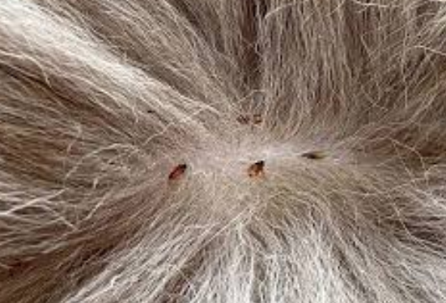

a flea

a flea / a noun

to flee/ a verb

## encourage

watering the soil.....

encourages plants to grow well

continuous tense

encouraging

i find the lab results encouraging

her brother was encouraging her to learn to ride a bike

**i find your achievements highly encouraging**

your enthusiasm is encouraging me to do better.

## discourage

to be discouraged

to discourage (someone or something)

**Keep sending your resume, don’t let a few rejections discourage you.**

Keep doing your experiment, don’t let a few failures discourage you.

**AI example:** Keep persevering with your experiment. Don't let a few failures discourage you from moving forward.

# June 17, 2024

[docs.google.com/document/d/1VIWZoa-fi-Hlw2tFbewcKqen-QxS6VVxgRHb-fNRQAs/edit#heading=h.gd6k1mbys9j6](https://docs.google.com/document/d/1VIWZoa-fi-Hlw2tFbewcKqen-QxS6VVxgRHb-fNRQAs/edit" \l "heading=h.gd6k1mbys9j6" \t "https://www.cambly.com/en/student/_blank)

we rented an apartment

## To be in awe of someone

i am in awe of you!!

you are very brave!

I am in awe of you as you are so confident.

I am in awe of my professor's vast knowledge and profound wisdom.

fish and chips

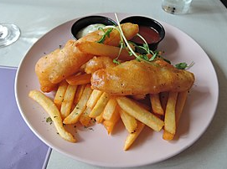

traditional UK dish

i cleaned everything so that somebody else can use it (in the future)

## compliment

you make me lose myself in the song/ the music

when was the last time that you received a compliment?

when was the last time you gave a compliment to someone else?

## complement

**what is the difference between compliment and complement?**

complement

to match it/ to enhance it

**which foods do you think are very complementary to each other?**

Chocolate and Strawberries: This dessert combination is a match made in heaven. The rich, decadent flavor of chocolate pairs beautifully with the sweet, slightly tart flavor of strawberries.

Avocado and Eggs: The creamy texture and mild flavor of avocado complements the rich, savory taste of eggs, especially in dishes like avocado toast with an egg on top or scrambled eggs with avocado slices.

is greasy

sour and tangy酸味浓郁

**"The lemonade was perfectly balanced, with just the right amount of sour and tangy flavor to satisfy my thirst."**

**（柠檬汁的酸度和果味恰到好处，正好满足了我的口渴。）**

it helps you have better digestion

it helps you to digest the meat

it cleans your palette after the greasy food

## to flatter

what is the difference between complimenting someone and flattering them?

超过必要的限度，过分

解释：这个短语通常用来描述某人的行为、情感或事物的表现超过了正常或合适的限度，显得过于夸张或过分。

例句：Her praise for the movie was over the top; she made it sound like the greatest film ever made.  
（她对这部电影的赞扬太过分了，她说得好像这是有史以来最伟大的电影。）

1. I think somebody like Trump, **who loves people to flatter him** and build him up and not only to not control, but to push him further, to egg him on.
2. You tend to flatter the person that you’re asking

OTT/ over the top

obsequious

it is OTT

It is over the top/ OTT/ idiom

it means too much

**"His over-the-top flattery of the boss made everyone in the room feel awkward."**

（他对老板的过分恭维让房间里的每个人都感到不自在。）

# June 11, 2024

[docs.google.com/document/d/1AZfK2xzrA2LJ1hWj6orNJsP9_WomFsQf5IxPBp81YaI/edit](https://docs.google.com/document/d/1AZfK2xzrA2LJ1hWj6orNJsP9_WomFsQf5IxPBp81YaI/edit" \t "https://www.cambly.com/en/student/_blank)

[docs.google.com/document/d/1EaSvx4OLf3c5UgG56HoSribc1qqqgXqMZP3-EDSUQy0/edit](https://docs.google.com/document/d/1EaSvx4OLf3c5UgG56HoSribc1qqqgXqMZP3-EDSUQy0/edit" \t "https://www.cambly.com/en/student/_blank)

are you crossing all the T's and dotting the i's?

**My example: Before starting my new job, I need to cross all the T’s and dot the i’s.**

**AI example:**

1、Before signing the contract, I need to cross all the T's and dot the i's to ensure everything is in order.

2、As a detail-oriented person, he always makes sure to cross all the T's and dot the i's before submitting any report.

3、She knew the importance of crossing all the T's and dotting the i's, especially when it came to legal documents.

idiom/ to put things in order

## to cross the T's and dot the i's

idiom/ to organise and arrange things correctly and tidily.

## mask

to mask (something)

to mask a smell

women use **perfume**.



men use body **spray**.

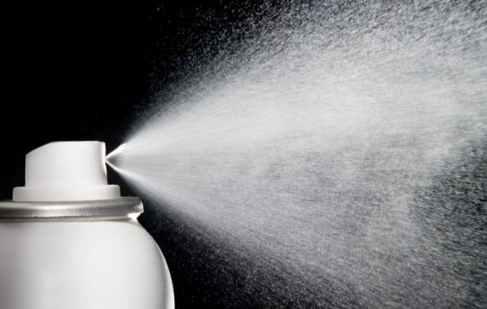

eau de cologne/ a french word for nice smelling water

its a sexist thing!!

to mask the noise

too astringent涩

to mask the astringent taste

feelings and opinions

**we can mask our true feelings and opinions**

he was masking his sadness/ disappointment etc.

**you may just put on a happy mask and pretend you're okay.**

**to mask the core issue**

**Don't wear a face mask.**

**不要戴口罩。**

## to dampen

to dampen/ physical or emotional/ or abstract

to dampen/ to subdue

to smother

imagine a fire

many flames

a lot of heat

a slow suppression

to dampen the spirits

**the bad news dampened my spirits**

**to dampen our clothes to keep cool**

i live in a very damp area

a damp climate

to dampen sense of humor/ his sense of fun

**His heart attack hasn’t dampen his sense of humor.他的心脏病发作并没有削弱他的幽默感。**

Technology devised to root out and understand fake news, how it spreads, and to try and **dampen its flow抑制其传播**.

The idea is that they inevitably **dampen innovation** in the investment.他们的想法是，它们不可避免地会抑制投资创新。

## reverse

before streaming, before DVDs we had VHS tapes

ancient technology!!

you had to reverse the VHS tapes when it was finished

yesterday, i failed my driving license test

i couldn’t reverse my car into the space

**Considering the bad weather, i decided to reverse my plan to go outside.**

to lift my spirits

we need to reverse that so they start investing.我们需要扭转这种局面，以便他们开始投资。

Plants then consume these carbohydrates in a reverse process.然后植物以相反的过程消耗这些碳水化合物

# June 10, 2024

meat wrapped in banana leaves?

beef or pork?

it looks very intricate/ complicated.

beans?

red beans

## Sago



it is quite bland

it is quite plain

it has no taste. it is bland/ plain

It absorbs the other flavors?

boil it?

you boil the wraps.

where we will stay

will you drive through the mountains? or will you hire someone to drive?

[docs.google.com/document/d/1EaSvx4OLf3c5UgG56HoSribc1qqqgXqMZP3-EDSUQy0/edit](https://docs.google.com/document/d/1EaSvx4OLf3c5UgG56HoSribc1qqqgXqMZP3-EDSUQy0/edit" \t "https://www.cambly.com/en/student/progress/_blank)

## To mask

no.11 / to cover

how would you change this sentence to make it more concise?

to mask the smell

i put a pot of coffee on the stove to cover the smell of wet dogs in my house because my friend was coming to visit.

you can cut some words and it will still make sense

which words can we cut?

i put a pot of coffee on the stove

i put some coffee on...

its more concise

i put some coffee on to mask..

because i had a visitor

i hope you have a wonderful evening and i will see you tomorrow

Have a great night! See you!

# June 10th, 2024

i slept.....

i only took one personal photo

notice

i became a member/ a student here

the frogs were singing

and dragonflys

**do you never want to have to study again??**

a training process

First you **undergo training** for one month.

[engoo.com/app/daily-news/article/love-doing-nothing-this-is-the-competition-for-you/XewPUBd7Ee-XIs8DnWtJxA](https://engoo.com/app/daily-news/article/love-doing-nothing-this-is-the-competition-for-you/XewPUBd7Ee-XIs8DnWtJxA" \t "https://www.cambly.com/en/student/progress/_blank)

do some acting

## he has a vacant stare.



to be vacant

she was staring vacantly at the tv

when you look at something, generally you blink

to realize, to be conscious of

to know

**what is the opposite of aware?**

to be unaware of

to ignore, not to notice

i was unaware of the dangers....

that the boss assigned to you

to submit it on time

employee员工

employer雇主

on probation?

you are practicing

a bona fide employee

## peace of mind

**Meaning: a [feeling](https://dictionary.cambridge.org/dictionary/english/feeling" \o "feeling) of [calm](https://dictionary.cambridge.org/dictionary/english/calm" \o "calm) or not being [worried](https://dictionary.cambridge.org/dictionary/english/worried" \o "worried)**

Example:

For **my peace of [mind](https://dictionary.cambridge.org/dictionary/english/mind" \o "mind)**, [please](https://dictionary.cambridge.org/dictionary/english/please" \o "please) [check](https://dictionary.cambridge.org/dictionary/english/check" \o "check) that the [door](https://dictionary.cambridge.org/dictionary/english/door" \o "door) is [locked](https://dictionary.cambridge.org/dictionary/english/lock" \o "locked).

you can **have peace of mind** that this is something that's important to us.

Every time we face difficulties/ challenges we need to have **the peace of mind** to deal with them.

i like to make sure my health insurance is always **up to date** as it gives me peace of mind

the nervousness

i have to write down my speech

i can memorize it

i practice it until **it becomes second nature to me**.

stable is also a type of house for an animal. What type of animal lives in a stable?

## birds live in a nest

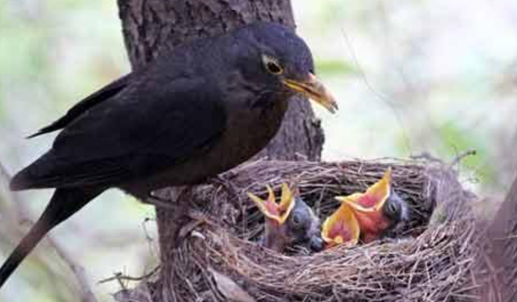

## foxes live in a set

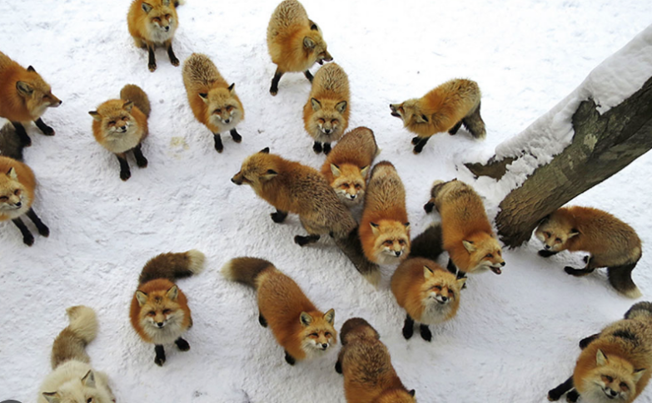

## dogs live in a kennel

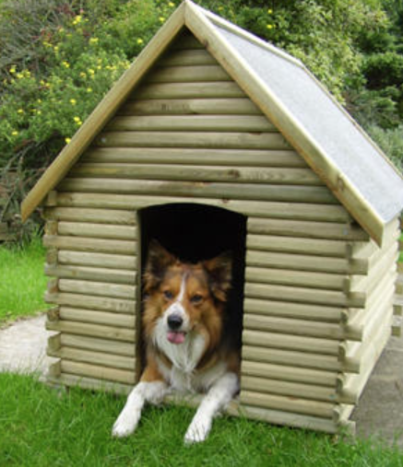

a horse or a donkey lives in a stable

## a horse stable

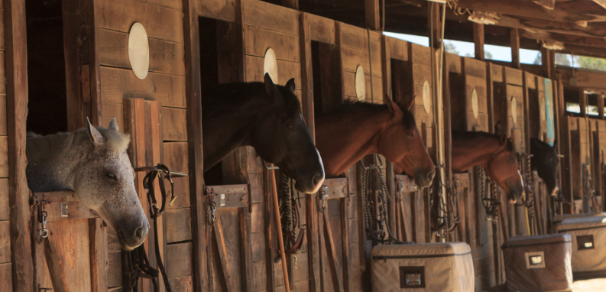

take time to stop and smell the roses

在城市的喧嚣中，我们常常会忘记生活的本质。记住，要时常停下来，花时间闻闻玫瑰的香气，享受那一刻的宁静与美好。  
In the hustle and bustle of the city, we often forget the essence of life. Remember **to take time to stop and smell the roses**, to enjoy the tranquility and beauty of that moment.

当你感到压力过大时，不妨放慢脚步，找个安静的地方坐下来，闭上眼睛，深呼吸，然后试着去闻闻周围的玫瑰花香。你会发现，压力会随之消散。  
When you feel overwhelmed with stress, why not slow down, find a quiet place to sit, close your eyes, take a deep breath, and try to smell the roses around you. You'll find that the stress will dissipate.

在追求职业成功的道路上，不要忘了沿途的风景。记得要时常停下来，闻闻路边的玫瑰花香，感受生活的美好，这样你的人生才会更加充实和有意义。  
On the path to professional success, don't forget the scenery along the way. **Remember to take time to stop and smell the roses**, to feel the beauty of life, so that your life will be more fulfilling and meaningful.

would your mind be racing?

would your mind be working overtime?

## a gimmick

Meaning:

something to attract attention but is essentially valueless.

something that is not [serious](https://dictionary.cambridge.org/dictionary/english/serious" \o "serious) or of [real](https://dictionary.cambridge.org/dictionary/english/real" \o "real) [value](https://dictionary.cambridge.org/dictionary/english/value" \o "value) that is used to [attract](https://dictionary.cambridge.org/dictionary/english/attract" \o "attract) people's [attention](https://dictionary.cambridge.org/dictionary/english/attention" \o "attention) or [interest](https://dictionary.cambridge.org/dictionary/english/interest" \o "interest) [temporarily](https://dictionary.cambridge.org/dictionary/english/temporarily" \o "temporarily), [especially](https://dictionary.cambridge.org/dictionary/english/especially" \o "especially) to make them [buy](https://dictionary.cambridge.org/dictionary/english/buy" \o "buy) something

**publicity gimmick The [campaign](https://dictionary.cambridge.org/dictionary/english/campaign" \o "campaign) was a [publicity](https://dictionary.cambridge.org/dictionary/english/publicity" \o "publicity) gimmick [aimed](https://dictionary.cambridge.org/dictionary/english/aim" \o "aimed) at [winning](https://dictionary.cambridge.org/dictionary/english/winning" \o "winning) back [customers](https://dictionary.cambridge.org/dictionary/english/customer" \o "customers).**

**sales/marketing gimmick They give away [free](https://dictionary.cambridge.org/dictionary/english/free" \o "free) [gifts](https://dictionary.cambridge.org/dictionary/english/gift" \o "gifts) with children's [meals](https://dictionary.cambridge.org/dictionary/english/meal" \o "meals) as a [sales](https://dictionary.cambridge.org/dictionary/english/sales" \o "sales)/[marketing](https://dictionary.cambridge.org/dictionary/english/marketing" \o "marketing) gimmick.**

**I wasn't trying to get famous through a gimmick.**

**first of all it's a marketing gimmick.  
首先，这是一个营销噱头。**

## the proof is in the pudding

you don’t know until you try it

i tried it twice

i only tried it twice

metal health

mental

grand

grandiose

to empty your mind

to clear your head

## to unplug

a chance to unplug

a play on words

to unplug our minds/ to swtich off/ to space out etc#t

to take time to stop and smell the roses

**After a long day of staring at my computer screen, I need to unplug my mind and take a walk in the park.  
（经过一整天盯着电脑屏幕后，我需要让我的思绪得到放松，去公园里走走。）**

**In today's fast-paced world, it's important to unplug our minds from social media and reconnect with ourselves.  
（在如今快节奏的世界里，让我们的思绪从社交媒体中解脱出来，重新与自己建立联系是很重要的。）**

**The weekend is finally here! I'm going to unplug my mind and enjoy a book in the quiet of my bedroom.  
（周末终于到了！我要让我的思绪得到放松，在卧室的安静中享受一本书。）**

## a quiet place with clean waters

a quiet place

# May 19th, 2024

a basketball and hoop

i shot some hoops

a small religious festival for Saint Antonio

**can be repaired in time for my defense?**

“能在我答辩前及时修复吗？”

[docs.google.com/document/d/1AZfK2xzrA2LJ1hWj6orNJsP9_WomFsQf5IxPBp81YaI/edit](https://docs.google.com/document/d/1AZfK2xzrA2LJ1hWj6orNJsP9_WomFsQf5IxPBp81YaI/edit" \t "https://www.cambly.com/en/student/progress/_blank)

<https://www.youtube.com/watch?v=GP7mkuIHuOs>

## Fill in

Mike filled her in on the details

They don't have time to fill her in fully, but promise they will when they get back from their next mission.

And we're going to fill in that hole as best we can.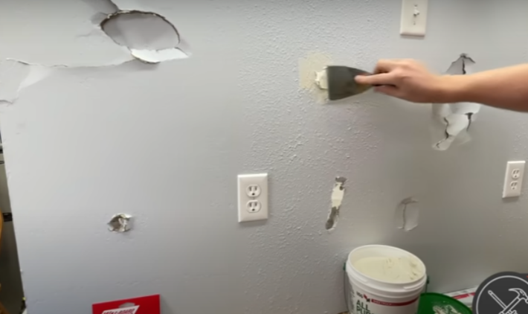

she found the courage

she got braver

to go through with

filled her in

## to catch on/ caught on

## to come around/ she came around to the idea

## to talk someone into doing something.....

she was full of doubts

they don’t want their daughter to start an online business

Emily persisted

## against the odds/ idiom

Meaning:If you do or [achieve](https://dictionary.cambridge.org/dictionary/english/achieve" \o "achieve) something against (all) the [odds](https://dictionary.cambridge.org/dictionary/english/odds" \o "odds)/against all [odds](https://dictionary.cambridge.org/dictionary/english/odds" \o "odds), you do or [achieve](https://dictionary.cambridge.org/dictionary/english/achieve" \o "achieve) it [although](https://dictionary.cambridge.org/dictionary/english/although" \o "although) there were a lot of [problems](https://dictionary.cambridge.org/dictionary/english/problem" \o "problems) and you were not [likely](https://dictionary.cambridge.org/dictionary/english/likely" \o "likely) to [succeed](https://dictionary.cambridge.org/dictionary/english/succeed" \o "succeed)

Example:

And any success they have is gained against the odds.

against the odds, she succeeded!

parents often want their children to stay close by

i am the kind of person that doesn’t want to **take risks**

## sink or swim/ idiom

Meaning:If you are [left](https://dictionary.cambridge.org/dictionary/english/left" \o "left) to [sink](https://dictionary.cambridge.org/dictionary/english/sink" \o "sink) or [swim](https://dictionary.cambridge.org/dictionary/english/swim" \o "swim), you are given no [help](https://dictionary.cambridge.org/dictionary/english/help" \o "help) so that you [succeed](https://dictionary.cambridge.org/dictionary/english/succeed" \o "succeed) or [fail](https://dictionary.cambridge.org/dictionary/english/fail" \o "fail) [completely](https://dictionary.cambridge.org/dictionary/english/completely" \o "completely) by [your](https://dictionary.cambridge.org/dictionary/english/your" \o "your) own [efforts](https://dictionary.cambridge.org/dictionary/english/effort" \o "efforts)

自己去闯，成败全凭自己

Example:

My [employer](https://dictionary.cambridge.org/dictionary/english/employer" \o "employer) gave me no [help](https://dictionary.cambridge.org/dictionary/english/help" \o "help) when I [started](https://dictionary.cambridge.org/dictionary/english/start" \o "started) my new [job](https://dictionary.cambridge.org/dictionary/english/job" \o "job) - I was just [left](https://dictionary.cambridge.org/dictionary/english/left" \o "left) to [sink](https://dictionary.cambridge.org/dictionary/english/sink" \o "sink) or [swim](https://dictionary.cambridge.org/dictionary/english/swim" \o "swim).

maybe i wont want to be confined by a company

maybe i will never feel ready. Maybe its not possible to ever feel fully prepared

sometimes you have to jump in feet first

employment as a civil servant

## state owned companies

## private companies

## laid off/ made redundant

its easy for people to be laid off/ made redundant.

Because of [falling](https://dictionary.cambridge.org/dictionary/english/falling" \o "falling) [orders](https://dictionary.cambridge.org/dictionary/english/order" \o "orders), the [company](https://dictionary.cambridge.org/dictionary/english/company" \o "company) has been [forced](https://dictionary.cambridge.org/dictionary/english/forced" \o "forced) to [lay](https://dictionary.cambridge.org/dictionary/english/lay" \o "lay) off several hundred [workers](https://dictionary.cambridge.org/dictionary/english/worker" \o "workers).

I won't have to worry about being laid off. If I behave exactly the way they expect me to, they'll like me.

state owned companies or as a civil servant

the competition is intense/ is fierce

compete/ apply for one position

i am not the type of person who is good at exams

## to talk someone out of something

## to talk someone into it/ to convince

to talk someone out of something/ to dissuade

they tried to dissuade her from pursuing her dream

## to crack down (on something or someone)

Example: to [start](https://dictionary.cambridge.org/dictionary/english/start" \o "start) [dealing](https://dictionary.cambridge.org/dictionary/english/dealing" \o "dealing) with [bad](https://dictionary.cambridge.org/dictionary/english/bad" \o "bad) or [illegal](https://dictionary.cambridge.org/dictionary/english/illegal" \o "illegal) [behaviour](https://dictionary.cambridge.org/dictionary/english/behaviour" \o "behaviour) in a more [severe](https://dictionary.cambridge.org/dictionary/english/severe" \o "severe) way:

The [library](https://dictionary.cambridge.org/dictionary/english/library" \o "library) is [cracking](https://dictionary.cambridge.org/dictionary/english/cracking" \o "cracking) down on [people](https://dictionary.cambridge.org/dictionary/english/people" \o "people) who [lose](https://dictionary.cambridge.org/dictionary/english/lose" \o "lose) [their](https://dictionary.cambridge.org/dictionary/english/their" \o "their) [books](https://dictionary.cambridge.org/dictionary/english/books" \o "books).

He [campaigned](https://dictionary.cambridge.org/dictionary/english/campaign" \o "campaigned) [earnestly](https://dictionary.cambridge.org/dictionary/english/earnestly" \o "earnestly), [promising](https://dictionary.cambridge.org/dictionary/english/promising" \o "promising) to [crack](https://dictionary.cambridge.org/dictionary/english/crack" \o "crack) down on [street](https://dictionary.cambridge.org/dictionary/english/street" \o "street) [crime](https://dictionary.cambridge.org/dictionary/english/crime" \o "crime).

the teachers are cracking down on the use of mobile phones during class

to become more strict/ to crack down

to try to reduce or eliminate some unwanted behaviour

to crack down

smuggling/contraband

drugs

a parent

## idiom/ to pull the wool over (someones ) eyes

to lie to someone or try to deceive them

the kids try to pull the wool over their parents eyes.

You were trying to pull the wool over his eyes.

And they're trying to pull the wool over our eyes and make us believe that they're going to take responsibility for solving this.

## you are grounded!!

Parents say 'you are grounded'! to their kids

a shop keeper/ a retailer

## a shop lifter

a shop lifter/ a person who steals things from shops

the shop lifter/ is the person

shop lifting/ verb/ the action

counterfeit money

fake money/ fake notes

## idiom/ to blow off steam

Meaning:to do or say something that [helps](https://dictionary.cambridge.org/dictionary/english/help" \o "helps) you to get [rid](https://dictionary.cambridge.org/dictionary/english/rid" \o "rid) of [strong](https://dictionary.cambridge.org/dictionary/english/strong" \o "strong) [feelings](https://dictionary.cambridge.org/dictionary/english/feeling" \o "feelings) or [energy](https://dictionary.cambridge.org/dictionary/english/energy" \o "energy)

They just want to blow off steam.

he's trying to blow off steam after a hard week of crime fighting by going on a casual date.

to vent emotions/ to blow off steam

instant noodles

potato chips

in tact items

undamaged instant noodles

squeeze/ squah

squash#

the packaging is still intact but the noodles inside are broken.

**“Some people go to convenience stores and crush instant noodles as a way to blow off steam when they feel stressed.”**

i heard it a long time ago.

bubble wrap

do you like it?

pop the bubbles



self healing

de-stressing

therapy

## to jump at the chance

## to go through with (something/it)

to do something [unpleasant](https://dictionary.cambridge.org/dictionary/english/unpleasant" \o "unpleasant) or [difficult](https://dictionary.cambridge.org/dictionary/english/difficult" \o "difficult) that has already been [agreed](https://dictionary.cambridge.org/dictionary/english/agreed" \o "agreed) or [promised](https://dictionary.cambridge.org/dictionary/english/promise" \o "promised):

**He'd [threatened](https://dictionary.cambridge.org/dictionary/english/threatened" \o "threatened) to [divorce](https://dictionary.cambridge.org/dictionary/english/divorce" \o "divorce) her but I never [thought](https://dictionary.cambridge.org/dictionary/english/thought" \o "thought) he'd go through with it.**

**The [company](https://dictionary.cambridge.org/dictionary/english/company" \o "company) has [decided](https://dictionary.cambridge.org/dictionary/english/decided" \o "decided) not to go through with the [takeover](https://dictionary.cambridge.org/dictionary/english/takeover" \o "takeover) of [its](https://dictionary.cambridge.org/dictionary/english/its" \o "its) [smaller](https://dictionary.cambridge.org/dictionary/english/small" \o "smaller) [rival](https://dictionary.cambridge.org/dictionary/english/rival" \o "rival).**

to complete/ to execute your plan/

to go through with something

you have a plan/ will you do it or not/ will you **go through with it** or not......

a small risk involved

are you really going to run the 100km marathon? Are you going to go through with it?

Do you still want to **go through with** investing in this project?

it is not a short term investment. It will take time to make your money back

Ben has been through a difficult time

She has been through a lot this year

## to see (something) through

i intend to see my degree though (to the end). I will not quit.

to see through someone

i see through you ( i see your intentions)

# May 12th, 2024

my supervisor

some format

how the content is delivered?

in what format it is given?

How to format the data

the order

symbol/sign

symbol

they will slate my thesis

they will disparage my thesis

[engoo.com/app/daily-news/article/report-reveals-fraud-of-plastic-recycling/J7p_4AfPEe-b2cOTho1Pvg](https://engoo.com/app/daily-news/article/report-reveals-fraud-of-plastic-recycling/J7p_4AfPEe-b2cOTho1Pvg" \t "https://www.cambly.com/en/student/progress/_blank)

[engoo.com/app/daily-news/article/apples-quarterly-iphone-sales-fall-once-more/pdmOKgo2Ee-Gtq9mpxAr8Q](https://engoo.com/app/daily-news/article/apples-quarterly-iphone-sales-fall-once-more/pdmOKgo2Ee-Gtq9mpxAr8Q" \t "https://www.cambly.com/en/student/progress/_blank)

take something out of context and make it misleading

## to take something out of context

to constitute/ to qualify as

his actions did n ot amount/ qualify as fraud

amount to fraud

qualify as fraud

## Incinerate

Meaning:to completely destroy something by burning

Medical waste in hospitals is typically incinerated to eliminate the risk of disease transmission

all my belongings were incinerated by the house fire

incinerators/ machines that burn waste and turn it into energy

If we incinerate this, it goes up into the air and eventually into the waterways.

## To dump

to dump/ to throw out/ to throw away

to be dumped/ to dump is a slang word meaning......what?

it means to be rejected by your girlfriend or boyfriend

**i dumped him last week**

**i was dumped by him last week**

**we are not together anymore. i got dumped!**

a detergent/ something that cleans e.g washing up liquid

our products are easy for you to recycle

safe to use

and they are safe to use

a summary of this article in a nutshell

what are the pertinent points of this article?

## pertinent/ most important

## distorts the facts about recycling

distort the information

quantify

to count/ quantify

**once or twice**

this is not peoples idea/ perspective of recycling

peoples view of recycling

the fourth paragraph from the end...

But many other plastic products are collected for recycling. And instead of being recycled, they're exported, **incinerated**, sent to landfill sites, or dumped in the ocean.

disingenuous

to be sneeky and false/ disingenuous

a cap on plastic use

a limit on the amount of plastics

## green washing

**how do we ensure companies go beyond green washing?**

我们如何确保公司超越“漂绿”行为？

注：“漂绿”（greenwashing）是一个术语，指的是企业为了提升环保形象而采取的表面功夫，但实际上并未真正减少对环境的影响或改善其环境绩效。这种做法往往涉及误导性宣传或误导性陈述。

its green wash!!

to make people believe that something is more environmentally friendly than it really is/ to green wash something

every day 2,000 truckloads of plastic waste **is dumped into** our oceans, lakes and rivers.

punish/ penalise

it comes down to 'the bottom line'  
归结为“底线”

# May 5th, 2024 Spoken English-Feelings

<https://www.youtube.com/watch?v=udWXxCOGgs8&list=PLD6t6ckHsruYoalxbzcjX1TNn4h7ShiRk&index=63>

i have o/deed on them!

o.d/ stands for: over dosed

i have o.d (overdosed) on them!

## expression/ familiarity breeds contempt

 the human mind isn't used merely because we take it for granted. Familiarity breeds contempt.

There's an old saying, "familiarity breeds contempt," that could apply in this case.

with people or with things

to cut them/ to snip them off the tree

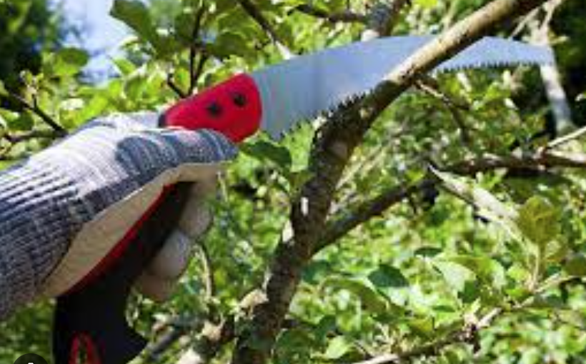

[docs.google.com/document/d/1AZfK2xzrA2LJ1hWj6orNJsP9_WomFsQf5IxPBp81YaI/edit](https://docs.google.com/document/d/1AZfK2xzrA2LJ1hWj6orNJsP9_WomFsQf5IxPBp81YaI/edit" \t "https://www.cambly.com/en/student/progress/_blank)

is this a dialogue?

10 is amazingly happy/ 1 is miserable

you have achieved something/ there is satisfaction

stressed is an umbrella term for many different emotions and conditions

i feel nervous/ more specific

I’m worried about some results/ more specific

i don’t fee; secure/ more specific

more appropriate

frustrated

you are blocked/ an obstacle

i am so frustrated that i cant get my computer to work!!

to feel relieved

a sigh of relief

## a weight off your shoulders /idiom

you're taking a weight off your shoulders.  
你肩上的担子减轻了。

It takes a little bit of weight off your shoulders.  
它减轻了你肩膀上的一点重量

he gave me two A's

how is scared different to feeling worried?

terrified

scared/ terrified

worried/ concerned

fearful

horror movie

afraid

hand wringing/ anxious

over thinking

The Shining with the actor Jack Nicolson

Here's Johnny!

with the axe

## apathy/ apathetic

[showing](https://dictionary.cambridge.org/us/dictionary/english/showing" \o "showing) no [interest](https://dictionary.cambridge.org/us/dictionary/english/interest" \o "interest) or [energy](https://dictionary.cambridge.org/us/dictionary/english/energy" \o "energy) and [unwilling](https://dictionary.cambridge.org/us/dictionary/english/unwilling" \o "unwilling) to take [action](https://dictionary.cambridge.org/us/dictionary/english/action" \o "action), [especially](https://dictionary.cambridge.org/us/dictionary/english/especially" \o "especially) over something [important](https://dictionary.cambridge.org/us/dictionary/english/important" \o "important):

Young [people](https://dictionary.cambridge.org/us/dictionary/english/people" \o "people) today are so apathetic about [politics](https://dictionary.cambridge.org/us/dictionary/english/politics" \o "politics).

Don't be so apathetic - how are you going to get a [job](https://dictionary.cambridge.org/us/dictionary/english/job" \o "job) if you don't [even](https://dictionary.cambridge.org/us/dictionary/english/even" \o "even) [start](https://dictionary.cambridge.org/us/dictionary/english/start" \o "start) [looking](https://dictionary.cambridge.org/us/dictionary/english/looking" \o "looking)?

**Shocklingly, the more we hear of atrocities and brutalities happening,the more apathetic and desensitized we become.**

you don’t have the energy to care any more/ apathetic

trivial/ temporary/ serious/ long term?

i am feeling a bit down

i am feeling very apathetic

## to feel torn

the verb/ to tear/ e.g to tear a piece of paper in half

torn/ past tense of to tear

they feel conflicted

you don't feel whole, you feel conflicted

## you feel pulled in different directions

"I often feel pulled in different directions between my job responsibilities and my family commitments."

"As a college student, I feel like I'm constantly being pulled in different directions by my studies, extracurricular activities, and social life."

"In today's fast-paced world, people often feel pulled in different directions by the various opportunities and challenges that present themselves."

## expression/ a fork in the road

"If you come to a fork in the road, take it."

I had reached a fork in the road.

You're at a fork in the road.

So that criticism was a fork in the road for me.It forced me to decide if I would let the cruelty of

those remarks forever silence me or if, despite the criticism, I would speak out on issues of importance.

## to weigh up the pros and cons

She can weigh up the pros and cons of this method.

short term reward versus long term reward

he feels under appreciated

he feels he is worth more

he feels he is capable of more

he feel he deserves more respect

he might lose confidence in himself

you can lose hope

feel demoralised

## In a dilemma

meaning:in a [situation](https://dictionary.cambridge.org/us/dictionary/english/situation" \o "situation) in which a [difficult](https://dictionary.cambridge.org/us/dictionary/english/difficult" \o "difficult) [choice](https://dictionary.cambridge.org/us/dictionary/english/choice" \o "choice) has to be made between two different things you could do

Example:

I'm **in [dilemma](https://dictionary.cambridge.org/us/dictionary/english/dilemma" \o "dilemma)**. Should I [tell](https://dictionary.cambridge.org/us/dictionary/english/tell" \o "tell) him and [betray](https://dictionary.cambridge.org/us/dictionary/english/betray" \o "betray) my friend's [trust](https://dictionary.cambridge.org/us/dictionary/english/trust" \o "trust), or [let](https://dictionary.cambridge.org/us/dictionary/english/let" \o "let) him [continue](https://dictionary.cambridge.org/us/dictionary/english/continue" \o "continue) to [believe](https://dictionary.cambridge.org/us/dictionary/english/believe" \o "believe) that everything is [fine](https://dictionary.cambridge.org/us/dictionary/english/fine" \o "fine)?

This puts [financial](https://dictionary.cambridge.org/us/dictionary/english/finance" \o "financial) [institutions](https://dictionary.cambridge.org/us/dictionary/english/institution" \o "institutions) **in a very [considerable](https://dictionary.cambridge.org/us/dictionary/english/considerable" \o "considerable) [dilemma](https://dictionary.cambridge.org/us/dictionary/english/dilemma" \o "dilemma)**.

spirit has been broken/ to feel demoralised

menial

## menial tasks/ low status tasks/ manual tasks

Menial [work](https://dictionary.cambridge.org/us/dictionary/english/work" \o "work) is [boring](https://dictionary.cambridge.org/us/dictionary/english/boring" \o "boring), makes you [feel](https://dictionary.cambridge.org/us/dictionary/english/feel" \o "feel) [tired](https://dictionary.cambridge.org/us/dictionary/english/tired" \o "tired), and is given a [low](https://dictionary.cambridge.org/us/dictionary/english/low" \o "low) [social](https://dictionary.cambridge.org/us/dictionary/english/social" \o "social) [value](https://dictionary.cambridge.org/us/dictionary/english/value" \o "value):

It's [fairly](https://dictionary.cambridge.org/us/dictionary/english/fairly" \o "fairly) menial [work](https://dictionary.cambridge.org/us/dictionary/english/work" \o "work), such as [washing](https://dictionary.cambridge.org/us/dictionary/english/washing" \o "washing) [dishes](https://dictionary.cambridge.org/us/dictionary/english/dish" \o "dishes) and [cleaning](https://dictionary.cambridge.org/us/dictionary/english/cleaning" \o "cleaning) [floors](https://dictionary.cambridge.org/us/dictionary/english/floor" \o "floors).

a menial [job](https://dictionary.cambridge.org/us/dictionary/english/job" \o "job)/[task](https://dictionary.cambridge.org/us/dictionary/english/task" \o "task)

menial work might be considered jobs such as cleaning

the screws and nails?

organise them into categories **according to** size and length

length and width

there are many screws of each type

# April 28th, 2024

hail storms

there is hail

it is hailing

a typhoon

**you have to work other days to make up for the holiday.**

you have to make up the time you have lost/ the time you taken off

it **disrupts** people usual routine.

[engoo.com/app/daily-news/article/tasty-or-toxic-the-truth-about-mold-in-cheese/iD0JsKjxEe62QaPCWQF7LQ](https://engoo.com/app/daily-news/article/tasty-or-toxic-the-truth-about-mold-in-cheese/iD0JsKjxEe62QaPCWQF7LQ" \t "https://www.cambly.com/en/student/progress/_blank)

a fungus/ a kind of mushroom

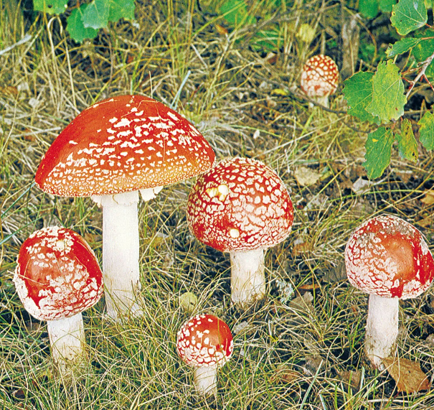

it has expired/ it has gone out of date/ it has gone moldy.

high humidity

northern Portugal has high humidity

## their quilts/ their blankets

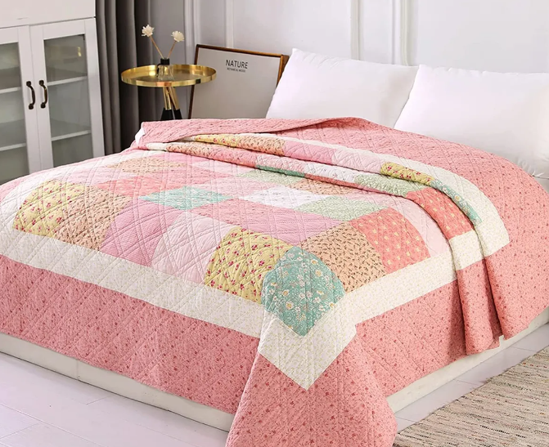

their bed sheets

they take their bed sheets outside to air them/ to dry them

## on purpose

i did something on purpose/ intentionally

intentionally/ with intention

## gravy

gravy/a sauce often made with meat juices



cake crumbles easily

cake is crumbly

**flavour or texture**

脆口：

The chips are perfectly crisp and tasty. （薯片又脆又好吃。）

The fried chicken has a crispy golden crust. （炸鸡的外皮金黄酥脆。）

软口：

The lamb shank was cooked to perfect tenderness. （羊小腿煮得恰到好处，非常嫩。）

The cake is soft and fluffy, just like a cloud. （蛋糕柔软蓬松，就像云朵一样。）

多汁：

The juicy watermelon is perfect for a hot summer day. （多汁的西瓜是炎炎夏日的完美选择。）

The steak was so juicy and flavorful. （牛排多汁又美味。）

黏糊糊：

The marshmallows are gooey and sweet. （棉花糖又黏又甜。）

The rice pudding is sticky and comforting. （米布丁黏黏的，吃起来很舒服。）

口感丰富：

The gummy bears are chewy and fun to eat. （橡皮糖很有嚼劲，吃起来很有趣。）

The ice cream has a creamy and rich texture. （冰淇淋有着丰富而滑顺的口感。）

其他口感：

The croissant is flaky and buttery. （羊角面包又酥又黄油味十足。）

The overcooked potatoes were mushy and not appetizing. （煮得过久的土豆糊糊的，一点都不好吃。）

The smoked salmon has a delicious smoky flavor. （烟熏三文鱼有着美味的烟熏味。）

The sparkling wine is effervescent and refreshing. （起泡酒清新冒泡，十分提神。）

整体或特定口感：

The curry was so finger-licking good that I couldn't stop eating. （咖喱好吃到让人想舔手指，我停不下来了。）

The delicate pastry was a work of art, both visually and in taste. （精致的糕点既是视觉的艺术品，又美味可口。）

The lemonade is the perfect drink for a refreshing break. （柠檬水是提神休息的完美饮品。）

## tingle

to tingle is a sensation

a lot of acid foods can make our tongues tingle

its kind of like a sparkle on our tongues

the bubbles in soda drinks

the bubbles in carbonated drinks

dance

there are some types of mold that are edible

## edible/ eatable

he left it inside the cave

had also **turned the cheese into** blue cheese.

cheese is wired food!!

how do people use mold to change the **flavour** or **texture** of food in Chinese cuisine?

the buns

## to ferment

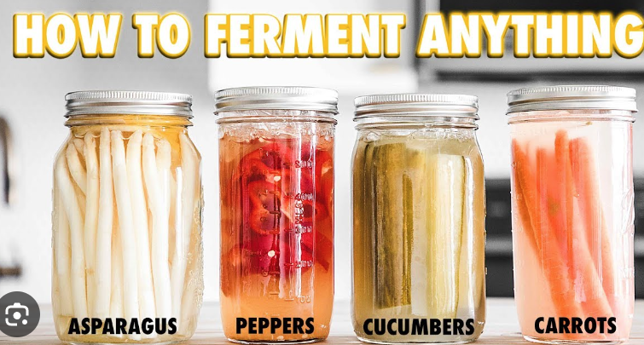

If [food](https://dictionary.cambridge.org/dictionary/english/food" \o "food) or [drink](https://dictionary.cambridge.org/dictionary/english/drink" \o "drink) ferments or if you ferment it, it goes through a [chemical](https://dictionary.cambridge.org/dictionary/english/chemical" \o "chemical) [change](https://dictionary.cambridge.org/dictionary/english/change" \o "change) because of the [action](https://dictionary.cambridge.org/dictionary/english/action" \o "action) of [yeast](https://dictionary.cambridge.org/dictionary/english/yeast" \o "yeast) or [bacteria](https://dictionary.cambridge.org/dictionary/english/bacteria" \o "bacteria), which may [cause](https://dictionary.cambridge.org/dictionary/english/cause" \o "cause) it to [produce](https://dictionary.cambridge.org/dictionary/english/produce" \o "produce) [bubbles](https://dictionary.cambridge.org/dictionary/english/bubble" \o "bubbles) or [heat](https://dictionary.cambridge.org/dictionary/english/heat" \o "heat), or [turn](https://dictionary.cambridge.org/dictionary/english/turn" \o "turn) [sugars](https://dictionary.cambridge.org/dictionary/english/sugar" \o "sugars) in it into [alcohol](https://dictionary.cambridge.org/dictionary/english/alcohol" \o "alcohol).

You make [wine](https://dictionary.cambridge.org/dictionary/english/wine" \o "wine) by [leaving](https://dictionary.cambridge.org/dictionary/english/leaving" \o "leaving) [grape](https://dictionary.cambridge.org/dictionary/english/grape" \o "grape) [juice](https://dictionary.cambridge.org/dictionary/english/juice" \o "juice) to ferment until all the [sugar](https://dictionary.cambridge.org/dictionary/english/sugar" \o "sugar) has [turned](https://dictionary.cambridge.org/dictionary/english/turn" \o "turned) to [alcohol](https://dictionary.cambridge.org/dictionary/english/alcohol" \o "alcohol).

Sauerkraut and kimchi are both [essentially](https://dictionary.cambridge.org/dictionary/english/essentially" \o "essentially) fermented [cabbage](https://dictionary.cambridge.org/dictionary/english/cabbage" \o "cabbage).

Fermentation

## yeast

people use yeast to ferment bread....

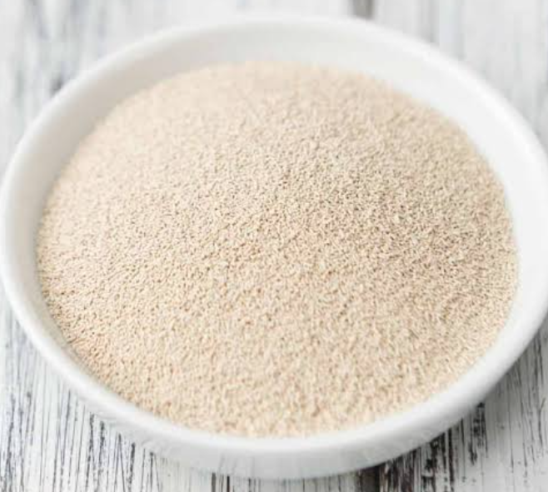

maggots

will add some soy sauce

different flavour combinations

contrasting flavour combinations

mackeral fish with gooseberries

what would you pick/ what would you choose?

corn

fried corn

fried corn is crunchy炸玉米粒是脆脆的。



# April 21st,2024

its raining heavily

it has been raining heavily

car games/ racing games

guitars and ukeles

the banjo

你

[docs.google.com/document/d/1AZfK2xzrA2LJ1hWj6orNJsP9_WomFsQf5IxPBp81YaI/edit](https://docs.google.com/document/d/1AZfK2xzrA2LJ1hWj6orNJsP9_WomFsQf5IxPBp81YaI/edit" \t "https://www.cambly.com/en/student/progress/_blank)

Alexandra

comaring 2 things/ x is like Y

he had a big nose. It was as long as a carrot!!}

my brother is as talented as Einstein

as slow as...

as fast as...

as hungry as....

as brainy as....

as lovely as...

my friend runs as fast as i do

my friend runs as fast as i do

i am as hungry as a pig that hasnt eaten for a long time

你

pig out

Alexandra

to pig out

i started pigging out

as hungry as a pig/ wolf

like

my sister is just like my mother

你

唠叨

Alexandra

she always nagging

to nag

watching this movie is like watching paint dry

to watch paint dry/ idiom/ to be boring

your cooking is like a michelling chefs

你

演技

Alexandra

acting

your acting performance

your acting skills

an award

an oscar

your acting performance/ skills is like an oscar winners!

the room smelt like a dead badger!!

this place looks like a good place to visit

teresa sings terribly she sounds like a chicken clucking

你

锯木头

Alexandra

she sounds like a saw sawing wood

i cannot bare that sound

Likewise.....

你

钩织

Alexandra

crochet

im afraid of it

i dont believe it because....

the mayor

the elected person in charge of the city/town

i dont like it either

me neither#

as well as/ in addition

你

and

Alexandra

and in addition

i like swimming aswell as hiking

i like swimming and hiking

i ate noodles as well as pasta

aswell as being able to make a good dish ....

she can also make achivements in other areas

she is very versatile

in addition to being a great cook she also a writer

aswell as having a headache

stomach ache

stomach pains

in contrast too/ more formal

in contrast to Beijing, Quanjo is a small city

as, like, aswell as, in contrast to, in addition

lets pretend

we are in a job interview

you are the interviewee

i am the interviewer

your strengths and skills

may only have previous experience with computer simulations

你

实物

Alexandra

the real thing

the real life robots

in my 3 years of my masters career

i have experience in working with both real life robots and computer simulations. Similarly i have experience giving real life presentations as well as online presentations

i like movies in the action genre.. Similarly all my friends do too

i place health as a 1st priority

你

烫嘴

Alexandra

sounds like- sim-i-lar-ly

a tongue twister/ a mouthful

on the other hand..../ expression

the rain

i dont like walking in the rain

you have some savings/ some money

what will you spend your savings on|?

on?

to make an investment for the future

你

保险

Alexandra

experiences/ making memories/ safety and security

insurance

which is most important to you?

having experiences

# April 14th,2024

a 6 month course

being psychic!

你

[docs.google.com/document/d/1AZfK2xzrA2LJ1hWj6orNJsP9_WomFsQf5IxPBp81YaI/edit](https://docs.google.com/document/d/1AZfK2xzrA2LJ1hWj6orNJsP9_WomFsQf5IxPBp81YaI/edit" \t "https://www.cambly.com/en/student/progress/_blank)

Alexandra

they break easily

dont say anything to upset her/ him

the person is already angry/grumpy/ fed up etc so we must walk on eggshells so we dont make it worse

the boss just recieved bad news about eh project. We had better walk on eggshells for the rest of the day!

你

刺激

Alexandra

irritate

to irritate them

the beauty is subjective

beauty is subjective/ a amtter of opinion

a matter **

你

发现美的眼睛

缺点

Alexandra

shortcomings/ faults/ flaws

his or her good points/ strengths

i saw our friend jack today./ hes such a nice guy!

### Wear my heart on my sleeve

he always wears his heart on his sleeve

你

哲学的？

Alexandra

i think that his philosophy is that variety is the spice of life!

he knows people from all different walks of life

a team spirit

a thick skinned person

i admire him

we should put our thinking caps on

你

情人眼里出西施

Alexandra

Beauty is in the eyes of beholder

number 4

the youth club was a hive of activity

the classroom was a hive of activity as the student completed their tasks

the company....

the factory...

the train station....

students**

he/she is in deep water

to be in trouble

a difficult situation

你

厚脸皮

Alexandra

cheeky

to be thick skinned/ to be robust, to be strong, not easily affected by the words or behaviour of others

the kids called him mean names, but he is very thick skinned so he didnt care

你

恶作剧

Alexandra

mischievious

to be a bit naughty but in a nice, cute, funny way

你

虚心请教

Alexandra

i am humble

你

辩论家

Alexandra

a debater

if someone is easily offended, hurt very easily, feels everything

sensitive

thin skinned

they are very thin skinned

你

脸皮薄

Alexandra

Thin-skinned

你

注重面子

Alexandra

to save face??

to keep a good reputation/ to save face

i dont want to lose face/ to be humiliated, to get a bad reputation

to save face/ remain dignified, keep a good reputation

hu-mil-i-a-ted

pride comes before a fall/ idiom

a journalist

你

泼一盆冷水

Alexandra

throw a bucket of cold water

dismiss you

你

priest

Alexandra

a holy person, a priest, a monk, a pastor etc

你

职业

Alexandra

career, profession

你

耕地

Alexandra

to farm arable land

to carry heavy machinery

to traverse rough ground

a ferrari car

a sports car

she has really bounced back

to bounce bak

back

你

弹簧

Alexandra

to bounce, to spring back

a service dog, a guide dog

# April 7th, 2024

短袖

Alexandra

i am waering a short sleeve shirt

i am waering short sleeves

wearing

你

薄衬衫

Alexandra

i am just wearing a thin shirt with long sleeves

你

修改格式

Alexandra

i need to modify the format

the annual marathon

25 miles

你

[docs.google.com/document/d/1AZfK2xzrA2LJ1hWj6orNJsP9_WomFsQf5IxPBp81YaI/edit](https://docs.google.com/document/d/1AZfK2xzrA2LJ1hWj6orNJsP9_WomFsQf5IxPBp81YaI/edit" \t "https://www.cambly.com/en/student/progress/_blank)

Alexandra

to put your mind at rest

你

绷紧神经

Alexandra

stress, anxious, worried

you have tension

you are tense

to put his mind at rest

你

严重的

Alexandra

he puts his mind at rest by telling him his situation is not serious

to take an action or to say something to make yourself or others feel more peaceful

你

火灾

Alexandra

fire

elaborate....

你

消防队员

Alexandra

a firefighter

firefighters

a seasonal cold

i hope they will put your mind at rest

i hope it will put your mind at rest

to put to rest/ to stop any more talk or investigation on a topic/ to bury someone

we put my grandad to rest last week/ we buried grandad last week

i have had enough of talking about money problems. Lets put the topic to rest!

to slip my mind/ it slipped my mind/ i forgot about it

i didnt do it on purpose

once the summer has arrived

你

左耳进

右耳出

Alexandra

left ear in, right ear out

can you berate a naughty nephew with this expression

to berate/ to tell off/ to scold

role play

it goes in one ear and out the other

you always have nightmares

a nighmare/ a bad dream

a superstition in the west/ if you eat cheese late at night you will have nighmares

你

我没有印象

Alexandra

i have no impression

i dont think we have any similar superstitions

researchers/ the people who do research

retailers/ shops

The key takeaway/ the most important piece of information to take away with you

你

相关性

Alexandra

there is a correlation

there is a correlation between reducing food waste and benefits for environmental conservation etc

these are not endless resources....these are not infinite resources

they are........... resources

they are limited/ finite resources

what is landfill?

we need more landfill sites to cope with wasted food

the more we waste the more landfills we need

we shouldnt take more than we need

i am not able to eat it all up before it has gone past its best

i cannot eat it all before the expiry date

the food spoils before i can eat it all

i will plan how much i can eat in one day

my fridge

in the fridge

你

过几天后

Alexandra

a few days later you forget

it is easy to forget what you have in the fridge

a discount/ a good price

its counter intuiative

economically viable

你

循环

Alexandra

a cycle

你

促进消费

Alexandra

it promotes consumption

6o homeless charities

to

China has a huge population

faced starvation

went hungry

# March 31,2024(1)

is you mother getting betteer

你

上上周

Alexandra

the last two weeks

fortnight

2 weeks ago i was working on my experiement

but last week i was working on my thesis

april the 13th is the deadline

你

[docs.google.com/document/d/1AZfK2xzrA2LJ1hWj6orNJsP9_WomFsQf5IxPBp81YaI/edit](https://docs.google.com/document/d/1AZfK2xzrA2LJ1hWj6orNJsP9_WomFsQf5IxPBp81YaI/edit" \t "https://www.cambly.com/en/student/progress/_blank)

Alexandra

the most busy/ the busiest

i landed a job/ casual language

only use it in familar company/ casual/ informal

the plane landed/ i landed the plane

i landed a fish when i went fishing

to make a name for your self/ to get a reputation

in the robotics industry

in the world of robotice

in the field of robotics

that guy gives politics a bad name

that guy has made a bad name for himself in politics

for himself in compuiters

football/ british

soccor/ american

to scold/ to tell off

to criticise

你

迟到三分钟

Alexandra

i was late by just a few minutes

i was just a few minutes late

a harsh approach/ to be very strict

the mistakes that Jack made

# March 31,2024(2)

critical words/ scolding words

inedible

disgusting

You idiot!!

what Jack does makes his boss unhappy

你

鸡蛋里挑骨头

Alexandra

to be nit picking

he doesnt have what it takes to be a chef

do you have what it takes to be a......?

dont let it impact you

dont let it get to you

dont let it get under your skin

idiom/ to get under your skin

idiom/ by the skin of your teeth

if something 'gets under your skin' you allow it to affect you

but take it in your stride! You can do it better next time

keep your chin up/ stay cheerful

we talked about it before

and get distracted

to challenge youself/ push yourelf to your limits

to step out of your comfort zone

it is easy to get nervous

i am trying to get a promotion at work

so i am studying for a new qualification

i am a bit worried, and a bit scared

in your stride

dont be impacted by your boss

to be 'on the go' / expression/ to be busy, always moving

can you take a call right now? Do you have time to have a phone call?

to hydrate/ to keep hydrated

to dehydrate/ to be lacking in water

make sure you stay hydrated/ make sure you drink plenty of water

stay hydrated

to pay off/ to be worthwhile

huslte and bustle

hustle and bustle

the hustle and bustle of the market

i love the hustle and bustle of a busy street

i dont like the hustle and bustle of city life

你

快节奏

Alexandra

the fast paced environment

sounds, action, business, crowds etc

# March 24th,2024(1)

[engoo.com/app/daily-news/article/vegetarians-may-be-at-lower-risk-of-disease-than-meat-eaters/GWe4oniVEeyx5ocLPE1_6g](https://engoo.com/app/daily-news/article/vegetarians-may-be-at-lower-risk-of-disease-than-meat-eaters/GWe4oniVEeyx5ocLPE1_6g" \t "https://www.cambly.com/en/student/progress/_blank)

Alexandra

an alert

a notification

out of breath

being out of breath when you are running is a sign you need to take more exercise

你

眼睛干涩

Alexandra

dry eyes

when your eyes are dry this is a sign that you need to get some rest

a category, a collective term

i like some poultry

calls for/ requires, needs, asks for

to be a handfull

the kids were a handfull today!!

handful

the customers in the cafe were a real handful today

to be a handful/ to be difficult to manage

people who do research/ researchers

were'nt

vegetables

weren't

were not

veg-ter-bles

tell me in a nutshell what the article is about

did a study

eaters

failure

heart disease

they suggest completely cutting out meat from your diet or at least cutting down

# March 24th,2024(2)

Alexandra

moderation is the best diet#

the poison is in the dose

if you eat a lot of salt food

processed food

oily food

a high sodium intake diet#

your digestive system#

kidneys/ plural

urine/pee/wee

if we over do it

if we have too much of it

a good thing can become a bad thing if we have too much of it

late at night

it will make it hard for you to fall asleep

your digestive system is still working

a medical exam

i had a physical check up

higher than the optimum amount

he recommended that i eat more plant based foods

你

刺激性食物

Alexandra

less inflamatory food

less heavy foods

it is better to eat food that is easier to digest

full of salt/sodium

you need to avoid salty foods

you need to avoid food high in salt

你

减少负担

Alexandra

less the burden on the digestive system

lessen the burden

the kidneys are responsible for processing the salt in your body

a pescatarian diet

naughty foods/ guilty pleasures

cake, chocolate, potatoe chips

i think having a little bit of meat in your diet is ok/ good

for your whole life

你

快餐

Alexandra

eat takeaway food#

fast food

processed food

not natural/ synthetic flavours?

你

加工

调味料

Alexandra

they add a lot of seasoning

the foods can be highly processed

they can be very morish

to be morish/ to want more and more

你

煲汤

嘌呤

Alexandra

purine

你

高嘌呤

ventilation

gout

Alexandra

it can give you gout

it can lead to gout#

the soups are very rich and can lead to gout

rich food/ very heavy

你

连锁反映

连锁反应

Alexandra

it can lead to other symptoms/ other side effects

negative consequences

你

菠菜

Alexandra

spinach

green leaf vegetables

bananas

你

钾

Alexandra

high in potassium

你

加重

Alexandra

it can aggravate

你

加重负担

Alexandra

it can excacerbate

# March 17th,2024(1)

Alexandra

a weight off your shoulder

there's no time like the present

you can squeeze it into your schedule

we always make excuses not to exercise

you realise it made a big difference

you lived healthier

you lived in a healthier way

you were more healthy becuase of it

to be on cloud 9

after i solved the problem i had been struggling with i was on cloud 9

你

To turn over a new leaf

Alexandra

to turn over a new leaf

你

To have a new lease of life

Alexandra

internal or external factors

你

中彩票

Alexandra

win the lottery

i made an impact on me

你

John's life looked perfect on the outside: a solid job, a loving wife, and a bright future. But beneath the surface, he was battling a serious gambling addiction. It started off as harmless fun, but quickly spiralled out of control, becoming detrimental to every aspect of his life. The consequences of his actions hit hard when he lost his job. The reality that his career was over due to his addiction forced him to ingest the harsh truth of his situation. This was a wake-up call about his mortality, highlighting how quickly things could go downhill if he didn't change his ways. His wife's departure was the final straw. He was faced with financial ruin. His savings were pretty much wiped out and now the collapse of his marriage. It was a stark reminder that his choices had real consequences, not just for him, but for the people he loved. Realising the gravity of his situation, John knew he had to turn his life around. He sought help, joining support groups where he learned the importance of thinking rationally, making carefully considered decisions. It was a tough journey, filled with introspection and accountability, but it was necessary for his recovery. Now, John is on a better path. He has a new job and is rebuilding the trust he lost with his friends and family. His experience taught him the hard lesson that while it's easy to let addiction take control, fighting back and making responsible choices is crucial for a better future. John's story is a powerful reminder that it's never too late to change direction and take control of your life. It underscores the importance of living rationally and recognising the detrimental effects of addiction, not just to oneself but on loved ones as well.

Alexandra

it got out of hand

to spiral out of control

in a nutshell

in a nutshell/ a summary

to spiral/a spiral#

你

It started off as harmless fun, but quickly spiralled out of control

Alexandra

a never ending circle/ a spiral

it (the addiction) spiralled out of control

he (his begaviour) spiralled out of contrl

control

behaviour

# March 17th,2024(2)

Alexandra

to be detrimental/ to have a negative effect

你

It started off as harmless fun, but quickly spiralled out of control, becoming detrimental to every aspect of his life

harmful

Alexandra

to be harmful/ to be detrimental/ to be negative on

have a bad impact

having distruptive pupils in class is detrimental to learning

it hit hard/ expression

the plot line of the movie hit me hard

losing my job hit me hard

when his dog died, it hit him hard

你

被诊断

Alexandra

being diagnised with a bad disease hit me hard

diagnosed

to ingest/ to consume/ to digest/ to taken within yourself

i ingested the poison by mistake

i ingested all the information given to me

to go downhill/ to get worse

its all downhill from here/ idiom/ kit will be easy from now on

你

困境

Alexandra

a dilemma

it has a lot of imagery

it is evocotive

it evokes

mortality

to be mortal

god is immortal

humans are mortal

we have to accept our immortality

the final straw/ idiom

the final straw/ the thing that broke something

你

压死骆驼的最后一根稻草

Alexandra

the straw that broke the camels back

they have to carry a lot of weight

we dont know the maximum weight it can carry

Buckaroo/ a board game

with a donkey

can cope

prety much

pretty much

你

差不多

Alexandra

nearly, close, almost

i was pretty much ready to leave the meeting but then the boss asked us to stay longer

i pretty much understand everything he says

in life, i got pretty much everything i ever wanted

你

留到明天

Alexandra

ive pretty much solved the problem so im going to stay up late and get it finished. I dont want to procrastinate

你

His savings were pretty much wiped out and now the collapse of his marriage.

Alexandra

wiped out

to be wiped out/ to be eliminated, to be decimated, to be erased

to feel wiped out/ to be tired

to be burnt out/ to be totally exhausted

你

程度

Alexandra

the degree to which it is felt

my passion has never been wiped out even after experiencing so many things

你

有人吃光食物了？

Alexandra

to wipe/ to clean

the bowl has been wiped clean

you wiped the table

the window has been wiped

你

抹布

Alexandra

i used a rag to wipe the window

to remove the dirt/ to wipe clean

# March 10th, 2024

后两周

in the next two weeks

the next fortnight

a fortnight/ two weeks

the crocheting



its in the bag/ its sorted

Practise is the standard for testing truth.

if you succeed you are happy

if you fail you can rectify it/ learn something from it

i don’t know how it will taste

you feel regret

you regret it

something delays you/ prevents you

the plane has an incident

## Spot on

The information that his person had apparently was spot on.他的人掌握的信息显然是准确的。

And many of the issues that you raise are so spot on.

you are spot on!

you see it from another point of view.

you see it from a different perspective.

Perspective

## Cut someone some slack

to not be too strict towards someone

to give someone a break

i will cut you some slack

keep up the good work!

pay close attention

## Get out of hand

the kids party got out of hand and all the children were squabbling

## Squabble

**Meaning:**

an [argument](https://dictionary.cambridge.org/dictionary/english/argument" \o "argument) over something that is not [important](https://dictionary.cambridge.org/dictionary/english/important" \o "important)

**Example:**

Polly and Susie were having a squabble about who was going to [hold](https://dictionary.cambridge.org/dictionary/english/hold" \o "hold) the dog's [lead](https://dictionary.cambridge.org/dictionary/english/lead" \o "lead).

Often [relationships](https://dictionary.cambridge.org/dictionary/english/relationship" \o "relationships) between [family](https://dictionary.cambridge.org/dictionary/english/family" \o "family) [members](https://dictionary.cambridge.org/dictionary/english/member" \o "members) are so [strained](https://dictionary.cambridge.org/dictionary/english/strained" \o "strained) that squabbles [break](https://dictionary.cambridge.org/dictionary/english/break" \o "break) out.

someones behaviour has got out of hand

during our argument

they got out of hand

they were fighting over the toys!

it was a nightmare!

my friend has had a difficult life....

he/she/we/they stuck with them through thick and thin

a delivery driver

if you dont succeed

a good mentality/ a good attitude

something got out of hand

to repair it

when you took your driving test..

when you are taking your driving test....

are the roads packed like sardines?

the examination room was packed like sardines

they will stick with me through thick and thin

the last ten idioms

My DAILY Idioms | Daily British English | British culture

<https://www.youtube.com/watch?v=fIAtf4pndOE&t=140s>

## It's in the bag

Meaning: this means you are certain about getting or achieving something.

Example:when you’ve just done your exams and you haven’t got your results yet, but you’re really sure that you aced it, people will ask how did it go and you can say it’s in the bag.

## The proof is in the pudding(实践是检验真理的唯一标准，布丁好不好吃，只有吃了以后才知道)

Meaning:the value, quality or truth of something can only be judged by the results.(I won’t believe it until I see them play)  
example:

## To miss the boat错失良机

**Meaning:** to be too slow to take advantage of an opportunity.->（miss out on an opportunity / miss out on golden opportunities）

（You snooze you lose-if you are not alert and attentive, you will not be successful.）

**Example:**I had thought that we had missed the boat with going a concert for this year.

A blessing in disguise

Meaning:An apparent misfortune that eventually has good results.

Example:there was a wedding venue that I really liked and I was like that is the one, this dream venue didn’t have any availability for this year which felt really disappointing however, however we later found out through word of Mouth (meaning through other people talking and telling)

## To cut someone some slack（放宽某人的要求）

Meaning:to give someone a chance, it’s a really human really empathetic idiom, that means to just relate to that human and try and let them off a little bit for what they’ve done.(to make things slightly easier for someone than you normally would, because of their special circumstances or situation)

Example:this year my friend forget my birthday, I wasn’t really that disappointed because it’s not big deal, when I told my mom , she just said cut her some slack, she’s going through a difficult time at the moment.

## To get out of hand

Meaning:when a situation becomes out of control.

Example:the first memory that springs to mind(脑海中浮现的第一个记忆) is when my great friend got really drunk when she was about 17...

## Through thick and thin(风雨同舟)

Meaning:to remain loyal to someone under all circumstances, no matter how difficult.

Example:

one of my best friend, she has supported her partner through losing his dad, family divorce, these big things that really test a relationship and you get through them, you weather the storm together你们一起渡过难关, you can then say that we’ve been through thick and thin together.

You can reassure someone that you will stick by them through thick and thin.

## To be packed like sardines

Meaning:it means so many people in one place is usually a small vessel like a train or shop.

## So far so good

Example:(which brings me to my example)->commuting

So far so good

Meaning:something (such as a project or an activity has proceeded well or without problems up to the present time.)->up to the current time it’s been okay.

Example:

Time flies when you're having fun

Meaning:when time feels like it’s passing quickly when you are engaged in something you enjoy.

Example:

Language to spread POSITIVITY and light ✨| Let me cheer you up ☺️| British English

<https://www.youtube.com/watch?v=i88gNoq5fAo>

## Every cloud has a silver lining.

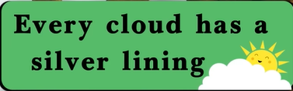

Meaning:every difficult or sad situation has a positive or more hopeful aspect.

Example:

My friend unfortunately lost her job but every cloud has a silver lining because she has more time at home to focus on her children and just figure out what she wants to do because she wasn’t really like her job.

## When one door closes, another opens

Meaning: if one thing you do fails, you will soon have an opportunity to try to succeed at something else.

Example:if you’ve applied to a university and they said no or if you’ve applied to a job and you didn’t get an interview.

## When life gives you lemons, make lemonade

Meaning:try to turn a negative situation into a positive one.(lemons represent sourness in life)

Example:

Losing your job or not getting the job that you want, you could just find a positive our of that and instead use that to motivate you to your next thing that you do.

## There's light at the end of the tunnel

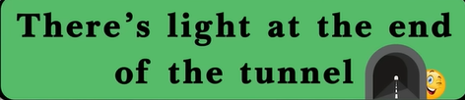

Meaning:there’s hope that a bad situation will soon come to an end!

Example:I can keep going because I know the positive is coming.

## Hang (on) in there

Meaning:remain persistent and determined in difficult circumstance.

Example:Work can get [tough](https://dictionary.cambridge.org/dictionary/english/tough" \o "tough) in the [middle](https://dictionary.cambridge.org/dictionary/english/middle" \o "middle) of a [term](https://dictionary.cambridge.org/dictionary/english/term" \o "term) but [hang](https://dictionary.cambridge.org/dictionary/english/hang" \o "hang) in there and it'll be OK.

You've got nothing to lose

Meaning:you cannot make things worse or cause any disadvantages for yourself by doing a particular thing.

Example:Why don't you take the [job](https://dictionary.cambridge.org/dictionary/english/job" \o "job)? You've got nothing to [lose](https://dictionary.cambridge.org/dictionary/english/lose" \o "lose).

## Keep your chin up/chin up!

Meaning:something you say to someone in a difficult situation in order to encourage them to be brave and strong.

Example:

## There's no time like the present.

Meaning：used to suggest that something should be done now rather than later.

example：(this is very useful for someone like me who is a serial procrastinator to the point where it becomes unbelievable)

## To be on cloud 9

Meaning:

To be extremely happy.

Example:

"Was Helen [pleased](https://dictionary.cambridge.org/dictionary/english/pleased" \o "pleased) about getting that [job](https://dictionary.cambridge.org/dictionary/english/job" \o "job)?" "Pleased?

She was on [cloud](https://dictionary.cambridge.org/dictionary/english/cloud" \o "cloud) nine!"

## To turn over a new leaf

Meaning: to turn the page on your life / start to act or behave in a better or more responsible way.

Example:Apparently he's [turned](https://dictionary.cambridge.org/dictionary/english/turn" \o "turned) over a new [leaf](https://dictionary.cambridge.org/dictionary/english/leaf" \o "leaf) and he's not [smoking](https://dictionary.cambridge.org/dictionary/english/smoking" \o "smoking) any more.

## To have a new lease of life

Meaning:a much improved prospect of life/quality of life after applying some changes.

Example:They believed that they had been given a new lease of life and a purpose.

# March 3,2024(1)

on the pavement

they were wondering if this boy was selling food....

you need to engage with people passing by

but the boy was silent/ quiet

he hadnt eaten lunch

why arent you engaing with the people walking by?

你

有人会买你的东西吗

Alexandra

is anybody buying your stuff/produce?

you werent engaging with people

你

一袋薯片

Alexandra

they bought him a bag of chips

你

一盒饭

Alexandra

and then a box of lunch

or/ a lunch box

they watched him eating from afar

pomegranite

they were so moved by his hard work they bought all his pomegranites

he was hiding his face underneath his hood

he was covering his legs and feet with his coat

in the morning he has to go to school

你

清真寺学校

Alexandra

mosque school/ religious school

he was illiterate

he couldnt write

你

摊位

Alexandra

they came to the boys little stall

what do you want to be when you grow up?

he said he wants to be a doctor when he grows up

你

商量

Alexandra

they discuss

they talk about...

they discuss the possibility of the child going to school

你

懂事

# March 3,2024(2)

the boy was so sensible and thoughtful and considerate

he said no because he needed to go to work

to sell on the street

cover his thighs/ upper legs

你

不小心

Alexandra

accidentally

你

打翻

Alexandra

accidentally knocked over the pomegranites

they drove him back home

because he hadnt been to school before...

你

资格

Alexandra

he doesnt have the certificates/ the qualifications

idiom/ start from scratch

he has to catch up on classes

he has to go on a big learning curve

你

监督

Alexandra

to supervise him

to mentor him

to encourage him to study hard

it is urgent

all his time must be spent studying

to help them sustain themselves

你

裁缝公司

Alexandra

they opened a tailor school

they teach children how to become tailors

an apprenticeship

apprenticship

to learn a skill/ learn a trade

the majority

only a small proportion of the money comes from the clothes they sell

the majority of money comes from the donations

你

透明度

Alexandra

they want to show wehere the money goes to

how the money is used

to be transparent

to show transparency

the money is going to good causes

你

受助者

Alexandra

the recipient

the benefactor

are women

most of the people in the tailor school are women

the women become dependents

afganistani

af-gan-is-stani

你

巴基斯坦

Alexandra

in pakistan also

conservation charities

# February 25th,2024

专家

Alexandra

submit it to the expert

nerve racking

gray and un inspiring

a little tender still?

你

[engoo.com/app/daily-news/article/smartphone-use-may-lead-to-addiction-loneliness-depression/BDSS0E08EeiH8SstbMf6QQ](https://engoo.com/app/daily-news/article/smartphone-use-may-lead-to-addiction-loneliness-depression/BDSS0E08EeiH8SstbMf6QQ" \t "https://www.cambly.com/en/student/progress/_blank)

[engoo.com/app/lessons/conversation-topics-describing-things-addiction/uZ8AgGFeEeetLnettym9eA?category_id=Jc1wVsYdEeiT3kds4fNU1g&course_id=ZeJ3csYdEeiZs4ci1vs_Uw](https://engoo.com/app/lessons/conversation-topics-describing-things-addiction/uZ8AgGFeEeetLnettym9eA?category_id=Jc1wVsYdEeiT3kds4fNU1g&course_id=ZeJ3csYdEeiZs4ci1vs_Uw" \t "https://www.cambly.com/en/student/progress/_blank)

Alexandra

and very widespread

we all know someone who has suffered an addiction

insomnia

a sleeping disorder

my friend suffers swith insomnia

with

fatigued/ leyhargic

lethargic

manipulative

they are very manipulative

he is amanipulative person

the government manipulates the medis so it can stay in power

media

你

挑拨离间

Alexandra

provocative

causing a rift between the 2 friends

a rift/ a casm, a distance, a disagreement

he is manipulating thr situation to cause a rift

the

he will spread some rumors/ make up some rumors...

to makle the situation go his way

make

to make

selfish

greedy

jealous

a bully

narcissistic

narcissist]

and make you not finish your task

it will distract you and prevent you from finishing your task on time

dopamine

S

serotonin

the level

at normal levels

this is what addiction does to us

# February 19th,2024

jaw

[engoo.com/app/daily-news/article/how-a-12-year-old-boy-brought-vanilla-to-the-world/FN6S8sRQEe62ow86T2FkuA](https://engoo.com/app/daily-news/article/how-a-12-year-old-boy-brought-vanilla-to-the-world/FN6S8sRQEe62ow86T2FkuA" \t "https://www.cambly.com/en/student/progress/_blank)

an orchid/ a type of flower

the scent/ the smell of something

pods/ natural cases that fruit or vegetables grow in e.g pea pods, vanilla pods

the shell, the casing

## idiom/ to be like 2 peas in a pod

they are very alike, to be very similar

你

estate

Alexandra

a bitter sweet story

delectable

wind

orchids

chilli

P

Pepper

a pepper grinder

ground pepper

tamarind

cumin

corriander

你

香葱

大蒜

Alexandra

chives

你

洋葱

Alexandra

garlic

long green stems

cardomon

你

酱

Alexandra

sauce/s

# February 18th,2024

i am taking pain killers

to prevent the possibility of pain in the future

some old mills and waterfall

mills were old buildings for grinding wheat and ithe cereals

other

你

纯手工

Alexandra

How a 12-Year-Old Boy Brought Vanilla to the World

poem/ my doggy ate my essay

Survey: Just 20% of US Employees Have Best Friend at Work

[engoo.com/app/daily-news/article/how-a-12-year-old-boy-brought-vanilla-to-the-world/FN6S8sRQEe62ow86T2FkuA](https://engoo.com/app/daily-news/article/how-a-12-year-old-boy-brought-vanilla-to-the-world/FN6S8sRQEe62ow86T2FkuA" \t "https://www.cambly.com/en/student/progress/_blank)

pastries/ sweet or savory foods wrapped or cooked within pastry

pastry made from flour, water and butter kneaded together

sounds like/ u-bik-kwi-tus

milk tea shops are ubiquitus in your home town?

violent crime is ubiquitus in some big cities

你

流浪猫在校园里很常见

Alexandra

a stary cat

a stray animal

on

campus

because there are many unemplyed people

pollinate

你

授粉

Alexandra

pollination

the pollen

the worker bee

the beekeeper

raises the bee colony

maintains the bee colony to produce honey

fertilization

they fertilize the male and female flowers

to pollinate

fruit-less

fruitless activity/ time spent without any results

it was a fruitless marriage/ no children

it was a fruitless trip to the shops

it was a fruitless exercise

你

求而不得

皇帝

Alexandra

emperor

the emperors search for the exlixier of life was fruitless

so big headed!!

elixier

the student surpassed the professors expectations

it will be fruitful!

你

不连续

Alexandra

it will break my routine

# February 12th, 2024(1)

did you have a lay in?

you have to be patient and neat

a concrete

some concrete examples

more concise

what do you use it for?

SEO's

search engine optim isation#

keep the iphone dry

you must not expose it to water

do not leave the iphone plugged into the charger for longer than is required

the charger

the electricity supply

a fire extinguisher

is a must

you have had first hand experience

it is best to void exposure to direct sunlight and extreme temperatures

avoid

do not overcharge the decice

concise

what are the safety instructions for being a human being?

10 recommendations

a scooter

a pedestrian/ a person that walks on public streets

to be mindful/ considerate and aware

perspective

Be mindful of your surroundings.

another perspective

cant argue with that!

its very plain, maybe even boring, very average

that movie was very pedestrian!

the food at that restaurant is very pedestrian

i dont think that idea will work because it is too pedestrian

Certainly! Here are concise safety instructions for being a human being: Physical Safety: Be aware of surroundings. Follow traffic rules. Use protective gear. Practice proper lifting. Avoid substance abuse. Mental and Emotional Well-being: Prioritize self-care. Seek support when needed. Manage stress. Set boundaries. Engage in fulfilling activities. Social Safety: Build healthy relationships. Practice online safety. Understand consent and boundaries. Stand up against bullying and discrimination. Protect personal data and privacy. Environmental Safety: Dispose of waste properly. Conserve resources. Stay informed about hazards. Advocate for sustainability. Following these guidelines promotes overall well-being and security in various aspects of life.

# February 12th,2024(2)

our categories are the same

are different

mental and emotional well being

practice proper lifting

a ,little bit leftfield

it can hurt your back

set boundaries

NVC

we can take care

## to step over the line/ idiom, phrase

you have stepped over the line!!

you have crossed the boundary/ to step over the line

to improve my posture

to prevent curvature of my spine

you have made an achievement

i can **stick to** it everyday

2 days **in a row**

i have skipped the exercise 2 days in a row

otherwise

# February 11,2024

Pasting Spring Festival couplets

clean up the house

fireworks

Alexandra

set off fireworks/ firecrackers

a display of fireworks

a firework display

你

[engoo.com/app/daily-news/article/should-you-turn-off-devices-before-unplugging-them/3WwUiMQ8Ee6iBB_emB07ew](https://engoo.com/app/daily-news/article/should-you-turn-off-devices-before-unplugging-them/3WwUiMQ8Ee6iBB_emB07ew" \t "https://www.cambly.com/en/student/progress/_blank)

Alexandra

to unplug/ to relax

im going to put on some music and just unplug...

the praise sandwich

i beg to differ

to cool off/ idiom

i like to cool off in the pool after a big run

the car has broken down/ the car has stopped working

sparks were flying!!

a metaphorical term./ sparks flying/ for love or hate

more longevity

a comic book forum

an online forum/ a place where people type and chat online

iron

if your clothes are creased or wrinkled

你

科普

Alexandra

a science article

topic

please invent/describe a safety instruction for an electrical device

For your new iphone we recommend that you....

你

没电

Alexandra

if it runs out of battery

if it runs out of power

plug it in

# February 6th, 2024

## 查理

# February 5th, 2024

## 蛀牙

i have some cavities/ holes

I have a cavity.

I've got tooth decay.

I need to see the dentist about a cavity.

There's decay in my tooth.

My tooth has a cavity.

I've got a hole in my tooth.

## Tooth name

Incisors - 门齿

Canines - 犬齿

Premolars - 小臼齿

Molars - 大臼齿

Wisdom teeth - 智齿

Central incisors - 中切牙

Lateral incisors - 侧切牙

Cuspids - 尖牙

**the teeth at the back of your mouth, flat for vegetation/ the molars**

First molars - 第一大臼齿

Second molars - 第二大臼齿

They didn’t cause me any pain.

They didn’t hurt me.

They cause me pain.

**It is pushing on the other teeth and causing inflammation.**When wisdom teeth emerge, they can push against nearby teeth and gums, causing discomfort and pain known as "wisdom teeth pain." This varies in intensity, with some experiencing mild discomfort while others face swelling and significant pain. Seeking dental care is important if pain or infections occur, with extraction often recommended to relieve symptoms.

If the surgery causes an infection, it will be a problem because the dentists will be closed.

antiseptic mouthwash抗菌漱口水

You can use dental floss to floss your teeth.用牙线清一下牙齿

The dentist gave me a filling.牙医给我补了牙

Pain killer.止痛药

[rainydaypoems.com/poems-for-kids/nature-poems/winter-morning-by-ogden-nash](https://rainydaypoems.com/poems-for-kids/nature-poems/winter-morning-by-ogden-nash/" \t "https://www.cambly.com/en/student/_blank)

He is a poet.

Frosty white / to be as white as frost on the ground.

Frost / a weather phenomenon



To be snowy / to be white and fluffy and cold.

Slushy / to be slush like / to be watery like water.

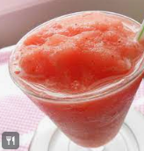

The covered in cream

If snow is falling to the ground.

To spread sugar

To take a bite.

You cannot help but take a bite.

You are smashing it!!  
"你太厉害了！""You're doing great!!"

## Winter is the King of showmen

Winter is often referred to as the "king of showmen" because it transforms the landscape into a magical wonderland through its snowfall and frost. The imagery in the poem highlights how winter turns ordinary scenes into extraordinary ones, such as tree stumps becoming snowmen and houses resembling birthday cakes. Winter covers everything in a smooth, clean, and frosty white, making the world appear **enchanting and delightful**. (冬天覆盖了一切，给世界披上了一层光滑、清洁和霜白色的外衣，使世界看起来迷人而愉悦。)This transformation earns winter the title of the "king of showmen" because of its ability to create such **captivating scenes.(迷人的场景)**

**To create a visual visual delight for humans. / it delight us.**

## Powdery

Meaning:

(of [snow](https://dictionary.cambridge.org/dictionary/english/snow" \o "snow)) [loose](https://dictionary.cambridge.org/dictionary/english/loose" \o "loose) and [dry](https://dictionary.cambridge.org/dictionary/english/dry" \o "dry) and having not [yet](https://dictionary.cambridge.org/dictionary/english/yet" \o "yet) [started](https://dictionary.cambridge.org/dictionary/english/start" \o "started) to [melt](https://dictionary.cambridge.org/dictionary/english/melt" \o "melt)

Example:

The [snow](https://dictionary.cambridge.org/dictionary/english/snow" \o "snow) was [fresh](https://dictionary.cambridge.org/dictionary/english/fresh" \o "fresh) and powdery.雪是新鲜的、粉状的。

# February 4th, 2024

<https://engoo.com/app/daily-news/article/i-beg-to-differ-how-to-disagree-politely-in-english/XKo_nr6FEe6J_0dO4V87rA>

## Out and about

Meaning:

active or doing things

Example:

I’m sorry, I missed your visit yesterday, I was out and about.

I'm out and about at the moment, but I can call you back when I get home.

## Praise

Meaning:

To show support or approval

Example:

We can't praise you enough for all of your hard work on the project.  
我们对您在该项目上所做的所有辛勤工作表示高度赞扬

## A praise sandwich

Meaning:

Connected to constructive criticism, a way to deliver feedback, a method to give feedback.

1.bread , praise/ 2. negative, filling / 3. bread praise

Example:

Put it that way

Meaning:

Example:

I wouldn’t put it that way / I wouldn’t express it in the same way.

# January 29,2024

# January 28,2024(1)

# January 28,2024(2)

# January 22,2024

# January 21,2024

# January 15,2024

# January 14,2024

# January 8,2024(1)

# January 8,2024(2)

# January 7,2024

# November 26th, 2023

https://www.dave-bailey.com/blog/nonviolent-communication

常见健身房练习的肌肉以及它们的中英文缩写和全拼：

胸肌 (Pectoralis Major)

缩写：Pec

肱二头肌 (Biceps Brachii)

缩写：Bicep

肱三头肌 (Triceps Brachii)

缩写：Tricep

肩部 (Deltoids)

缩写：Delts

背部 (Latissimus Dorsi)

缩写：Lats

大腿前侧肌群 (Quadriceps)

缩写：Quads

臀部 (Gluteus Maximus)

缩写：Glutes

小腿后侧肌群 (Hamstrings)

缩写：Hams

腹肌 (Rectus Abdominis)

缩写：Abs

腹横肌 (Transverse Abdominis)

缩写：TVA

描述锻炼后的酸痛感或紧绷感可以使用以下词汇和短语：

酸痛感 (Soreness): Muscular soreness or discomfort felt after exercising.

酸痛 (Ache): A dull or persistent pain often associated with exertion or strain.

紧绷感 (Tightness): Feeling tense or taut in muscles due to exercise.

酸软 (Tenderness): Feeling sensitive or sore when pressure is applied to muscles.

肌肉紧绷 (Muscle Tightness): Sensation of muscles being taut or stretched.

## Sloppy

* Meaning:

"Sloppy" describes something that is untidy, careless, or poorly done. It suggests a lack of attention to detail or a general lack of neatness and precision.

* Example:

"The report was filled with sloppy mistakes and typos."

"She received a sloppy presentation that lacked structure and coherence."

"He did a sloppy job of painting the room; there were paint spills everywhere."

## raw information

the basics of what you have witnessed , before making a judgment of what it implies

* Meaning:

"Raw information" refers to data or facts that have not been processed, analyzed, or organized in any specific way. It's **unprocessed** or unrefined data that may require interpretation or manipulation to be useful.

* Example:

"The survey collected raw information from participants that needs to be analyzed for meaningful patterns."

"The company received raw information from the market research, which needs to be sorted before drawing conclusions."

"The raw information provided by the sensors requires further processing to extract useful insights."

Observation:you ate 2 slices of cake

Evaluation:you are so greedy!

we are assuming

## Assumption / assume

* Meaning:

"Assume" means to take something for granted or to suppose something to be true without verifying it, often based on speculation or without concrete evidence.

* Example:

"I assume she'll be here by noon, but I haven't received confirmation."

"Don't just assume that everything will work out; let's double-check."

"He assumed the package had arrived, but it hadn't been delivered yet."

## Be hardwired to(naturally, involuntarily, without concious thought)

* Meaning:

"Be hardwired to" refers to an innate or deeply ingrained characteristic or behavior that is instinctive, automatic, or natural to a person or a living being. It suggests that something is an inherent part of someone's nature or is deeply embedded in their habits or traits.

* Example:

"Human beings are hardwired to seek social connections and interactions."

"Instinctively protecting one's offspring is hardwired into many animal species."

"She's hardwired to react defensively when criticized; it's just her nature."

**Our brains are hardwired to take raw information and instantly make up a simple story — good or bad, right or wrong, hero or villain**.

## Jerk away

* Meaning:

"Jerk away" typically refers to making a sudden, quick movement away from something or someone. It implies a sudden and often involuntary action to move oneself quickly away from a situation or a person.

* Example:

"She jerked away from his touch, feeling uncomfortable."

"The dog jerked away when I tried to put the leash on."

"He jerked away from the edge of the cliff when he realized how close he was."

## stereotype

a stereotype/ a generalisation or assumtion

* Meaning:

A "stereotype" refers to a widely held and oversimplified belief or idea about a particular group of people, often based on assumptions, generalizations, or misconceptions rather than individual differences or realities.

* Example:

The stereotype that all scientists are socially awkward is not accurate."

"Gender stereotypes suggest that certain jobs are more suitable for men or women."

"Racial stereotypes can perpetuate harmful biases and discrimination in society."

## Perpetuate(使持续)

* Meaning:

"To perpetuate" means to continue or prolong something, often a situation, a belief, a tradition, or a cycle, typically in a way that sustains its existence, sometimes without improvement or change.

* Example:

"The misinformation continues to perpetuate due to social media."

"By reinforcing these stereotypes, we perpetuate discrimination."

"The lack of education perpetuates poverty in many communities."

## the benefit of the doubt

To give someone the benefit of the doubt

more acceptable/ more tolerant/ more understanding

* Meaning:

"The benefit of the doubt" refers to a generous assumption or belief that someone is innocent or has good intentions, even though there might be doubts or uncertainties about their actions or behavior.

* Example:

"Although she was late, I gave her the benefit of the doubt and assumed there was a good reason."

"I'll give him the benefit of the doubt until I have more information."

"Sometimes it's important to offer the benefit of the doubt before jumping to conclusions."

## Resent(不满)

* Meaning:

"Resent" means to feel bitterness, anger, or indignation toward someone or something, often as a result of perceived unfair treatment, offense, or mistreatment.

* Example:

"She resented being overlooked for the promotion."

"He resented his friend's constant criticisms."

"They resent the new rules imposed by the management."

## our memories play tricks on us

* Meaning:

"Our memories play tricks on us" means that our recollections or remembrances can sometimes be unreliable, inaccurate, or deceptive, leading us to remember things differently than how they actually occurred.

* Example:

"I could have sworn I left my keys on the table, but it turns out they were in my bag. Our memories play tricks on us sometimes."

"When retelling the story years later, our memories can play tricks on us, and details might change."

"Due to the passage of time, memories can play tricks on us, making events seem different than they were."

# November 25th, 2023

[dave-bailey.com/blog/nonviolent-communication](https://www.dave-bailey.com/blog/nonviolent-communication" \t "https://www.cambly.com/en/student/_blank)

It is easy to forget

Use it or lose it

* Meaning:

"Use it or lose it" means that if you don't make use of something or exercise a skill, you might lose the ability to do so in the future due to lack of practice or opportunity.

* Example:

"If you don't practice speaking a language, it's 'use it or lose it'—you might forget it over time." "Regular exercise is essential; it's a case of 'use it or lose it' when it comes to physical fitness." "When it comes to maintaining flexibility, it's a matter of 'use it or lose it' as we age."

The clothes haven’t been hung up.衣服还没有挂起来

i am always the one who hangs up the clothes!!!

you never hang up the clothes!!

i feel you don’t care about me

i feel forgotton about

i feel upset

## Bewildered

* Meaning:

"Bewildered" describes a state of confusion, puzzlement, or feeling lost and uncertain due to being perplexed or bewildered by something unexpected or confusing.

* Example:

"She looked around the unfamiliar surroundings, feeling bewildered."

"After hearing the complex instructions, he appeared bewildered and unsure where to begin." "The sudden change in plans left everyone bewildered and unsure of what to do next."

## Venting emotions

* Meaning:

"Venting emotions" refers to expressing or releasing one's feelings, usually by talking about them openly or letting out feelings of frustration, anger, or stress.

* Example:

"After a long day, she felt better after venting her emotions to her friend."

"It's healthy to find ways of venting emotions rather than keeping them bottled up." "He often goes for a run as a way of venting his emotions."

## Project your anger onto me

* Meaning:

"Project your anger onto me" means to attribute or transfer one's anger, frustration, or emotions onto another person, often without valid reason, by blaming or directing that emotion toward them.

* Example:

"Please don't project your anger onto me; I'm not responsible for what happened." "I understand you're upset, but it's not fair to project your anger onto others."

"He tends to project his frustrations onto his coworkers when he's stressed."

Project your rage onto me

## validation of someones emotions

* Meaning:

"Validation of someone's emotions" refers to acknowledging, accepting, and recognizing the feelings and experiences of another person as legitimate and real. It involves showing understanding, empathy, and support for how someone feels without judgment or criticism.

* Example:

"She provided validation of his emotions by listening and empathizing with his concerns." "Validating someone's emotions can help them feel understood and accepted."

"It's important to offer validation of your partner's emotions during difficult times."

i appreciate you are angry right now but i am here to help you please don’t project your rage onto me

i understand you are upset right now...  
  
i appreciate you are feeling..... right now  
  
i can see that you are .... right now  
  
you are angry with my behaviour

I’m sorry if you feel i don’t care about you

you can express your need to me and we can discuss it

to take turns

we can work it out/ figure it out together

## Make an agreement

* Meaning:   
  "To make an agreement" means to reach a mutual understanding or a formal arrangement between two or more parties regarding a specific matter or issue. It involves coming to terms, reaching a consensus, or settling on terms that all parties involved agree upon.
* Example:

"The two companies made an agreement to collaborate on the new project."

"After negotiating for hours, they finally made an agreement on the terms of the contract."

"It's important to ensure clarity and mutual consent when making an agreement."

达成协议时确保清晰度和双方同意很重要

## neutralising language

soothing phrases  
"Everything will be alright."

"Take a deep breath; you're doing great."

"I'm here for you whenever you need."

"It's okay to feel this way; you're not alone."

"You're stronger than you think."

"This too shall pass."

"I believe in you."

"Remember to take care of yourself."

"You're doing the best you can, and that's enough."

"I'm listening if you want to talk."

# November 20th, 2023

[dave-bailey.com/blog/nonviolent-communication](https://www.dave-bailey.com/blog/nonviolent-communication" \t "https://www.cambly.com/en/student/_blank)

A side effect(of this subject)

* if we are too empathtic, spend too much time being empathetic we can waste time or lose our focus/ a side effect
* Being direct
* empathy can inhibit direct speech.

Balance of empathy and the purpose of the conversation

## Side-effect

* Meaning:

The term "side effect" refers to an unintended or secondary consequence that occurs as a result of a specific action, typically associated with medication, treatment, or an intervention. These effects are additional to the primary or intended effect and can be both positive or negative.

An action caused that was not the intended purpose

* Example:

1. Medication: Nausea, dizziness, or headaches can be side effects of certain medications.
2. Vaccines: Soreness at the injection site or mild fever are common side effects of some vaccines.
3. Technology: A side effect of installing new software might be increased battery usage on a device.
4. Environmental Changes: Introducing a new species to an ecosystem might have unforeseen side effects on other species.
5. Economics: A policy aimed at reducing inflation might have the side effect of increasing unemployment.

Digress

* Meaning:

"To digress" means to stray away from the main topic or point of discussion, often by talking or thinking about something unrelated. It involves temporarily moving away from the central subject or deviating from the original focus.

* Example:

"Sorry to digress, but I wanted to share a quick story related to what we were discussing."

"Let's not digress too much from our main goal for this meeting."

"His tendency to digress during conversations made it challenging to stay focused on the main issue."  
  
i founded this company in 1979

i am in the driver’s seat when it comes to my career

## To be in the driver’s seat

* Meaning:

"To be in the driver's seat" is an idiom that means to be in control or in charge of a situation. It refers to having the authority, power, or responsibility to make decisions and direct the course of events.

* Example:

"After the restructuring, she found herself in the driver's seat, leading the new team." "Taking charge of the project put him in the driver's seat for its success." "Having years of experience in the field, she felt comfortable being in the driver's seat during negotiations."

i am happy to help you with the seating, but i will take a passenger seat on the food because i am not a good cook.

## To be in the passsenger’s seat

* Meaning:

"To be in the passenger’s seat" typically means being in a position where one is not in control or leading a situation. It often suggests being in a supportive or secondary role, letting someone else take the lead or make the decisions.

* Example:

"During the planning phase, she preferred to be in the passenger’s seat and support her colleague's ideas."

"After the management change, he found himself in the passenger’s seat, supporting the new director's decisions."

"In this project, I'm happy to be in the passenger’s seat and assist wherever I can."

i hear you are in the drivers seat for this new robotics project!!

the needs of the business will be 2nd or 3rd in priority rather than 1st if we don’t apply

Self-empathy.如果我们不运用自我同理心，企业需求将不会是第一优先，而可能排在第二或第三位。

# November 19th, 2023

<https://www.dave-bailey.com/blog/nonviolent-communication>

How to use Nonviolent Communication(NVC)

## increase the odds(to increase the possibility)

* Meaning:

"To increase the odds" means to improve the likelihood or probability of a favorable outcome or success in a particular situation.

* Example:

"Regular exercise and a balanced diet can increase the odds of leading a healthy life." "Studying hard can increase the odds of getting good grades."

"Making wise investments can increase the odds of financial stability."

When i lose my temper, i can say something hurtful to people around me, but one hour later, my words are not good, i feel regretful.

-->

"When I lose my temper, I tend to say hurtful things to those around me. However, after about an hour, I regret my words as they're not constructive or kind."

## To be conscious of our words

* Meaning:

"To be conscious of our words" means to be mindful and aware of the words we use when speaking, considering their impact on others and the potential consequences.

* Example:

"It's important to be conscious of our words, as they can greatly affect how others feel."

"She's always conscious of her words, making sure not to hurt anyone's feelings."

"As a leader, being conscious of your words is crucial in setting a positive tone for the team."

## To amplify our consciousness

* Meaning:

"To amplify our consciousness" suggests intensifying or increasing our awareness, understanding, or mindfulness about a particular subject, situation, or aspect of life.

* Example:

"Mindfulness meditation can help amplify our consciousness and enhance our focus on the present moment."

"Reading diverse perspectives can amplify our consciousness about social issues."

"Traveling to new cultures often amplifies our consciousness and broadens our worldview."

# November 13th, 2023

slow warm up

a little bit awkward

uncomfortable silences

Grapefruit

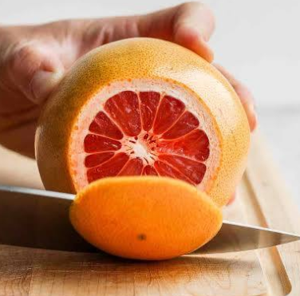

Pomelo

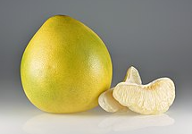

you have a special affection for her你对她有特殊的感情

cotton tree

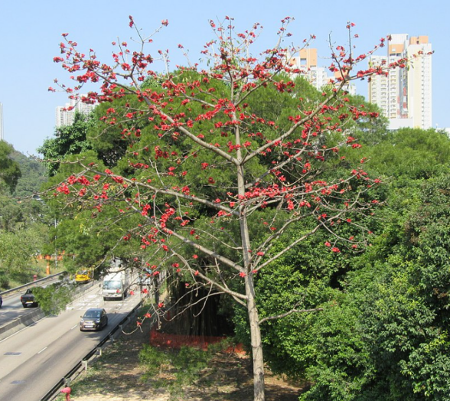

it takes time and nurture to make the tree grow strong  
"要使树木茁壮成长需要时间和精心呵护。"

an oak tree is strong and resilient

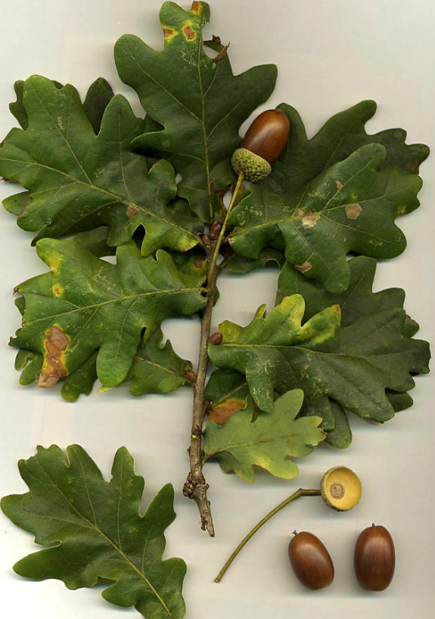

# November 6th, 2023

## Put it to one side

* Meaning:

"Put it to one side" means to set something aside or temporarily keep it away from the main focus or attention. It implies not dealing with something immediately and instead placing it aside for later consideration or action.

* Example:

"I'll put this project to one side for now and focus on more urgent tasks."

"Let's put our differences to one side and work together on solving this issue."

"She decided to put her worries to one side and enjoy the evening with her friends."

What is the purpose or meaning of this TV show?

## Build its nest

It's fascinating to watch how meticulously they build their nests to ensure safety for their offspring."

To be aware

* Meaning:

"To be aware" means to have knowledge or consciousness about something, to be mindful or cognizant of a particular fact, situation, or detail.

* Example:

"It's crucial to be aware of the potential risks before making a decision."

"She wasn't aware of the changes in the schedule, so she missed the meeting."

"Being aware of cultural differences helps in creating a more inclusive environment."

To raise awareness about animals

## To raise awareness about

* Meaning:   
  "To raise awareness about" means to increase knowledge, understanding, or consciousness regarding a particular issue, cause, or topic among a group of people or within a community.
* Example:

"The organization aims to raise awareness about climate change through educational campaigns." "She volunteered to raise awareness about mental health in schools."

"The event was organized to raise awareness about the importance of wildlife conservation."

a babyish face一张稚气的脸

gentle eyes

What is the texture of fur?

Soft

fluffy蓬松的

The animal with the big horn --> hippo / hippopotamus

## Berate

* Meaning:

"To berate" means to scold or criticize someone strongly and angrily. It involves harshly reprimanding or expressing disapproval towards someone for their actions or behavior.

* Example:

"She berated her employees for their constant tardiness."

"He was berated by his parents for not completing his chores."

"The coach berated the team for their lack of effort during the game."

a mother is berating her kid

## Telling her kid off

* Meaning:

"Telling her kid off" means scolding or reprimanding a child, often in a stern or disapproving manner, due to misbehavior or disobedience.

* Example:

"She was seen telling her kid off for not finishing homework on time."

"He regretted telling his kid off for breaking the vase, realizing it was an accident."

"After the incident, she spent some time explaining rather than just telling her kid off."

# November 5th, 2023

itinerary

a favourite that she would like to revisit

to revisit/ to go again

the first thing she does

i checked the online reviews

it will take 7 hours to get there.

i have booked **a return ticket**.

what gift should i take/ bring her?

Making preparations for the lessons makes her anxious.

her hard work is paying off.

## Pay off

**Financial:**

Meaning: To completely repay a debt or loan.

Example: "She finally paid off her mortgage after years of payments."

**Success or Achievement:**

Meaning: To yield positive results or benefits after effort or investment.

Example: "His hard work in the company for years paid off when he was promoted to manager."

**To Bribe:**

Meaning: To give money or a bribe to someone in exchange for something, often illegal or unethical.

Example: "The corrupt businessman tried to pay off the officials to avoid penalties."

What she is doing is worthwhile.

A flower oil / essential oil

Rose essential oil

lavender essential oil

I need to redo it

## Redo

* Meaning:

"Redo" means to do something again or to repeat a task that has been done previously, often to improve it or to correct mistakes from the first attempt.

* Example:

"After receiving feedback, she decided to redo her essay to make it stronger."

"The team had to redo the experiment due to errors in the initial procedure."

"The architect had to redo the design after it was rejected by the client."

sometimes they are absent

sometimes they are not available

## he is settling in well

* Meaning:

"He is settling in well" means that someone is adjusting comfortably or adapting successfully to a new environment, situation, or place.

* Example:

"After moving to the new city, she is settling in well and making new friends."

"The new employee is settling in well; he seems to be getting along with the team."

"Despite initial concerns, the children are settling in well at their new school."

i think you left a review on my teacher profile, it said ‘lovely’

## BnB/ bed and breakfast/ a small family run hotel

My mother ran a BnB

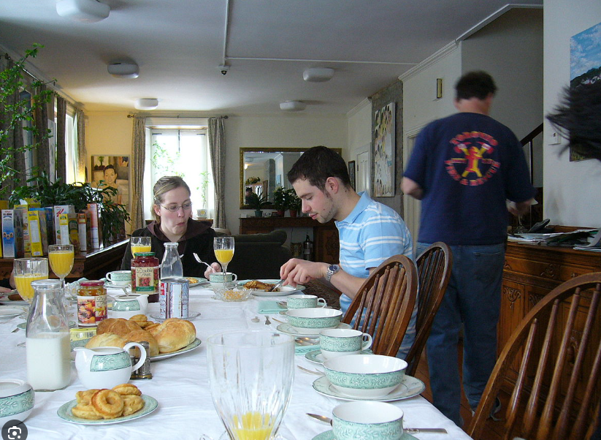

safari/ the name of a type of holiday where you usually travel in a car to see wild animals

rhinoceros

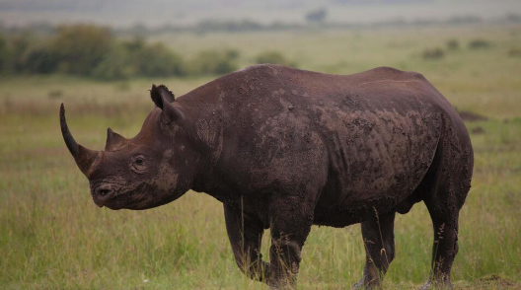

October 30th, 2023

we have a new dog

a stray dog

## Pick up

i need to pick up my dry cleaning from the laundromat/ laundry我需要从自助洗衣店/洗衣店取干洗的衣服

i need to pick up my keys to my new apartment我需要领取新公寓的钥匙

i need to pick up my parcel from the post office.取包裹

Increases and decreases

Before Christmas the amount of shoppers in the high street picks up. But after new year the number of shoppers drops off.

the company profits began to pick up

To lift or grab something: It can mean physically lifting or taking hold of something.

"Please pick up those books from the floor."

To learn or acquire something: It can mean to grasp or understand something, often a skill or knowledge.

"I'm trying to pick up Spanish before my trip to Spain."

To improve or increase: It can indicate a rise or enhancement in something.

"Sales are expected to pick up after the marketing campaign."

To answer or receive a phone call: It refers to responding to an incoming call.

"Could you pick up the phone, please?"

## Drop off

my mum drove me to school and then dropped me off-->>my mum dropped me off at school

i dropped my father off at the airport

i decided to drop off my mac book at the repair shop

can you go to the grocery store to get some bread

Since streaming began, tv audiences have dropped off gradually every year.

there are many alternatives to TV these days

they are more handy (useful)

I have a handful of yarn.

i dropped off infront of the telly/ i fell asleep

i will drop off infront of a boring movie

my grandma always drops off sitting in her chair

①To deliver or deposit something or someone at a specific location:

"I need to drop off this package at the post office."

"Can you drop me off at the station on your way?"

②To decrease or decline in quantity or quality:

"Sales tend to drop off during the winter season."

"The quality of their products has dropped off recently."

③To fall asleep quickly or suddenly:

"After a long day, he tends to drop off as soon as he hits the bed."

④To let someone out of a vehicle:

"I'll drop you off here; it's closer to your house."

[engoo.com/app/daily-news/article/2023-comedy-wildlife-photography-finalists-announced/nTVyhmfIEe6HBq9d-VNasw](https://engoo.com/app/daily-news/article/2023-comedy-wildlife-photography-finalists-announced/nTVyhmfIEe6HBq9d-VNasw" \t "https://www.cambly.com/en/student/_blank)

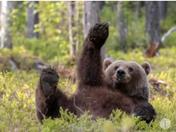

Follow in (someone’s) footsteps

Meaning:

to do the same as another person did before

Example:

Jane followed in her mother's footsteps and became a doctor.

a circular tube一根圆管

## Amateur

Meaning:

doing something or being done without payment

"Amateur" refers to someone who engages in a particular activity, sport, or field of study for pleasure or as a hobby rather than as a professional or expert.

Example:

"He's an amateur photographer, but his pictures are quite impressive."

"She plays the piano as an amateur, enjoying it in her free time."

"The team consists of amateur athletes who compete for fun rather than for a living."

i am an amateur baker.

# October 29th, 2023

cabin fever

a phrase that means to feel a little crazy because you are stuck indoors

Meaning:

"Cabin fever" describes the feeling of being restless or irritable due to being confined or isolated for an extended period, often indoors or in a remote location.

Example:

"After several days of heavy snow, we started to experience cabin fever."

"The isolation during the lockdown led to cabin fever for many people."

"Being stuck on the cruise ship for a week caused a severe case of cabin fever among the passengers."

Quite precise相当精确

[Steamed Eggs](https://www.madewithlau.com/recipes/steamed-egg)



poached eggs



That satisfied me

you have to be a detective to solve the problem

detective

Meaning:

A detective is an investigator, often a member of a law enforcement agency, whose job is to gather information, examine evidence, and solve crimes.

Example:

"The detective carefully examined the crime scene for clues."

"She works as a detective, specializing in solving cold cases."

"The detective questioned witnesses to gather information about the incident."

what is causing the problem

Meaning:

Determining the cause of the problem often involves investigation, analysis, or examination of the circumstances or factors involved. It can vary greatly depending on the specific issue at hand, ranging from technical malfunctions to complex interpersonal matters.

Example:

"We're conducting tests to identify what's causing the computer to malfunction."

"The team is investigating what is causing the drop in sales."

"We need to understand what is causing the conflict between the two departments."

i had a restless night不安宁的

restless不安宁的

Meaning:

Restless describes a state of being unable to stay still or relax due to agitation, boredom, or a lack of contentment. It often involves a feeling of wanting change or activity.

Example:

"After being indoors all day, the kids were getting restless and wanted to play outside."

"She felt restless in her job and was considering a career change."

"He had a restless night, unable to sleep due to worry and anxiety."

what was your confession?

I asked her out

we met when we were undergraduates

i want to show my sincerity

i want to show her i am serious

do you have some things in common?

she is an intern(实习生) to gain practical work experience.

butterflies in my tummy/ stomach

Meaning:   
"蝴蝶在肚子里飞舞"这个表达形象地描述了因为紧张、兴奋或焦虑而感到不安的情绪。这种感觉常常出现在重要场合或特殊时刻前，让人感到紧张或激动。

Example：

"Every time before a presentation, I feel butterflies in my tummy." "She felt butterflies in her tummy right before the big exam." "Meeting my favorite singer made me have butterflies in my tummy."

always ask her questions about herself

be attentive and interested

girls always like guys that make them laugh

not contrived

Don’t try too hard

Meaning:

"Don't try too hard" means not to exert excessive effort or go to extremes while attempting to do something. It suggests that pushing too much might lead to unnecessary stress, and advises a more relaxed or natural approach.

Example：

"Relax and be yourself during the interview. Don't try too hard to impress."

"He's trying so hard to fit in that it's becoming awkward. Someone should tell him not to try too hard."

"She's talented; she doesn't need to try too hard to succeed."

genuine relaxed conversation

# October 22th, 2023

<https://printdiscuss.com/zero-conditional-conversation-questions/>

Spooky

Something spooky happened to me today!!

That house is spooky!!

Meaning:

"Spooky" describes something that is eerie, eerie, or unsettling, often associated with an uncanny or unsettling feeling, especially in relation to the supernatural or mysterious.

Example：

"The old abandoned house has a spooky atmosphere, especially at night."

"Her story about the haunted forest gave me a spooky feeling."

"The sudden sound in the dark alley was quite spooky."

make a fuss

to make a big deal/ to over-react about something

my mum made such a fuss about the mess in my bedroom!

My boss made a real fuss when i turned up to work 2 minutes late!

we all made a fuss about it

made a fuss over him

fuss can be a positive reaction and a negative reaction

Meaning:

"To make a fuss" means to react or express concern, excitement, or anger about something, often in an exaggerated or unnecessary way. It involves making a big deal out of a situation, sometimes causing unnecessary attention or drama.

Example：

"She made a fuss about the minor mistake, demanding immediate correction."

"Don't make a fuss; it's just a small scratch on the car."

"He made a fuss over the surprise party, grateful for the effort put into it."

i asked a lad the way to the post office

the lass in the supermarket gave me a coupon

to be well off/ to be lucky or to be rich (or both!!)

To be well off

Meaning:

"To be well off" means to have a comfortable or satisfactory financial situation, usually with enough money or resources to live comfortably and meet one's needs without significant financial worries.

Example：

"Despite not being wealthy, they are well off and can afford their expenses."

"After years of hard work, she became well off and could afford a luxurious lifestyle."

"Living within their means, they managed to become well off over time."

[printdiscuss.com/zero-conditional-conversation-questions](https://printdiscuss.com/zero-conditional-conversation-questions/" \t "https://www.cambly.com/en/student/_blank)

what are the consequences of something.

What happens if.....?

i havent experienced this but...

he must do well at his work

maybe he has lost his appetite

i feel very grumpy

Grumpy

Meaning:

"Grumpy" describes a mood or behavior characterized by irritability, complaining, or being easily annoyed. Someone who is grumpy might be in a bad mood and tend to express dissatisfaction or discontent.

Example：

"He's always grumpy in the morning until he has his coffee."

"Don't mind her; she's a bit grumpy today due to lack of sleep."

"The boss was unusually grumpy during the meeting, snapping at everyone.(对每个人大吼大叫)"

i am easily distracted

i lose my patience

it messes with my mind

Mess with

Meaning:

"Mess with" is an informal expression meaning to bother, interfere with, or provoke someone or something.

Example：

"I wouldn't mess with him when he's in a bad mood."

"Don't mess with the settings on the computer if you're not sure."

"She warned her friends not to mess with her belongings."

the cold stimulates sensitivity in my teeth

i get ice-cream head

eating something cold makes your head hurt a little bit/ ice-cream head

ice-cream head

Does it feel good in your tummy when you eat something cold?

Tummy / belly / stomach

Tired / snoozy

Freezing / cold / chilly

Chilly 形容天气冷，稍微有点寒冷的意思

Cold: "The cold weather forced us to wear heavy coats."

Freezing: "Last night was freezing, and frost covered the ground."

Chilly: "It's a bit chilly outside, so don't forget your jacket."

Icy: "The roads became icy after the snowstorm, making driving difficult."

Nippy: "The morning air was quite nippy, so I decided to grab a warm sweater."

Brisk: "The brisk wind made the day feel colder than it was."

Like a volcano

Like a dragon breathing fire

It makes my tongue tingle

Tingle(哆嗦)

Meaning:

The word "tingle" refers to a slight prickling or stinging sensation, often associated with a mild form of pins and needles or a pleasant, slightly sharp feeling.

Example：

"After applying the lotion, I felt a tingle on my skin."

"When I held the cold drink, I experienced a tingle in my fingers."

"As the circulation returned, his foot began to tingle."

What other foods make your tongue tingle?

Sour plums.酸梅

# October 21th, 2023

He smelt a deer and chased it.

he smelt a deer in the woods and ran after it

[s3.us-west-1.wasabisys.com/luminist/EB/A/Aickman_ed - Fontana Book of Great Ghost Stories 1.pdf](https://s3.us-west-1.wasabisys.com/luminist/EB/A/Aickman_ed - Fontana Book of Great Ghost Stories 1.pdf" \t "https://www.cambly.com/en/student/_blank)

page 31

It’s loading

It’s a short story.

i bake pumkin pie

Trick or treat

They wear fancy dress

## fancy dress

Meaning:

"Fancy dress" typically refers to wearing elaborate or decorative clothing for a special occasion, event, or costume party. It often involves wearing costumes or attire that is unusual, colorful, or eye-catching.

Example：

"She wore a fancy dress to the masquerade ball."

"The invitation stated 'Fancy dress encouraged' for the Halloween party."

"Everyone showed up in fancy dress for the themed event."

The elders长辈

an inn/ a pub or place to rent accommodation

the features of the village have formed or shaped the way the villagers think/ it has influenced them.

I was eager to swim everyday.

Noise-ridden

Meaning:

"Noise-ridden" 意味着充斥着噪音的，指某个地方或环境非常嘈杂或充满各种噪音。

Example：

"The downtown area was noise-ridden, with cars honking and people chatting loudly."

"Living near the airport, their house was noise-ridden due to the constant sound of planes."

"The festival became noise-ridden with music blaring from every corner."

## to be ridden with something/ to be full of

i am ridden with the flu我患了流感

i am very poorly with the flu

Meaning:

"To be ridden with something" means to be filled or burdened with a particular thing, typically something negative or unwanted.

Example：

"The old building was ridden with structural issues."

"His mind was ridden with doubts about the decision he had made."

"The town was ridden with crime, causing concern among the residents."

Rustics / rural people乡村人/农村人

rustic/ to be simple and a little rough

Meaning:

"Rustic" describes something that is simple, rural, or characteristic of the countryside. It often refers to a charmingly simple or unsophisticated quality.

Example：

"The cabin had a rustic charm with its wooden beams and simple furnishings.""那间小屋以其木梁和简朴的家具散发出乡村魅力。"

"She decorated her home in a rustic style, using natural materials and earthy colors." "她用自然材料和土色调装饰了她的家，呈现出了乡村风格。"

"The small, rustic village was known for its peaceful way of life.""这个小而朴素的村庄以其宁静的生活方式而闻名。

## to bruise/ to be bruised/ to be hurt with a blue/purple mark

Meaning:

"to bruise" 意思是皮肤或组织受伤后出现青肿或瘀伤。

Example：

"I accidentally bruised my arm on the edge of the table."

"She bruised her knee when she fell off her bike."

"The fruit bruised easily when handled roughly."

Bruise

Meaning:

"Bruise" 意思是皮肤或组织受伤后出现的青肿或瘀伤。

Example：

"She fell and got a bruise on her knee."

"He had a bruise on his arm from bumping into the table." "The boxer had a few bruises on his face after the match."

to have trauma/ to be hurt/ ptsd

a chap/ a man, a guy, a fella

a little chap/ a young man

a gallon/ a large amount一加仑/大量

## dull/ to be boring

Meaning:

"Dull"或者 "to be boring" 意味着缺乏刺激或兴趣，缺乏吸引力，不令人兴奋。

Example：

"The lecture was dull, and I struggled to stay awake."

"The movie was so boring that I fell asleep halfway through."

"The party turned out to be quite dull, with little entertainment."

Lads / boys

Lasses/girls

## take my word for it/ a phrase/ meaning/ trust me

Meaning:

"Take my word for it" 意为相信我的话，接受我的陈述或保证。

Example：

"You don't have to double-check, just take my word for it."

"I've been there before, and it's an amazing place, take my word for it."

"I can assure you it's safe; take my word for it."

broad daylight/ in the middle of the day

the well/ where people collect water

spirits/ ghosts

ghosts know when they are well off

## to be well off/ to be lucky

Meaning:

"To be well off" 意味着在经济上或物质上很富裕，拥有相对舒适的生活。

"To be lucky" 意味着拥有幸运或者走运，通常指在某种情况下得到了意外的好运气。

Example：

"He's well off financially, so he can afford to travel frequently."

"She considers herself lucky to have found such a wonderful job opportunity."

"Winning the lottery was a stroke of luck for him."

I know i am well off because i have a good job and lovely students.

My friends is very well off because he got a great job.

And one of the others is to become very well off.

Queer/strange

## Interfere/ meddle

the most common use of interfering/ a mother inlaw always interferes with the marriage of her son

to interfere/ to intrude on someone elses business

Meaning:

"Interfere"和"meddle"都表示干涉、干预或干扰别人的事情，通常指过度或不适当地干预他人的事务。

Example：

"Please don't interfere with my work; I know what I'm doing."

"He tends to meddle in other people's affairs, even when it's not his place to do so."

"She didn't want anyone meddling in her personal life."

An old guinea/an old coin

## The anvil / a black smiths tool

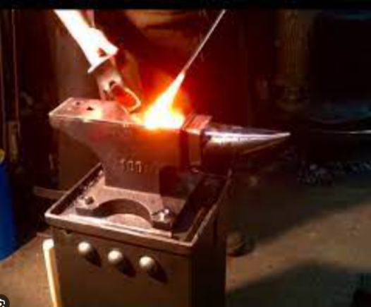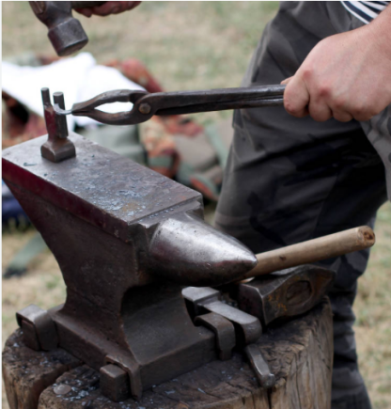

ghost hound/ the ghost of a dead dog

## A bad head / a headache

Meaning:

"Having a bad head" is a colloquial expression that typically refers to experiencing a headache or feeling unwell, especially related to a hangover after excessive alcohol consumption.

He asked them not to make any noise.

## Recap

can you give me a recap of the story so far in your own words....

Meaning:

"Recap" is a term used as an abbreviation for "recapitulation," indicating a summary or concise review of previously discussed or highlighted points, events, or information.

Example：

"After the meeting, the manager gave a quick recap of the decisions made."

"The news anchor provided a recap of the day's top stories."

"Before starting the next lesson, the teacher did a recap of the previous class material."

They can make amends.他们可以弥补

## Make amends

Meaning:

"Make amends" means to take actions or make efforts to repair or correct a mistake, wrongdoing, or harm that one has caused to someone else.

Example：

"After the argument, he apologized and tried to make amends by offering to help."

"She volunteered at the charity to make amends for missing the important event."

"He worked hard to make amends for his past errors by showing improved behavior."

They can correct their mistakes

# October 14th,15th 2023

what we will do for the next step.

to take a breather/ a phrase/ to relax.

we will go to a second hand market

people take their cars to a common field and sell second hand items from the boot of their car.

Boot of the car

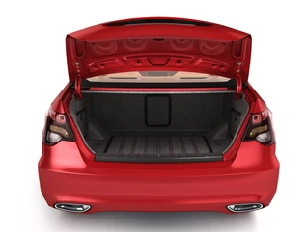

[engoo.com/app/daily-news/article/israel-declares-war-after-surprise-hamas-attack/iq9E5maPEe6zuJfOV0cnPQ](https://engoo.com/app/daily-news/article/israel-declares-war-after-surprise-hamas-attack/iq9E5maPEe6zuJfOV0cnPQ" \t "https://www.cambly.com/en/student/_blank)

A Barrage of

the man at the office gave the customer a barrage of abuse

i recieved a barrage of rude emails from the internet trolls

Meaning:

"A barrage of" refers to a large quantity or intense outpouring of something, often used to describe an overwhelming amount of information, criticism, questions, or actions directed at someone or something.

Example：

"She faced a barrage of questions from the reporters."

"After the announcement, he received a barrage of complaints from the customers."

"The internet was flooded with a barrage of opinions on the topic."

Prompt

prompt/ to be quick, rapid, punctual

in a reply email to someone you can say, thank you for your prompt reply

we should arrive at the theater promptly so we don’t miss the start of the show

to prompt someone/ to push them, or encourage them

i prompt you to give me examples

the protagonist/ the hero or main character

to abduct/ to kidnap

the competition between the tennis players intensified in the final game.

决赛中网球选手之间的竞争更加激烈。

The destruction of the environment intensified...

will be the champion/ winner

to intensify/ to become stronger

in the key stage , we need to do some intensified practice to gain a good score in the exam

intensified practice

Intensify

Meaning:

"Intensify" means to increase in degree or strength, to make something more intense, stronger, or more extreme.

Example：

"The storm is expected to intensify as it moves closer to the coast."

"The company decided to intensify their marketing efforts to reach a larger audience."

"The conflict in the region continued to intensify, causing concern among neighboring countries."

# Augest 20th, 2023

The Lion by Roald Dahl

The lion just adores to eat

 A lot of red and tender meat

And if you ask the lion what

 Is much the tenderest of the lot,

 He will not say a roast of lamb

Or curried beef or devilled ham

Or crispy pork or corned beef hash

Or sausages or mutton mash.

Then could it be a big plump hen?

He answers no. What is it, then?

Oh, lion dear, could I not make

You happy with a lovely steak?

Could I entice you from your lair

With rabbit pie or roasted hare?

The lion smiled and shook his head

He came up very close and said,

‘The meat I am about to chew

Is neither steak nor chops. IT’S YOU.’

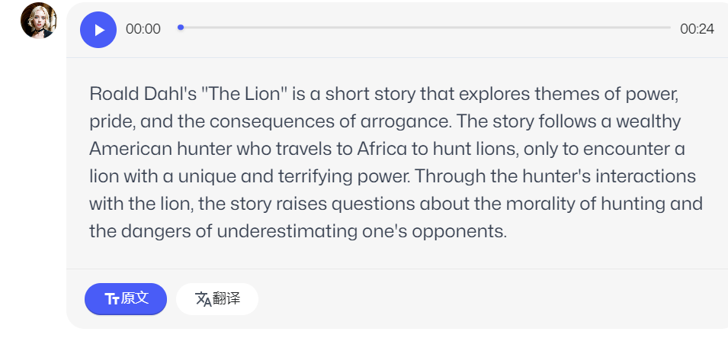

You can be bold.

tender / to be tender / to be soft and succulent.

this beef is very tender / to be soft and it melts in your mouth.

the tenderest / the most tender

of the lot / of it all

it is the tenderest of the lot / it is the most tender of all the meats

my favourite of the lot is push-ups

lamb and mutton

they are both sheep meat

lamb - baby young sheep

mutton - old sheep

roast lamb - 烤羊肉

what other types of cooking are there?

to roast - to bake / to cook something inside an oven.(to cook food in an oven or over a fire在烤箱或火上烹饪食物)

what are the different ways that you can cook an egg?

There are many ways to cook an egg, including boiling煮, frying煎, poaching水煮, scrambling炒, and baking烤. Each method produces a different texture and flavor, so it's worth experimenting to find your favorite!

you can boil an egg in boiling water.

you can steam an egg.

to poach = to crack the egg into very hot water.

poach - to cook something such as a fish, or an egg with its shell removed, by putting it in gently boiling water or other liquid.

-We had poached eggs for breakfast我们吃水煮蛋当早餐

to curry / curried / devilled / to be cooked with many spices.用许多香料烹饪

devilled - 烹饪术语，通常用来形容食物，尤其是肉类或蛋类

(maybe chili, cumin, coriander paprika, cardamom, pepper etc)也许是辣椒、小茴香、香菜、辣椒粉、小豆蔻、胡椒等

spice - a substance made from a plant, used to give special flavor to food.

Spices are widely used in South Asian cooking.

the devil / devilled / very hot, like hell

in Christian religion, the devil is the evil opposite of god. And he lives in a place called Hell which burns with fires.

when we ‘devil’ food , we make it burn by adding a lot of chili pepper.

it is a cultural name.

what are your favourite spices to curry food with?

Chili pepper.

辣椒炒肉

Stir-fried meat with Chili Pepper.

crispy - 用来形容食物或其他物体的质地，意为“脆的”或“酥脆的”

corned beef hash

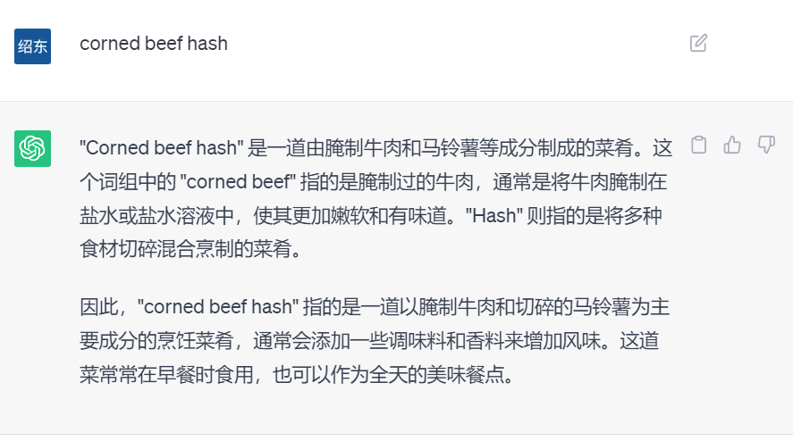

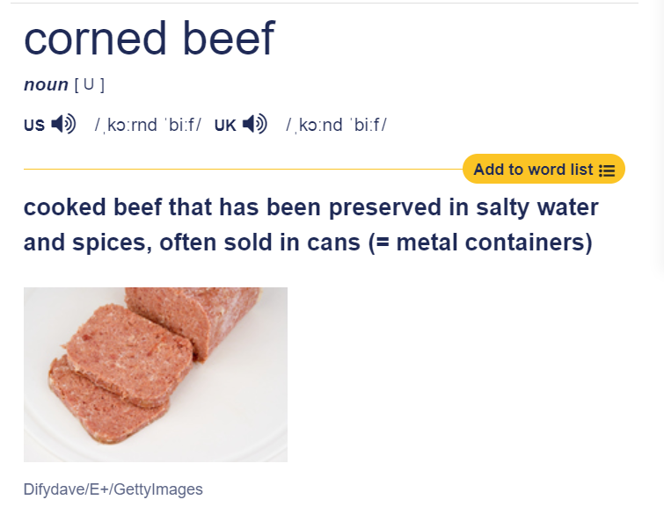

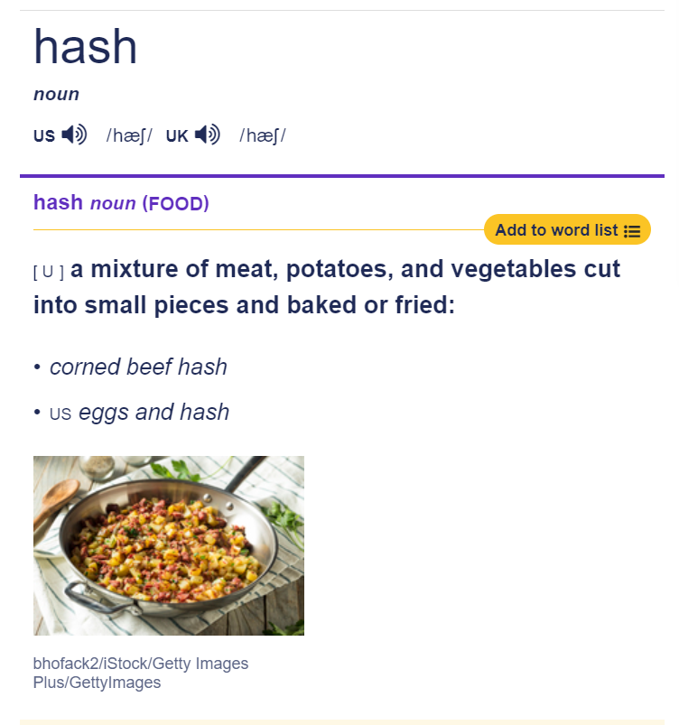

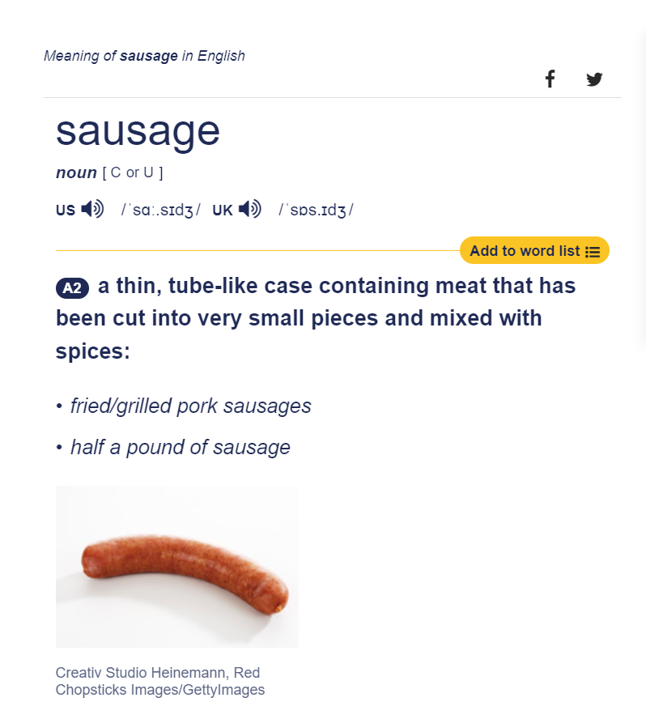

mash - to crush food, usually after cooking it, so that it forms a soft mass

Mash the potatoes and then mix in the butter and herbs.

将土豆捣碎，然后加入黄油和香草。

mutton mash

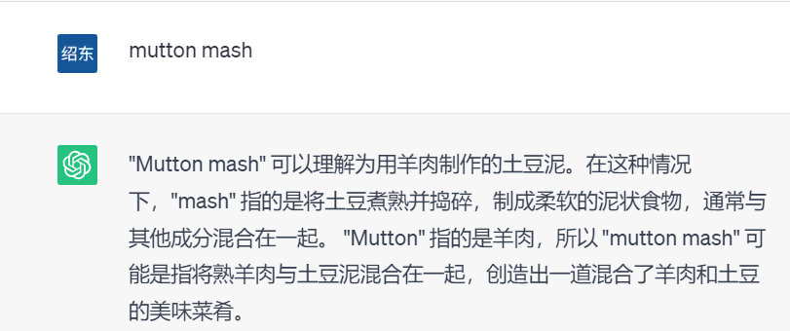

hen - an adult female chicken, often kept for its eggs母鸡

plump -  having a [pleasantly](https://dictionary.cambridge.org/us/dictionary/english/pleasantly) [soft](https://dictionary.cambridge.org/us/dictionary/english/soft), [rounded](https://dictionary.cambridge.org/us/dictionary/english/rounded) [body](https://dictionary.cambridge.org/us/dictionary/english/body) or [shape](https://dictionary.cambridge.org/us/dictionary/english/shape)

a nice plump chicken一只丰满的鸡

a lovely steak美味的牛排

lair 动物巢穴

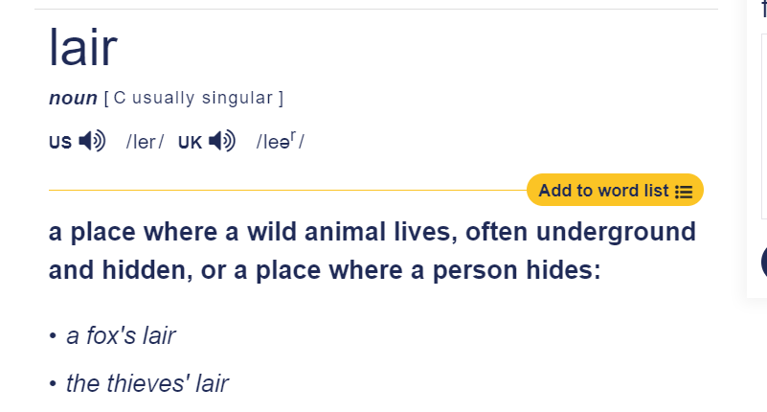

entice  - 吸引

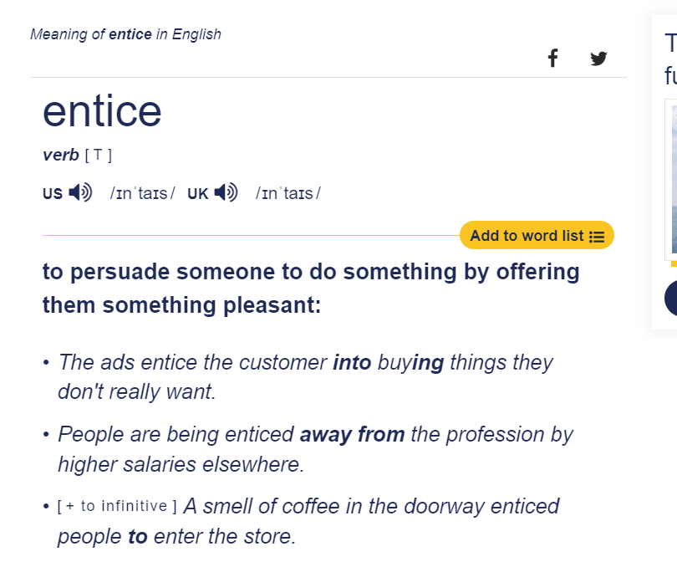

rabbit pie 兔子馅饼

hare 野兔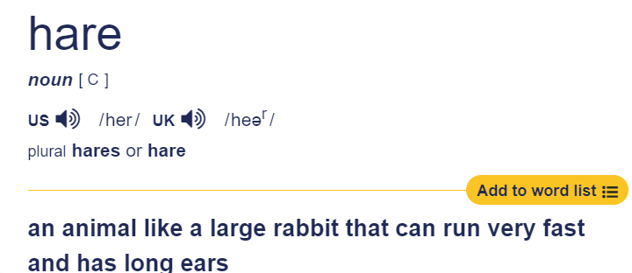

chop - 动作

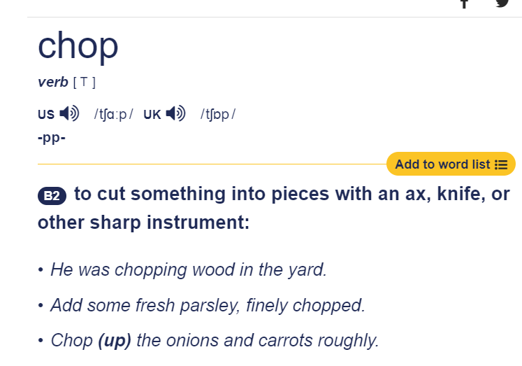

chop - 食物

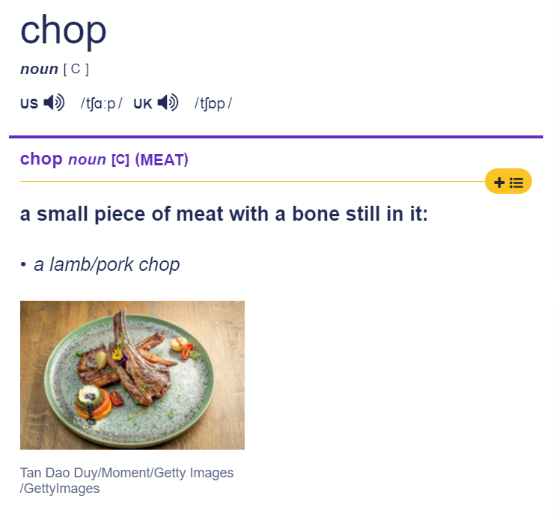

# August 13th, 2023

same old same old情况没有什么变化

[englishclub.com/esl-quizzes/vocabulary-3-phrasal-verbs.php](https://www.englishclub.com/esl-quizzes/vocabulary-3-phrasal-verbs.php)

make out - to claim, usually falsely, that something is true.

He made himself out to be a millionaire.他让人误以为自己是个百万富翁。

He made out like he was a perfect person.他装作自己是一个完美的人

She made me out to be a terrible person.

In the story the lead character was made out to be a hero.在故事中，主角被描述成了一个英雄。

to cover up

to destroy

these are the common usages for the phrasal verb ‘to make up’

to make up

to make it up to my boss, i need to work overtime。弥补，加班

to compensate for it, i need to work overtime.

make up - to invent something, such as an excuse or a story, often in order to deceive

I made up an excuse about having to take care of the kids.

make up - 化妆

the girl did her make up before going up女孩出门前化了妆

make up - to repair a relationship - to forgive someone and be friendly with them again after an argument or disagreement. - to reconcile

today they made up after they broke up yesterday.昨天分手后今天他们复合了。

do you think Bob and Jessica will make up after their argument yesterday?

I heard that Jessica made up a horrible stroy about Bob!

in the end , one of them always apologizes.

cover something up - to stop people discovering the truth about something bad.

The company tried to cover up its employment of illegal immigrants.

I think Bob has been covering up feelings for another person.我认为鲍勃一直在掩盖对另一个人的感情。

now we are gossiping!!!

Jessica had an intense argument with him.Jessica与他发生了激烈的争执

cheat on sb 表示在感情或婚姻关系中对某人不忠，出轨。

do you think Bob would cheat on Jessica?

I think it is a rumor.

heart to heart - a chat with honest emotion真诚的情感交谈

a heart to heart - is a chat where you discuss your feelings honestly.

I hope Bob and Jessica sit down and have a heart to heart.我希望鲍勃和杰西卡坐下来谈心

split up = break up - if a marriage breaks up or two people in romantic relationship break up, their marriage or their relationship ends.

she’s just broken up with her boyfriend.

amicably

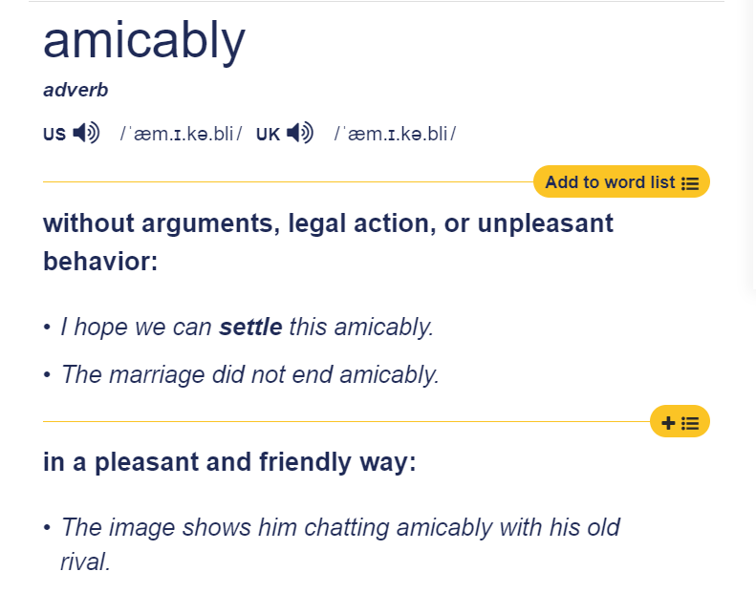

could they split up / break up amicably?他们可以友好地分手吗

to open up /  to speak freely

Bob needs to open up to Jessica about his true feelings.鲍勃需要向杰西卡坦白他的真实感受。

to look up to / to admire

I really look up to conservationists.我真的很尊敬自然资源保护主义者。

look up - to become better好转

Our financial situation is looking up at last.我们的财务状况终于好转了。

look up 抬头

i look up at the clouds.我抬头看云

look down

the weathy look down on the poor.有钱人看不起穷人。

# August 12th, 2023

an interview

embedded engineering

he feels i heed to practice public speaking a few more times.(practice makes perfect)

he feels i need to prepare what i am going to say in advance.

-to have it clear in your mind.

-failing to prepare is preparing to fail.预则立，不预则废

snap someone up

-to immediately offer someone a job or position because you want them very much.

She was snapped up by a large law firm.

somebody will snap you up!

phrasal verb quiz

[englishclub.com/vocabulary/phrasal-verbs-quiz.php](https://www.englishclub.com/vocabulary/phrasal-verbs-quiz.php)

run into  -to meet someone you know when you are not expecting to

bump into - to meet someone you know when you have not planned to meet him or her.

i ran into my neighbour.

i ran into my friend on the street.

run out of - to finish, use , or sell all of something, so that there is none left

pop down to - to make a quick visit to

pick up

cashier - the person serving in the supermarket.

i have run out of milk.Can you pop down to the supermarket and pick up some milk for me.

我的牛奶已经用完了。你能去超市帮我买点牛奶吗？

where do you keep the milk?

Can you show me where the milk is kept?

How much does the milk cost?

they will show you where the milk is.

i asked them what are you buying at the supermarket?

we chatted for a bit in the supermarket.我们在超时聊了一会儿

break down - if a machine or vehicle breaks down, it stops working.

Our car broke down and we had to push it off the road.我们的车坏了，我们不得不将它推离公路。

the washing machine broke down last week.

the car won’t start! The car won’t fire up! The car won’t turn over!这辆车无法启动

to broke off - to end a realationship

I broke off the relationship with my girlfriend yesterday!

to break a leg - good luck

# August 6th, 2023

[engoo.com/app/daily-news/article/a-sleepy-vacation-what-is-sleep-tourism/RHHB7CesEe65OJeNCXoyGQ](https://engoo.com/app/daily-news/article/a-sleepy-vacation-what-is-sleep-tourism/RHHB7CesEe65OJeNCXoyGQ)

an eye mask

my mind has gone blank

a herbal tea花茶

if i am anxious i will toss and turn, but generally i sleep like the dead.7

7 hours per night would be the optimum.

i prefer a feather pillow.我更喜欢羽绒枕头

a pillow stuffed with feathers / a feather pillow

some people prefer a memory foam pillow

memory foam / a type of material that remembers the shape of your head.

It moulds itself around you.

it is soothing / calming

serene

tranquil

maybe not so much money but a little.

didn’t have an affect on my sleep habits.

there are many factors / many variables.

what’s the weirdest / the strangest dream you ever had?

# July 30th, 2023

I recently watched an anime changed by history and i was hooked.

Tang dynasty 唐朝

ancestor 祖先

to be prosperous/  to be successful and wealthy

from boom to bust / from prosperity to decline / from riches to rages /  from rags to riches

stuttering 口吃

he has a stutter.

he is an average person. 他是一个普通人

because they are merchants, at that time, they had a low social status / standing.

merchants had low social status.

warriors 勇士

it goes in one ear and out the other. / idiom  它从一只耳朵进去，从另一只耳朵出去

the place was vibrant and prosperous.这个地方充满活力和繁荣

when they were 20 years old, the two men met each other.

what was the moral of the story?

the movie’s name is 长安三万里, we can divide the name into two part. one is changan which is the capital of Tangdynasty , we can understand it as the idea place in the poet’s mind at that time .another is 三万里，thirty throustand miles， the distance may  represent

the distance they have traveled to pursue their ideal

i can recite some poems.

he spends money like water / he splurges.

his brother kicked him out of the house / his brother threw him out

self-pity自怜

# July 29th, 2023

I don’t know the plot / the storyline我不知道剧情

she is laying down.

放松的形容词

calm

it is a very calming photo.

relaxed

serene([peaceful](https://dictionary.cambridge.org/us/dictionary/english/peaceful) and [calm](https://dictionary.cambridge.org/us/dictionary/english/calm), or (of a [person](https://dictionary.cambridge.org/us/dictionary/english/person)) not [worried](https://dictionary.cambridge.org/us/dictionary/english/worried) or [excited](https://dictionary.cambridge.org/us/dictionary/english/excite):)

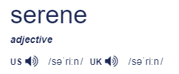

-> He approached the job with the serene confidence that he could succeed where others had failed.

she looks serene.

peace / peaceful

tranquil ([calm](https://dictionary.cambridge.org/us/dictionary/english/calm) and [peaceful](https://dictionary.cambridge.org/us/dictionary/english/peaceful) and without [noise](https://dictionary.cambridge.org/us/dictionary/english/noise), [violence](https://dictionary.cambridge.org/us/dictionary/english/violence), [worry](https://dictionary.cambridge.org/us/dictionary/english/worry), etc.:)

She [stared](https://dictionary.cambridge.org/us/dictionary/english/stare) at the tranquil [surface](https://dictionary.cambridge.org/us/dictionary/english/surface) of the [water](https://dictionary.cambridge.org/us/dictionary/english/water).

The [hotel](https://dictionary.cambridge.org/us/dictionary/english/hotel) is in a tranquil [rural](https://dictionary.cambridge.org/us/dictionary/english/rural) setting.

A [spasm](https://dictionary.cambridge.org/us/dictionary/english/spasm) of [pain](https://dictionary.cambridge.org/us/dictionary/english/pain) [crossed](https://dictionary.cambridge.org/us/dictionary/english/crossed) his [normally](https://dictionary.cambridge.org/us/dictionary/english/normally) tranquil [features](https://dictionary.cambridge.org/us/dictionary/english/feature).

他一向平静的脸上突然出现一阵疼痛

it is a very tranquil photo

she looks very tranquil

dots / little round circles

to swing in a hammock在吊床上荡秋千

it doesn’t have dots / it is not dotty.

it has stripes.条纹

stripy / stripey (with stripes or a pattern of stripes)

stripy shirts 条纹衫

what is the floor / the ground made of?

it is made of wood / wooden planks.

she is wearing trousers and a shirt.

she is wearing a pair of jeans.(Jeans:trousers made of denim are called jeans)

Polite

a mature lady / a mature man

other words that mean / to sleep /

to nap / to take a nap 小睡一下

to snooze / to take a snooze 小睡一会儿

I am feeling snoozy.我感到很困

I am feeling tired today /  I am feeling snoozy today.

mattress(a soft part of a bed where we lay our body down)

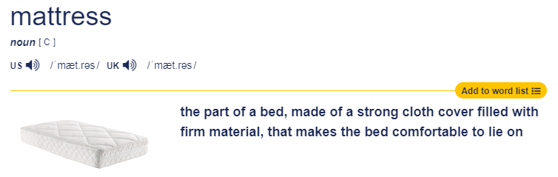

stilt  / wooden poles木杆

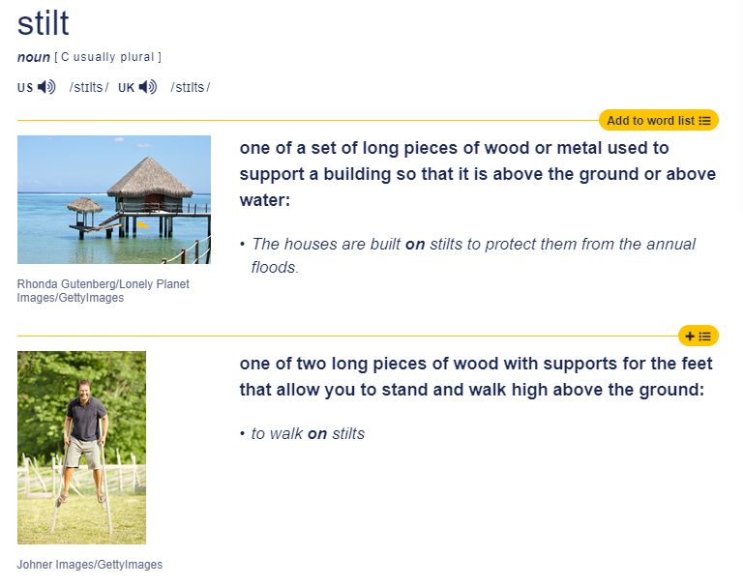

resort

a resort /  a place especially for tourists /  holiday 度假村

what is the most luxurious item  / thing that you own?

mortgage

an [agreement](https://dictionary.cambridge.org/us/dictionary/english/agreement) that [allows](https://dictionary.cambridge.org/us/dictionary/english/allow) you to [borrow](https://dictionary.cambridge.org/us/dictionary/english/borrow) [money](https://dictionary.cambridge.org/us/dictionary/english/money) from a [bank](https://dictionary.cambridge.org/us/dictionary/english/bank) or [similar](https://dictionary.cambridge.org/us/dictionary/english/similar) [organization](https://dictionary.cambridge.org/us/dictionary/english/organization), [especially](https://dictionary.cambridge.org/us/dictionary/english/especially) in [order](https://dictionary.cambridge.org/us/dictionary/english/order) to [buy](https://dictionary.cambridge.org/us/dictionary/english/buy) a [house](https://dictionary.cambridge.org/us/dictionary/english/house), or the [amount](https://dictionary.cambridge.org/us/dictionary/english/amount) of [money](https://dictionary.cambridge.org/us/dictionary/english/money) itself

Having a big mortgage is a real drain on your earnings.

He has a mortgage on his house.

I am not currently considering buying a house.

# July 23th, 2023

[englishclub.com/esl-games/vocabulary/matching-similes-2.php](https://www.englishclub.com/esl-games/vocabulary/matching-similes-2.php)

a tortoise/ a turtle but on the land

a mule/ a cross between a horse and a donkey

a lamb /  a baby sheep

I have been exercising all day. I am as hungry as a wolf!

(they don’t chew, they swallow their food whole)

I am so hungry, I could eat a horse!

they display their feathers to other peacocks( to attract a mate)

as stubborn as a mule

my brother drivers me crazy! He is as stubborn as a mule.

I tried to persuade them to change their minds

as gentle as a lamb

the little girl was so kind and as gentle as a lamb

your dog bit me!!! No, he would never do that, he is as gentle as a lamb!

as fast as a hare/ as slow as a tortoise

I always want to hit the snooze button

anyone who parachetes out of a plane is as brave as a lion.(或 bungee jumping)

they like to show off  / they are showoffs.

when my daughter passed her swimming exam she was proud as a peacock and showed everyone her certificate.

as diligent as a cattle.

# July 22th, 2023

[engoo.com/app/daily-news/article/being-sociable-helps-you-age-better-study-shows/i8H6shuBEe6mLJvqm5vZHQ](https://engoo.com/app/daily-news/article/being-sociable-helps-you-age-better-study-shows/i8H6shuBEe6mLJvqm5vZHQ)

mild

1)the weather has been mild this week

2)he has a very mild temperament

to age well

-to grow old but stay in good condition

I want to do yoga every day so that I age well.

the woman is 86 years old but she has aged well.

community-led

community led programs / are activities that are organized and run by the community.

teaching/mentoring

In the summer, university students volunteer to teach/ to mentor students from the village.

prescribe

they will prescribe taking part in social activities.

I would prescribe gardening indoors.

to ring true/ idiom / does it seem genuine, and truthful?

we are social animals. In most villages in China, they are retired and they just stay at home. They get together to cheer themselves up. It can decrease the monotony( Their lives can be monotonous and they get bored).

balcony

they would sing on their balconies.

everyone stood on their own balconies.

That is a heart warming story.

this is a good way to solve the social problem.

I think the results of  the study ring true.

I would tend my lychee trees.

I would grow plum trees.

I will learn to play an instrument.

# July 16th, 2023

[engoo.com/app/daily-news/article/prove-me-right-what-is-confirmation-bias/YRZ88ph9Ee23ICfBjgzqAQ](https://engoo.com/app/daily-news/article/prove-me-right-what-is-confirmation-bias/YRZ88ph9Ee23ICfBjgzqAQ)

I work out on my pecs

lay in→to have a lay in/ to stay in bed later than usual

Do you ever have a lay in?

## engage

1、Jessica and Paul got engaged yesterday

2、engage in (risky behaviour) (criminal activity) etc

the teenage boys were engaging in risky behaviour by jumping off the cliffs into the sea

3、the book was very engaging

## challenge

they should be more fair/ balanced

they should be unbiased/ without bias

to argue, to refute, to question, to challenge the results

i challenge your belief that Chinese cuisine is the best in the world!

the commonly held belief/ something that almost everybody believes in

i challenge your belief that the garden is a priority

you are telling me that you have a different opinion

how can we be 100 percent sure that we are correct?

we always believe what we want to believe.

## evidence

i have evidence that he is guilty (there could still be doubt)

i have proof that he is guilty (there can be no doubt)

echo what others say

we only engage with others that share our own opinions.

i want you to contradict me if i think that the sky is green?

In fact, the sky is mostly blue due to the way that sunlight interacts with Earth’s atmosphere.While it is true that the sky can take on different colors at various times of day or in different weather conditions.

# July 15th, 2023

I went to the local craft club.

quadriceps/quads

grin/grinning

## compel

I feel compelled to paint.

a very powerful impulse to do something/ to be compelled.

the government was compelled to change the laws after the protests.

the restaurant was compelled to change the environment after the customers complained.

## spot on

perfect

## versatile-n

my friend is versatile.

## versatility

my friend had great versatility.

## versatile

is beef a versatile ingredient in Chinese cuisine?

while beef isn't as widely used in Chinese cuisine as some other meats like chicken or pork, it can still be a versatile ingredient in some dishes. For example, beef is commonly used in stir-fry dishes like Mongolian Beef, as well as in noodle soups like spicy beef noodle soup.

a versatile ingredient is a food that can be cooked in many different ways or used in many different dishes

is salted cod a versatile ingredient in Chinese cuisine?

 I think that salted cod is not commonly used in Chinese cuisine. Although Chinese cuisine includes a wide range of seafood dishes, salted cod is not typically a seafood that you would find in China. Chinese seafood dishes typically rely on fresh ingredients such as crab, shrimp, and fish that are more commonly found in the coastal regions of China. Nonetheless, there may be some regional Chinese dishes that use salted cod, given that China is a large country with many regional variations in cuisine.

## is apple a versatile ingredient in UK cuisine?

in the UK the apple is a very versatile ingredient, we eat pork with apple sauce.

is apple a versatile ingredient in Chinese cuisine?

apples are not an ingredient that you would typically find in traditional Chinese cuisine, but they can still be used in various dishes. For example, some modern Chinese chefs may use apples in fusion dishes that blend Chinese and Western flavors. Additionally, apples can be used in desserts and sweet snacks like apple pie dumplings or caramelized apple slices. However, it's important to note that traditional Chinese cuisine relies heavily on fresh ingredients and doesn't typically use sweet or dessert-like ingredients in many dishes, so apples are not a common ingredient in that sense.

## what kind of craft did you do today?

knitting. I did some knitting today. it requires patience.

it is wearable art. so we can slow the speed of their decline by creating art. and we will end up stopping them fading away.

## July 9th, 2023

I feel tightness in my muscles.

bicep muscles  二头肌

triceps           肱三头肌

pectoral muscles  胸肌

I have been working on my pectoral muscles at the gym.

abdominal muscles 腹肌

I have been working on my abbs at the gym.

glutes  臀肌

my thigh muscles are ‘quads’

quadricep muscles / the quads

men wore skirts.

the men played bagpipes风笛

memorialise the poet 纪念诗人

## cuisine / cooking, food

Chinese cuisine is famous for being spicy.

English cuisine is famous for being very bad.

## compelling

-very interesting, intriguing

->He found the lightshow very compelling.

->I find true crime documentaries very compelling.

to be compelled  / to have such a strong desire, you nearly cannot stop yourself.

->I am compelled to paint great art.

->I am compelled to write a book.

->I am compelled to play the guitar.

compelled / to be consumed with desire to do something.

durable/ to be long wearing, to last a very long time

Electronic devices used to be more durable

these tyres are very durable

## what compels you?

I am compelled by…

I am compelled to…

I am compelled by my love of plants.

# July 3rd, 2023

https://engoo.com/app/lessons/ielts-speaking-test-preparation-level-8-describing-possessions/uC362uz0EeirW4PrnWOL9g?category_id=P6-s6hpMEemrUL__RArmKw&course_id=drH4urLREemum0PLgTsKcw

## a beaming smile

灿烂的笑容

grin / grinning

he can help feed the giraffes

wild animals野生动物

captive animals圈养动物

domesticated animals家养动物

animals are sometimes kept in captivity to help with their conservation / preservation

The dodo is an extinct animal.

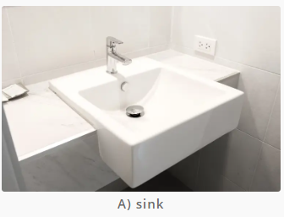

the hot tap / the cold tap

turn on the tap

tidy / comb / brush my hair

our daily routines

the sink plug 水槽塞

the plug 插头

plug socket 插座

the sink plug stops the water flowing out of the sink.

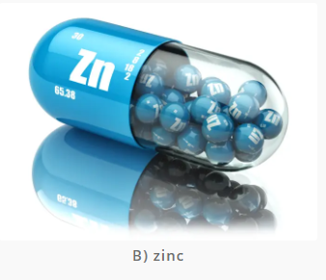

zinc / a trace element vital for a healthy immune system.(health supplements健康补品)

health supplements / tablets or capsules we ingest to improve or support our health.

My mum takes health supplements everyday.

particles of dust 灰尘颗粒

small balls

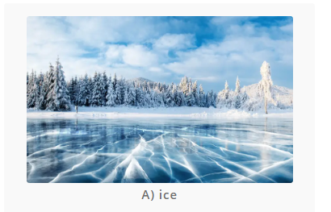

the snow has covered all the trees.

the river has frozen.

many people have been skiing in the place.

snow flakes雪花

the snow flakes are falling onto the ground.

rain drops 雨滴

rain drops are falling on the window.

your eyes sparkle when you are happy.

闪闪发光：

it shines, it glitters, it shimmers, it sparkles.

# July 2nd, 2023

## Sleep in

I slept in / I had a lay in.

I feel that I have been putting weight on recently.

the yoga mat 瑜伽垫

live stock / farm animals牲畜/农场动物

a florist / a person who sells flowers.

a bunch of flowers/a bouquet of flowers.

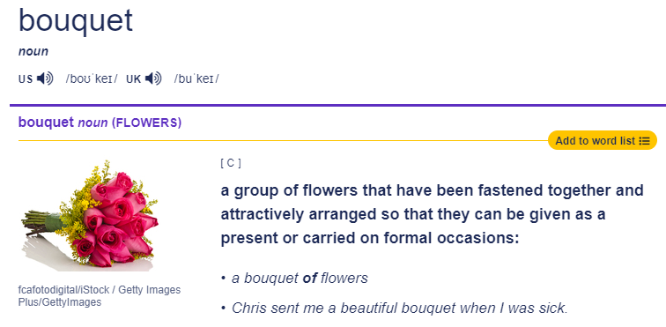

what kind of jobs are you looking for? what positions are you looking for?

I want to have a job where i am responsible for controlling electronic devices.

I want to design the software that controls electric devices.

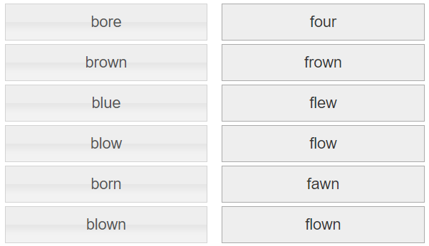

## fly - flew - flown

the poor bird couldn’t fly because it had a broken wing.

as soon as it saw us, the bird flew away / off.

I have flown to america many times.

I flew to america last week.

## frown

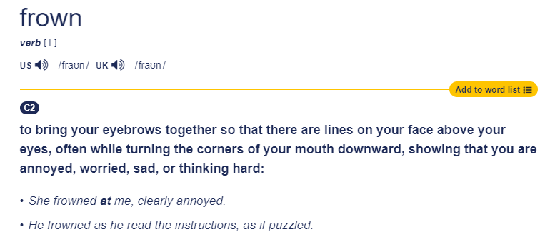

why are you frowning today?

fawn

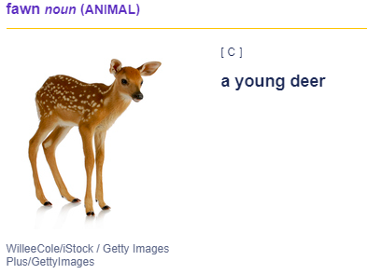

(to give someone a lot of attention and praise in order to get that person’s approval)

->Big movie stars are fawned over by the waiters at the restaurant.大电影明星受到餐厅服务员的阿谀奉承。

## to fawn over someone. / to fawn and fuss over someone

I hate waiters who fawn over you.

I walked through the forest and the trees were brown.

I looked up to the blue sky and the birds have flown.

# July 1st, 2023

# June 25th, 2023

I have a quiz about phrasal verbs.

<https://www.englishclub.com/ref/Phrasal_Verbs/Quizzes/Mixed_1/>

to allow for… / to consider\

if I had allowed for / if i had considered

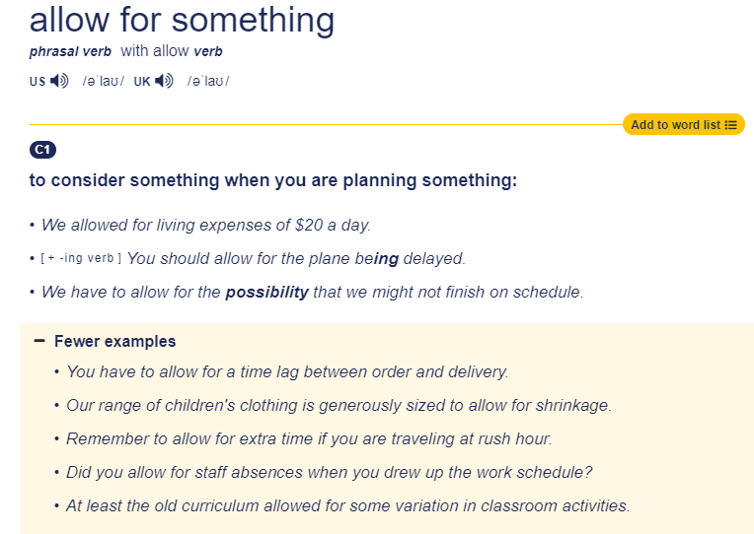

to run out of…

Do you always allow for all your expenses?你总是支付你所有的费用吗？

for ages /  for a very long time /  in donkeys years

an idiom/ in donkeys years/ a very long time/ for many years

I don’t know what became of him.我不知道他怎么样了。

what are some things that you have to deal with on a weekly basis?

do you have to deal with the laundry?

to donate / to give away for free

to be generous  / to be kind hearted, to give away many things to other people.

what is the most generous thing someone has done for you?

I really appreciate him. / I appreciate him so much.

weird / weirdo怪人

oddball / strange person怪人

self-centered  / inconsiderate / thoughtless

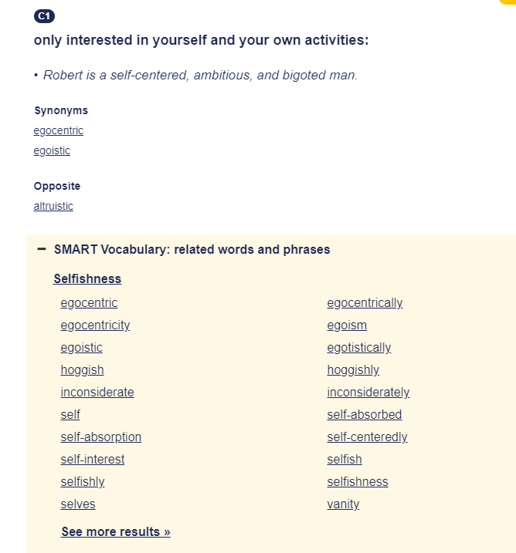

to give back / to return

you will lend me your camera.

I will borrow your camera.

I will give the camera back to you.

# June 18th, 2023

What goes around comes around恶有恶报，善有善报

You should not mistreat them. What goes around comes around.

in blows in gusts

after I graduated…

because my score was not high enough.

Most professors already had enough student.

I didn’t give up, i kept sending emails.HE responded to me. I didn’t expect him to respond to me.

I am so appreciative of my friends help.

to cook up an idea /  to come up with a plan or idea / to use your imagination.

fo foster / to nuture/ to encourage

to foster good luck / habits

nuance /  the small details /  subtle difference

turn a problem into a solution. / turn a negative into a positive.

at a lower price.以较低的价格

all the bosses / trainees can learn from these pitfalls.

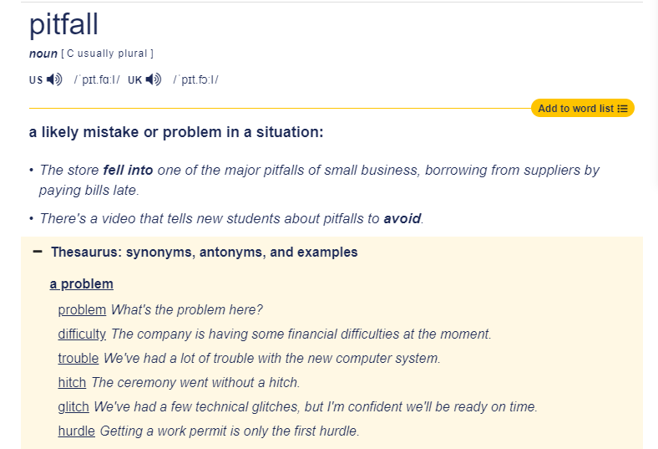

# June 11th, 2023

[engoo.com/app/lessons/describing-pictures-intermediate-describing-pictures-do-what-makes-you-happy/eLy-0k0cEeey1WvKVXzQFA?category_id=P_HriMOnEeifo0O-yMP42w&course_id=ZZasjsOnEeiHZVOMC0VfdA](https://engoo.com/app/lessons/describing-pictures-intermediate-describing-pictures-do-what-makes-you-happy/eLy-0k0cEeey1WvKVXzQFA?category_id=P_HriMOnEeifo0O-yMP42w&course_id=ZZasjsOnEeiHZVOMC0VfdA)

gullible - to believe in things easily

grin - 1)a wide smile 2)to smile a wide smile

1）a broad / sheepish grin灿烂 / 腼腆的笑容

2）He grinned at me from the doorway.他在门口对我咧嘴一笑。

# June 4th, 2023